Blueberry and oat muffins

Ingredients
Complexity: Low-medium

200g plain flour

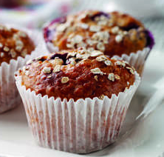
50g oats plus 1 x 15ml spoon

2 x 5ml spoon baking powder

150g light muscovado sugar

1 medium egg, beaten

284ml carton buttermilk

60ml vegetable oil

125g blueberries

Equipment
Muffin tray, paper cases, 2 x bowls, spoon, cooling rack.

Method
- Preheat the oven to 180ºC, Gas Mark 4. Place 12 paper cases in a muffin tray.
- Mix together the flour, oats, baking powder and sugar in a large bowl.
- In a separate bowl mix together the egg, buttermilk and oil and stir into the flour until combined, then stir in the blueberries.
- Spoon mixture into the paper cases and sprinkle over the remaining 1 tbsp oats. Bake for 25-30 minutes until golden.

Top tips
Ideal for freezing.

Food skills
Mix, stir & combine
Portion & divide
Decorate & garnish
Bake

