Where we buy vegetables
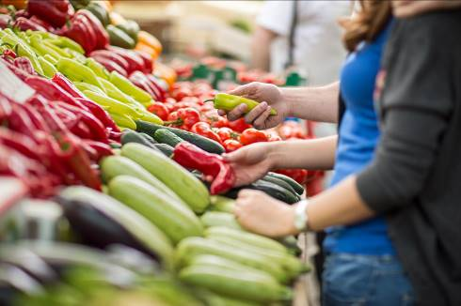
Market
This set of 5 cards introduces children to where we buy vegetables.

Vegetables can also be grown at home or in the early years setting.


Farm shop
Supermarket
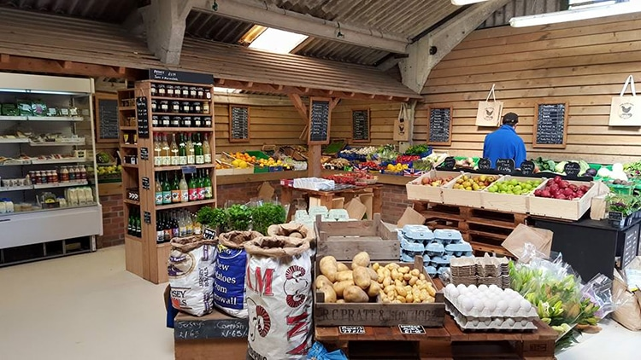
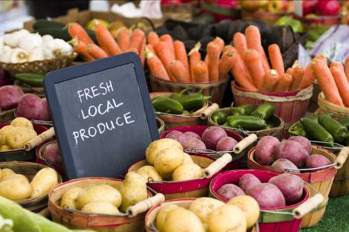
Online delivery
Greengrocer

