Grow your own veg

Did you know you can grow your own veg at home?

Why not have a go – you will need seeds, pots, compost and water!

Plants grow at different times of the year, plus need sunlight to grow.

You could grow the veg in pots on a windowsill.

- What vegetables do you want to grow?
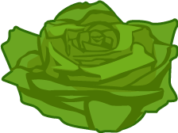There are many different types. Maybe start small with cress? Did you know that potatoes can grow in a bucket!

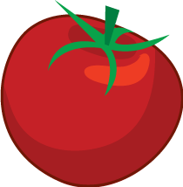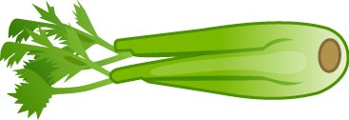
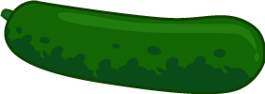
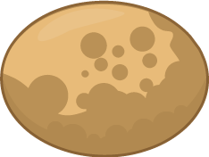


- Get planting
You’ll need seeds, compost and a container to start. Cress can be grown on kitchen paper – even easier (just sprinkle the seeds over paper and add water). If you’re growing potatoes, you’ll need to get ‘seed potatoes’ and ‘chit’ them.
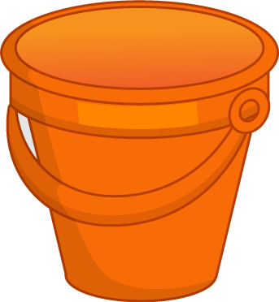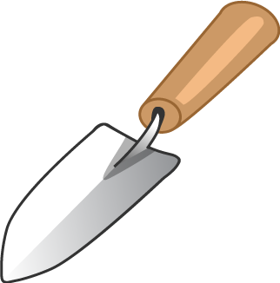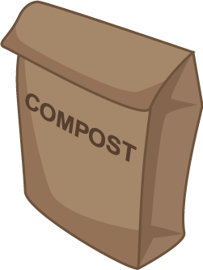
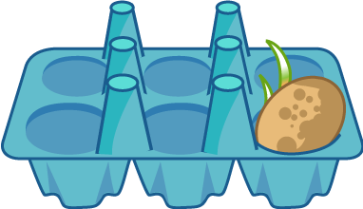

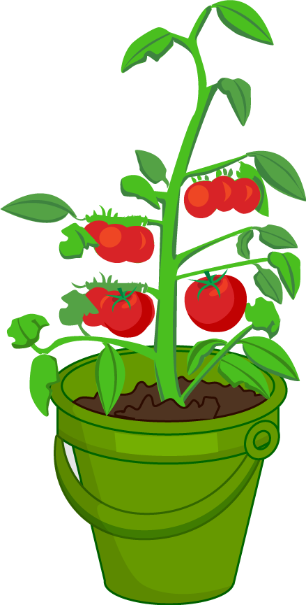
- Water and care for your plant
Once planted, water your plant and make sure it gets plenty of sunlight.
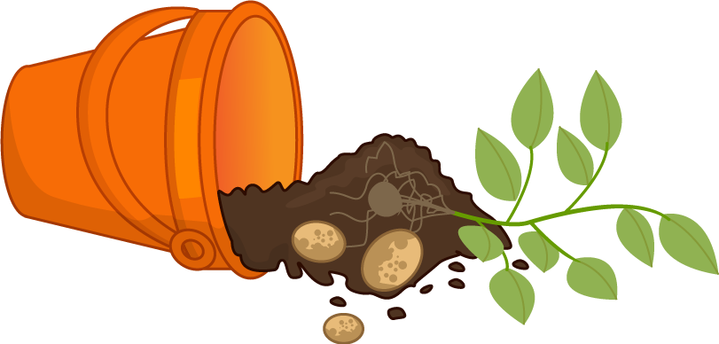
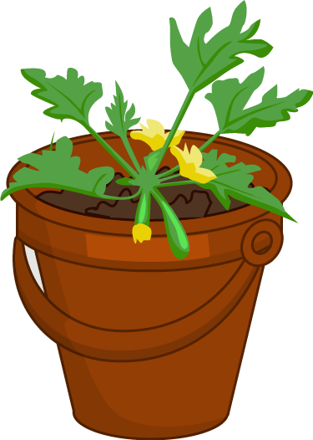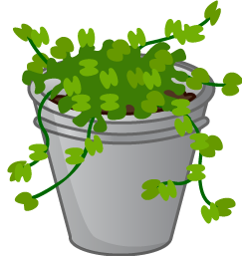Over time, the plant will grow – and you can eat the results!

