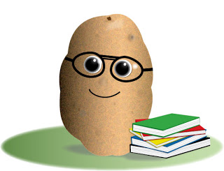
If I were a vegetable …

If you were a vegetable, what would you be?

Explain why you have chosen the vegetable.

Draw the vegetable below.

