Jacket potato served with prawn and avocado salad

Ingredients
Complexity: medium

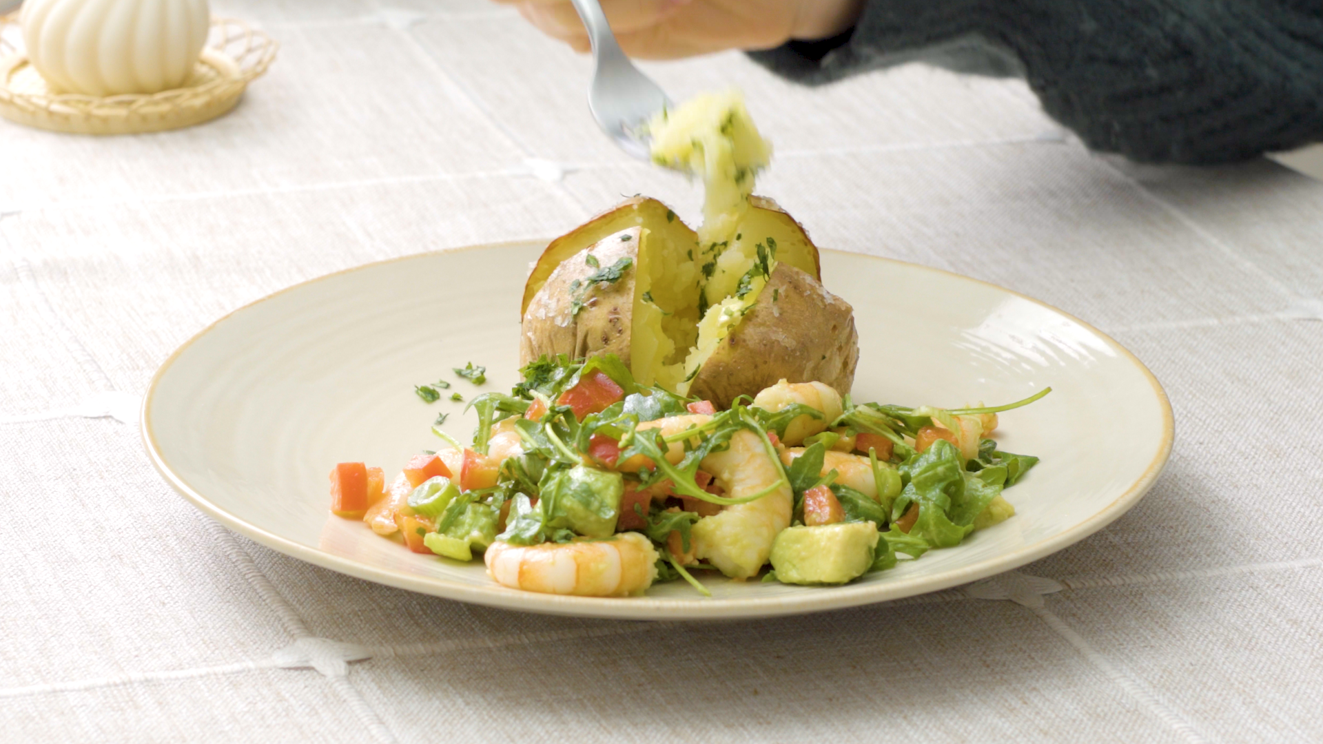
2 medium fluffy potatoes
e.g. Maris Piper or King Edward

For the prawn and avocado salad

20g watercress or rocket leaves

1 x spring onion

¼ red pepper

½ medium avocado

50g cooked, peeled prawns

1 x 15ml spoon reduced-fat salad dressing

Equipment
Fork, chopping board, vegetable knife, large bowl, spoon, plate.

Method
- Pierce the potato several times with a fork, and place in the microwave on high (900W) for approximately 10 minutes, until soft. (Microwave times will vary).
- Meanwhile, prepare the salad; finely chop the spring onion, deseed and finely dice the red pepper, peel and roughly chop the avocado.
- Put the salad leaves, spring onion, red pepper, avocado and prawns into a large bowl. Season.
- Pour the salad dressing over the salad and toss gently.
- Once the potatoes are cooked, slit open. Be careful the potatoes will be hot.
- Serve immediately with the salad.

Top tips
- For a crispy skin, once cooked in the microwave place the potatoes on a baking tray, in a hot oven (220⁰C, 200⁰C Fan, Gas Mark 7) for approximately 20 minutes.
- If time allows, make your own salad dressing: In a small bowl or clean jam jar whisk together, 1 x 15ml olive/rapeseed oil, zest and juice of ½ lemon, ¼ x 5ml spoon Dijon mustard, and 1 x 15ml fresh chopped parsley.

Food skills
- Measure.
- Weigh.
- Mix.
- Microwave.
- Cut/chop.

