Chilli con carne filled jacket potato

Ingredients

1 small onion

1 garlic clove
Complexity: medium - high

1 x 5ml spoon vegetable oil

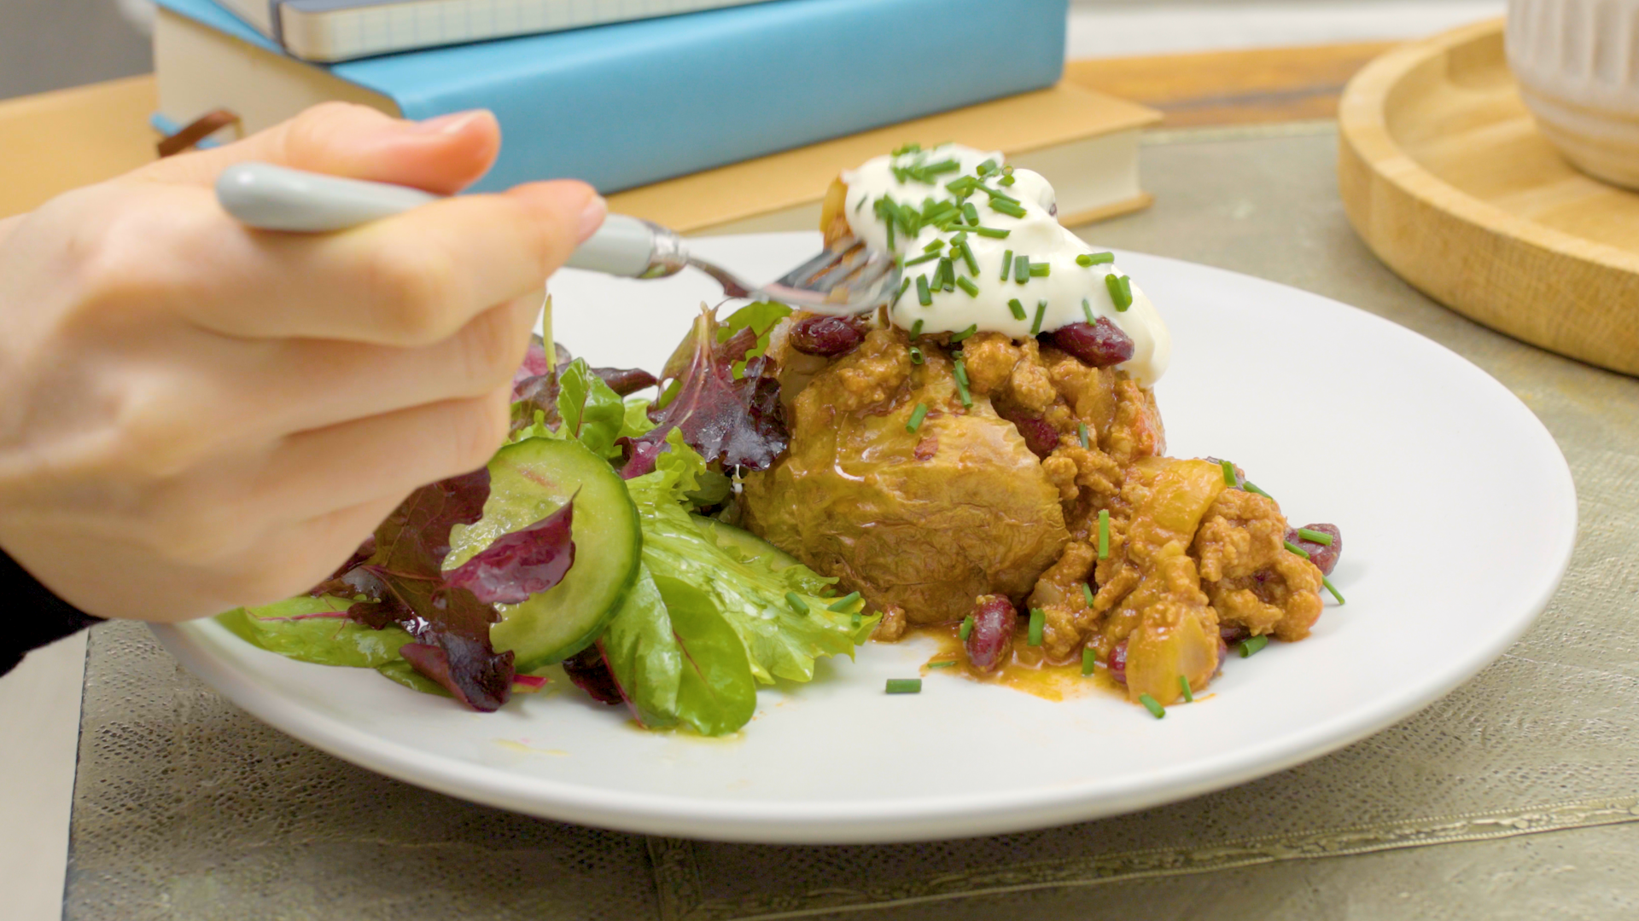
½ x 5ml spoon chilli powder

½ x 5ml spoon ground cumin

¼ x 5ml spoon ground coriander

250g lean beef mince 5% fat

1 x 15ml spoon tomato purée

1 x 200g can chopped tomatoes

1 x 200g can red kidney beans, drained and rinsed

2 medium fluffy potatoes
e.g. Maris Piper or King Edward

2 x 15ml spoons reduced fat soured cream

45g reduced fat hard cheese e.g. Cheddar

For the salad

1 x bag mixed salad leaves

¼ cucumber,

2 x 15ml spoons reduced fat French dressing

Equipment
Vegetable knife, chopping board, measuring spoons, frying pan, wooden spoon, can opener, fork, large bowl, grater, plate.

Method
- Peel and finely chop the onion.
- Peel and finely chop or crush the garlic.
- Heat the oil in a frying pan. Add the onion, garlic and spices and cook over a medium heat for 3-4 minutes until soft, stirring occasionally.
- Add the mince and cook for 5-10 minutes until brown, stirring occasionally, breaking up the mixture with the back of a spoon.
- Add the tomato purée, chopped tomatoes and red kidney beans. Season, stir and cook gently for 25-30 minutes.
- Pierce the potatoes several times with a fork, and place in the microwave on high for about 10 minutes, until soft. (Microwave times will vary).
- Meanwhile, prepare the salad; Slice the cucumber. Put the salad leaves and cucumber into a large bowl, add the dressing and toss gently.
- Once the potatoes are cooked, slit open. Be careful the potatoes will be hot.
- Grate the cheese.
- Spoon the chilli and a spoon of soured cream over the potato and add some of the grated cheese.
- Serve immediately with the salad.

Top tips
- For a crispy skin, once cooked in the microwave place the potatoes on a baking tray, in a hot oven (220⁰C, 200⁰C Fan, Gas Mark 7) for approximately 20 minutes.

Food skills
- Measure.
- Drain.
- Rinse.
- Mix.
- Microwave.
- Cut/chop.
- Grate.
- Fry.
- Simmer.

