

Food in Victorian times

Teachers’ guide

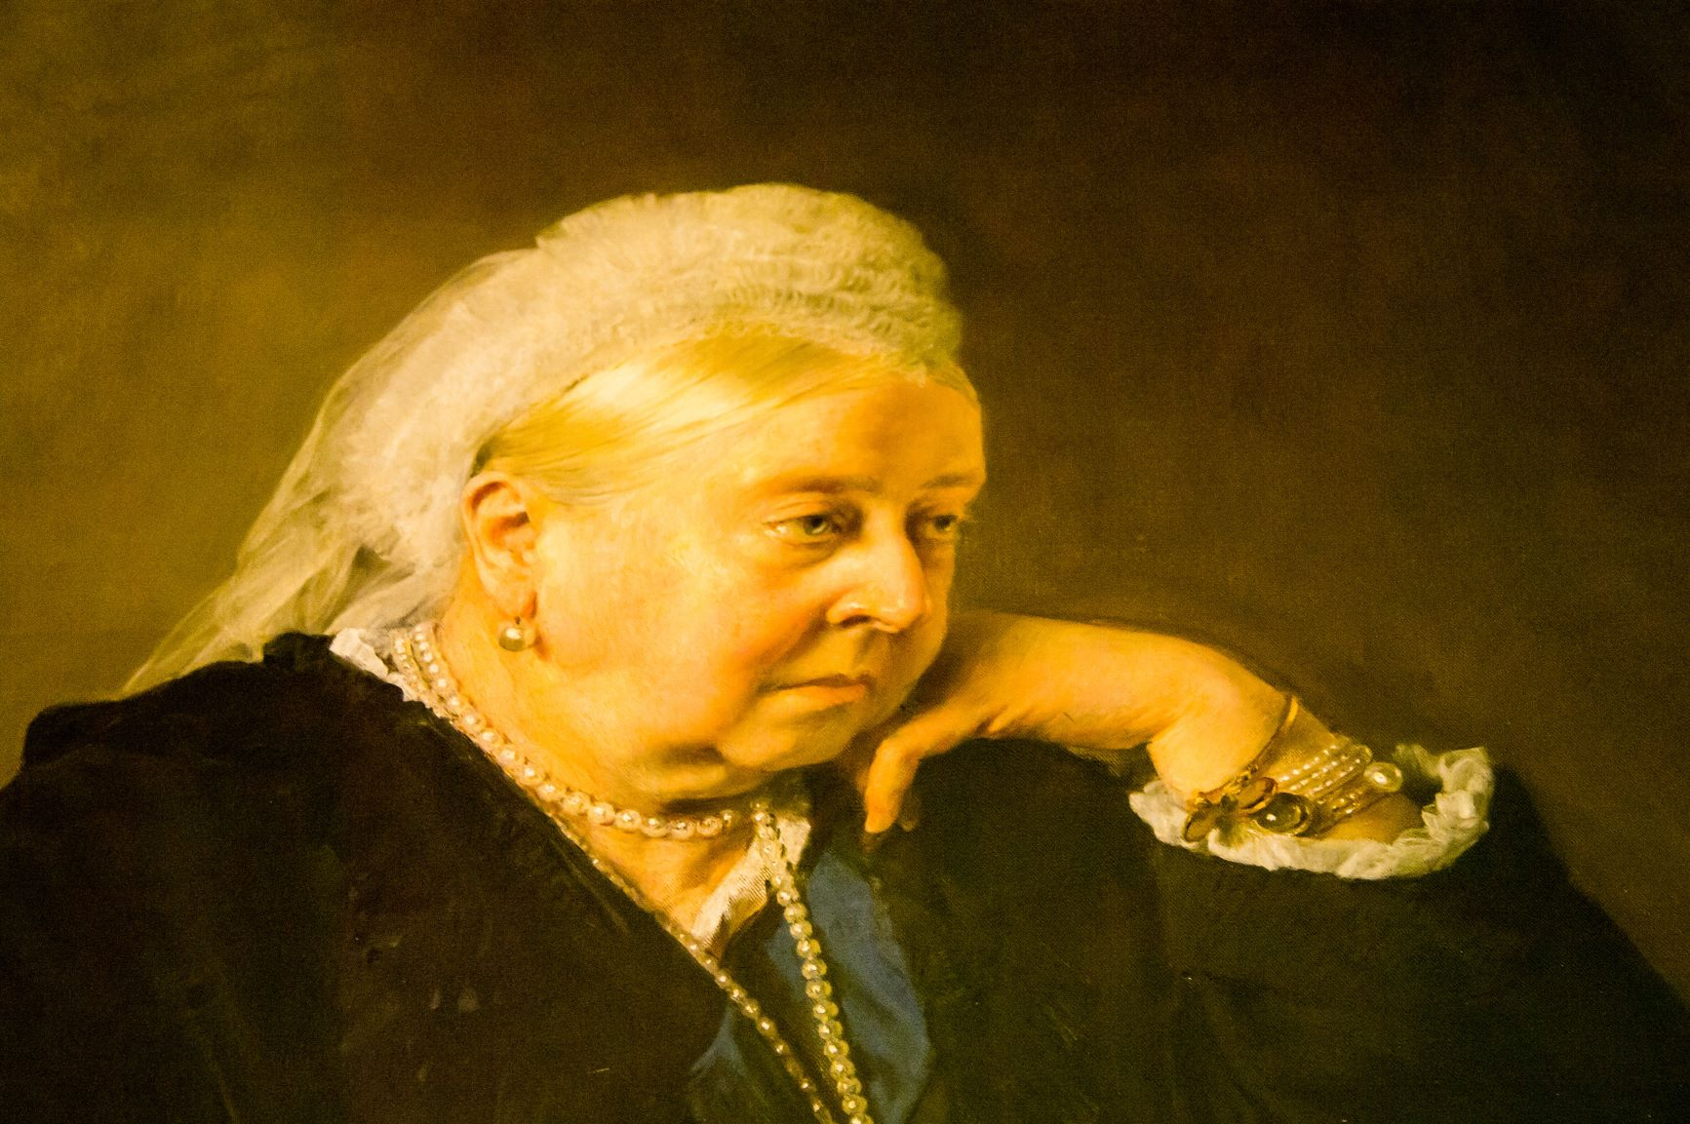

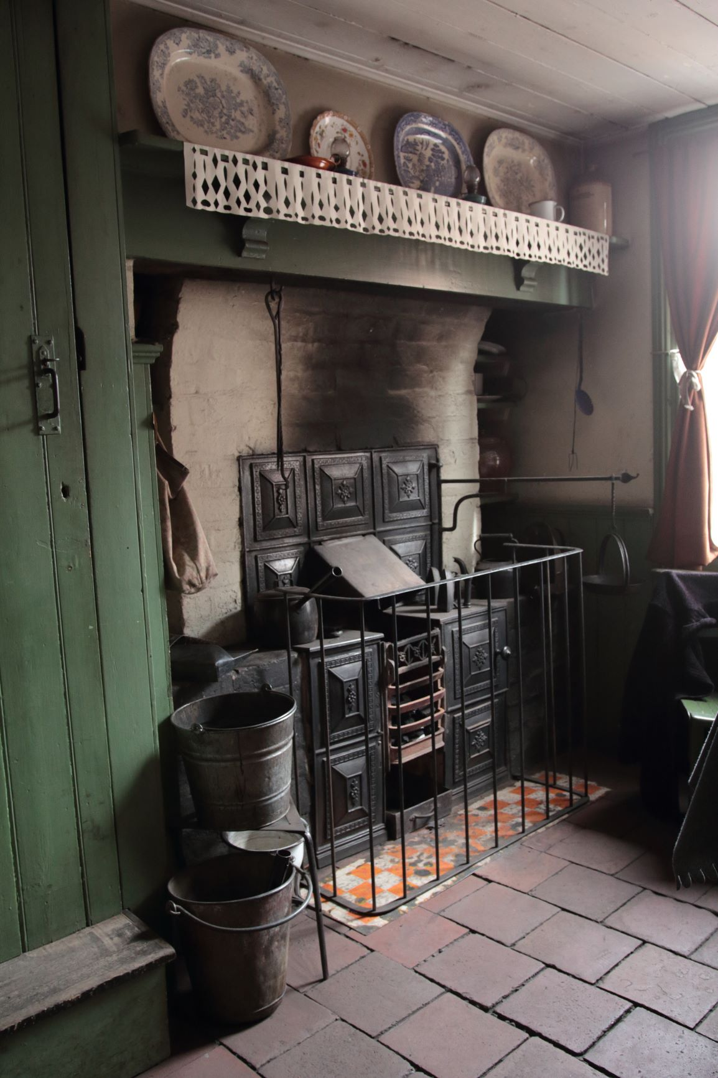
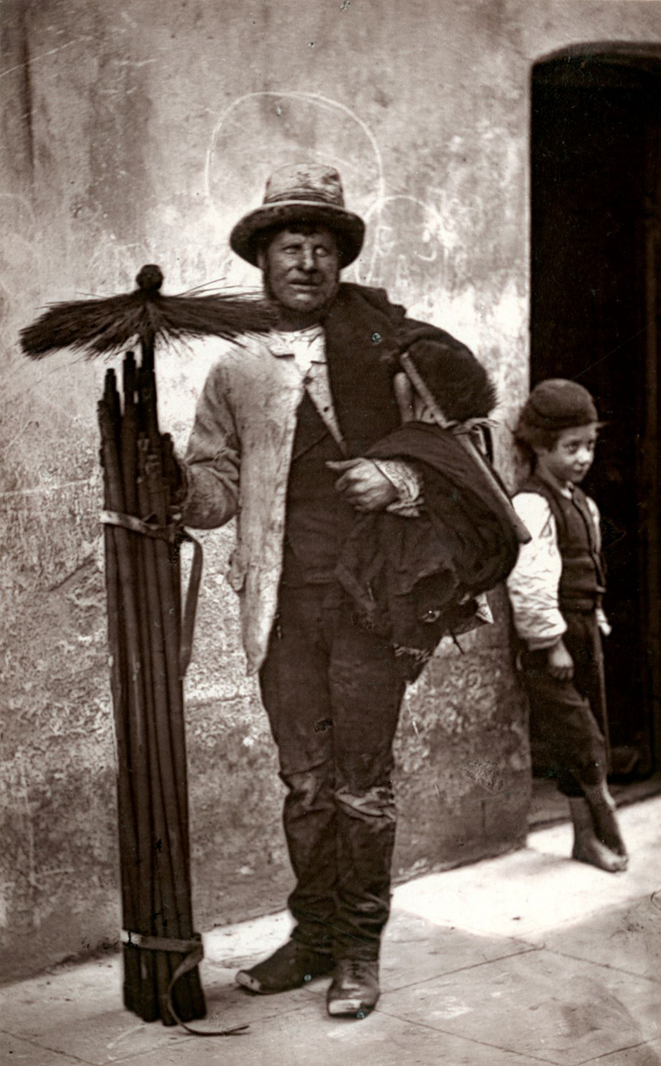

Food in Victorian times

This guide provides the background information needed to deliver the activities in this pack about food in the mid-Victorian times. A list and description of the available resources can be found on page 6.

It is envisaged that teachers delivering a block of work about the Victorians will be able to use this pack to supplement their teaching, with a specific focus on food.

Introduction

The Victorian period spanned 64 years from 1837 to 1901 and saw great changes in British ways of life. This included a surge in people moving from the countryside to towns and cities to find work, and developments in transport such as the railway network and manufacture of the first cars in the 1880s.

This resource focuses on food during the Victorian era, specifically the diet of the working classes during the mid-Victorian period (1855 – 1880). At this time, the working classes made up around three-quarters of the population. Within the working classes there were a wide range of incomes and living standards, but it is worth noting that extreme poverty was not common until later half of 19th century.

The diet of the working classes in the mid-Victorian period

Fruit and vegetables

The mid-Victorian diet included plenty of fruit and vegetables because they were cheap, widely available and could be used to bulk out meals. The Victorians ate fruit and vegetables that were in season. Here are some examples of the main fruit and vegetables eaten.
- Apples – cheapest and most commonly available urban fruits eaten from August to May.
- Cherries – cheap from May to July.
- Gooseberries, plums and greengages – available from July to late September.
- Candied peel and dried fruits always cheaply available and used to flavour desserts like bread pudding and in cakes and mincemeat.
- Onions – one of the cheapest vegetables (around a halfpenny for 12) and widely available all year around.
- Beetroot – eaten all year-round.
- Jerusalem artichoke – eaten from September to March, often homegrown (one of easiest vegetables to grow on an urban allotment).
- Carrots and turnips – inexpensive staples, especially during winter.
- Watercress – a cheap staple (around a halfpenny for four bunches) from April to January.
- Cabbage, broccoli and lettuce and radishes – available in the summer months.
- Peas – June and July.
- Beans – July to September.

Legumes and nuts
- Dried legumes (e.g. yellow split peas) - available all year round and widely used, e.g. pease pudding
- Chestnut – was the most commonly consumed nut. A favourite street snack in chestnut season from September to July.
- Hazelnuts – October to May.
- Almonds, brazil nuts – were imported so more expensive but widely consumed around Christmas as a treat.
- Coconuts – also imported and often given as a gift or won at fairs.

Fish and seafood

Fish was available from Monday evening to Friday evening as fishermen did not go fishing over the weekends.
- Herrings - eaten fresh in the autumn, winter and spring and dried/smoked (red herring) or pickled all year round. Red herrings were a year round staple of the Victorian working class because they were easy to cook.
- Sprats, eels and shellfish (oysters, mussels, cockles, whelks) – were favourites because they were cheap and available, and kept better than white fish.
- Cod, haddock and John Dory – were the preferred types of white fish. Typically, and unlike today, the whole fish was consumed, including the head and roe.
- Whitebait (fried) – were a favourite street food (fish and chips had not been invented).

Meats

Having meat in the mid-Victorian times was considered the mark of a good diet, having a limited amount was thought of as a ‘poverty’ diet. Pork was the most commonly consumed meat. All meats came from free-range animals.
- Joints of meat - would be an occasional treat for the poor eaten just a few times a year. Some would not have the facilities to cook a joint of meat so would take it to a cook house or bakery and pay a small fee to have it cooked.
- Meat on the bone (shin or cheek), stewed or fried - this was the most economical form of meat.
- Brains, heart, liver, kidneys (offal) – cheap and often used.

Other food
- Eggs – some people kept hens in their backyard, they could eat or sell the eggs.
- Milk – wildly consumed but not in large quantity due to cost.
- Butter – available but not a lot was eaten due to the cost. Dripping and lard were more commonly eaten.
- Hard cheeses - favoured by working classes as they had a long self-life.

Weekly meal examples

Here are some examples of what mid-Victorian working class families of four to six people are likely to have eaten during a week. There were a range of incomes within the mid-Victorian working classes. These columns illustrate what families with the higher (£2 per week), average (£1 per week) and lowest (less than £1 a week) income might have eaten.

 | Food budget around £2 a week | Food budget around £1 a week | Food budget less than £1 a week
Breakfast | Porridge made with milk but later in the week it would be half milk and half water. Toasted bread, possibly with butter and jam.  Breakfast on Sunday would usually be eggs – boiled or fried. Eggs were sometimes also eaten mid-week. | Bread, or porridge made with water and milk at the start of the week and then just water by the end. Often cheese and watercress could be served too.  Breakfast might involve cooked eggs on Sunday. | Breakfast was generally bread, sometime with butter. For the poorest a sandwich of bread and watercress was most common. At the start of the week, porridge made with water might be available.
Lunch | Often a sandwich with paste, leftover meat or watercress and cheese. They may also have had soup made from meat and vegetables, or meat or vegetable pies.  These were often bought as cheap street food. | Sandwiches made from leftovers. At the start of the week, when funds allowed, street food such as soup, pies and sandwiches may have been bought. | Usually bread with cheese, if possible, or more watercress. At the start of the week, soup may occasionally be bought as cheap street food.
Evening meal | Usually a roast dinner on Sunday. Leftovers would be eaten cold on Monday with pickles. On Tuesday, any further leftovers would be cooked up in a form such as curry. Mid-week might be a steamed meat suet pudding which would then be eaten cold the next day. It would usually be fish on a Friday. Pork chops or fried beefsteak would be served on Saturday. At all these meals, vegetables (in season), would be an important feature to bulk out the meal. Desserts were often served and would usually be fruit or dairy based, e.g. apple pie, rice pudding, stewed or fresh fruit like gooseberries or cherries.  Tea with milk and often sugar was a common drink. Coffee was more rarely served and generally with breakfast. | Usually there would be meat on Sunday, perhaps pork or mutton. This would be boiled instead of roasted so it wouldn’t shrink as much when it was cooked, leftover meat would be served cold on Monday. Tuesday and Wednesday would be a stew made with cheap cuts of meat (that weren’t always fresh) or offal, and vegetables, particularly onions. This would be served with bread and potatoes to make it go further. Thursday would be something vegetable based, perhaps cooked in a bone stock. Friday might be fish and potatoes and Saturday might be chops with vegetables.  Desserts were heavily fruit based (stewed or fresh, depending what was in season and its condition) and often bulked out with sweetened rice.  Tea was the staple drink but black coffee was available occasionally. | Usually meat on Sunday but in the form of a boiled meat pudding made with suet pastry and containing scraps of meat, offal and onions. This would be served with lots of vegetables such as potatoes, carrots, cabbage or Jerusalem artichokes. On Monday, the meat pudding would be served cold with bread and a salad (often beetroot and watercress). Tuesday and Wednesday would be stew or soup based on bones, meat or fat scraps. Thursday may be a dish made with rice or lentils boiled with fat and onions, served with bread. Friday might be red herrings or fish head soup with bread. Saturday would be fried or stewed offal, such as ox kidneys.  Desserts were very plain. A typical dish could be stewed apple with breadcrumbs and ground ginger.  Tea was a staple drink and coffee might be drunk with breakfast, even by the poorest.

Shopping

There were no supermarkets in Victorian times so people had to visit individual shops such as butchers and greengrocers to do their food shopping. Small shopkeepers had limited storage, but trains bought fresh fruit and vegetables daily so the Victorians would make frequent trips to shops to pick-up fruit and vegetables and other food throughout the week. This was also necessary as people did not have refrigerators at home to keep their food fresh. Most Victorians were paid on a Saturday, so their best meals of the week were usually at the weekend, with the quality of their meals deteriorating as the week went on and the money ran out. Meat would usually only be bought once a week due to the cost.

Cooking

Cooking methods used by the mid-Victorian working classes varied according to income. For example, only those at the top end of the income range would have access to different sized saucepans, as well as a frying pan, a kettle and a roasting dish. At the bottom end, people would have one saucepan, a frying pan and a kettle, as a maximum. Mid-Victorian working classes with more income might have a ‘range’ (a bit like a modern day aga) or built-in oven to the side of the fire. Those with less income, may just have had an open fire over which to hang saucepans and kettles for cooking. This, in addition to their low income, limited the types of meals they could cook. Light would also have been minimal, encouraging a very basic style of cooking.

Food waste

The mid-Victorian working classes had very little money so they made the most of any food they had. Leftovers from meals would be eaten cold the next day. Leftovers that were several days old and starting to spoil would be turned into a hash with frying pan heat a spices to disguise food on the turn and reduce the risk of food poisoning. They would keep the water used to boil vegetables to make gravies and soups and also boil animals bones to make stews and broths. The poorest mid-Victorians in particular would eat all part of the animal, not just offal such as kidneys, heart and brains but also sheep’s heads which could be bought very cheaply, and fish heads.

What Queen Victoria ate

In contrast to the mid-Victorian working classes, Queen Victoria enjoyed plenty of different food. With her position and wealth, she had a greater choice and greater access than most - so she indulged herself! Queen Victoria had a reputation for being greedy and although advised to eat less and exercise more, she preferred simply to get her cloths made bigger as she got larger. The clothing she wore in later life shows that Victoria — who stood just 5ft tall — had a waistline measuring 45 inches.

Queen Victoria held many royal banquets, entertaining visiting monarchs and dignitaries at Buckingham Palace but even when it was just the family there was still a feast. According to menus listed in ledgers stored at the Royal Archive, on June 8, 1857, she, Albert and 16-year-old Princess Victoria sat down and worked their way through Italian pasta soup and rice soup; mackerel and whiting; roast beef and capon with rice; chicken rissoles and asparagus; baked meringue and filled choux buns. On a different evening at home that same month, the three of them ate poached eggs and a clear chicken soup; sole gratin and fried whiting; roast beef and capon with asparagus; vol-au-vents with béchamel sauce and grilled eggs; and apricot flan and waffles ‘mit creme’. Fresh fruit was a surprising royal favourite, given that she usually leaned towards heavy cooked meats, potatoes and puddings.

Queen Victoria often wrote about food in journals and letters, usually to complain she had been somewhere and there hadn’t been enough! She often took a large variety of food with her to events and on outings, even if she had already had a big meal at home.

Sources of information

The following sources of information have been used to write this teachers’ guide:
- Article: An unsuitable and degraded diet? Part three: Victorian consumption patterns and their health benefits: https://www.ncbi.nlm.nih.gov/pmc/articles/PMC2587384/
- The daily mail article (Adapted from The Greedy Queen by Annie Gray, 2017): (https://www.dailymail.co.uk/news/article-4546434/Queen-Victoria-ate-six-course-dinners.html
- Home Made Pickles, by Phillis Browne (Girl's Own Paper, 1883) Recipes for pickling cabbage, walnuts, onions, sour plums, cucumbers and more! https://www.victorianvoices.net/ARTICLES/VT/2015/1509-pickles.pdf (Also available in the September 2015 issue of Victorian Times: https://www.victorianvoices.net/topics/cooking/preserves.shtml#:~:text=Recipes%20for%20pickling%20cabbage%2C%20walnuts,2015%20issue%20of%20Victorian%20Times.&text=Whether%20you%20prefer%20to%20call,recipes%20will%20have%20you%20drooling )

Teaching resources

Resource name | Description
Food in Victorian times | A presentation about food eaten by the mid-Victorian working classes and Queen Victoria
Victorian cooking | A worksheet to help pupils compare Victorian and modern-day cooking appliances.
Victorian food in the Eatwell Guide | A blank Eatwell Guide for pupils to populate with food eaten in Victorian times.
Victorian food diary | A food diary for pupils to complete and compare with what a Victorian may have eaten over a day.
Victorian pickling | A worksheet to help children investigate pickled food available in Victorian times and today.
Victorian pots and pans | A sheet for pupils to record their research into what Victorian pots and pans looked like and compare them with modern day versions.
Victorian seasonal food | A worksheet exploring when some of the food eaten by Victorians was in season.
Pease pudding recipe | A simple, modern day version of a pease pudding recipe.

Teaching tips

Getting started

Use the Food in Victorian times presentation to talk to pupils about what was eaten by the mid-Victorian working classes and Queen Victoria herself. Choose from the supporting worksheets to pick up on aspects of the presentation with your class.

Tasting session

You could hold a Victorian food tasting session with your pupils. Below are some examples of food you may wish to offer. Remember to check for food allergies before your tasting session. Here is an Ingredient check letter you may wish to send to parents/carers. Your pupils could record their tasting experience using the Tasting ingredients worksheet. You may find these Sensory vocabulary cards useful.

Food ideas for a tasting session:
- Pickled herrings
- Greengages
- Cockles (the Victorians would have eaten these fresh but for convenience you may like to use a jared variety)
- Chestnuts (the Victorians bought roasted chestnuts cheaply from street sellers. You could use a canned variety for your tasting session.)
- Candied peel
- Watercress
- Pickled red cabbage or gherkins

