A space menu that’s out of this world!

Use the checklist below to create a menu for a day if you were an astronaut.

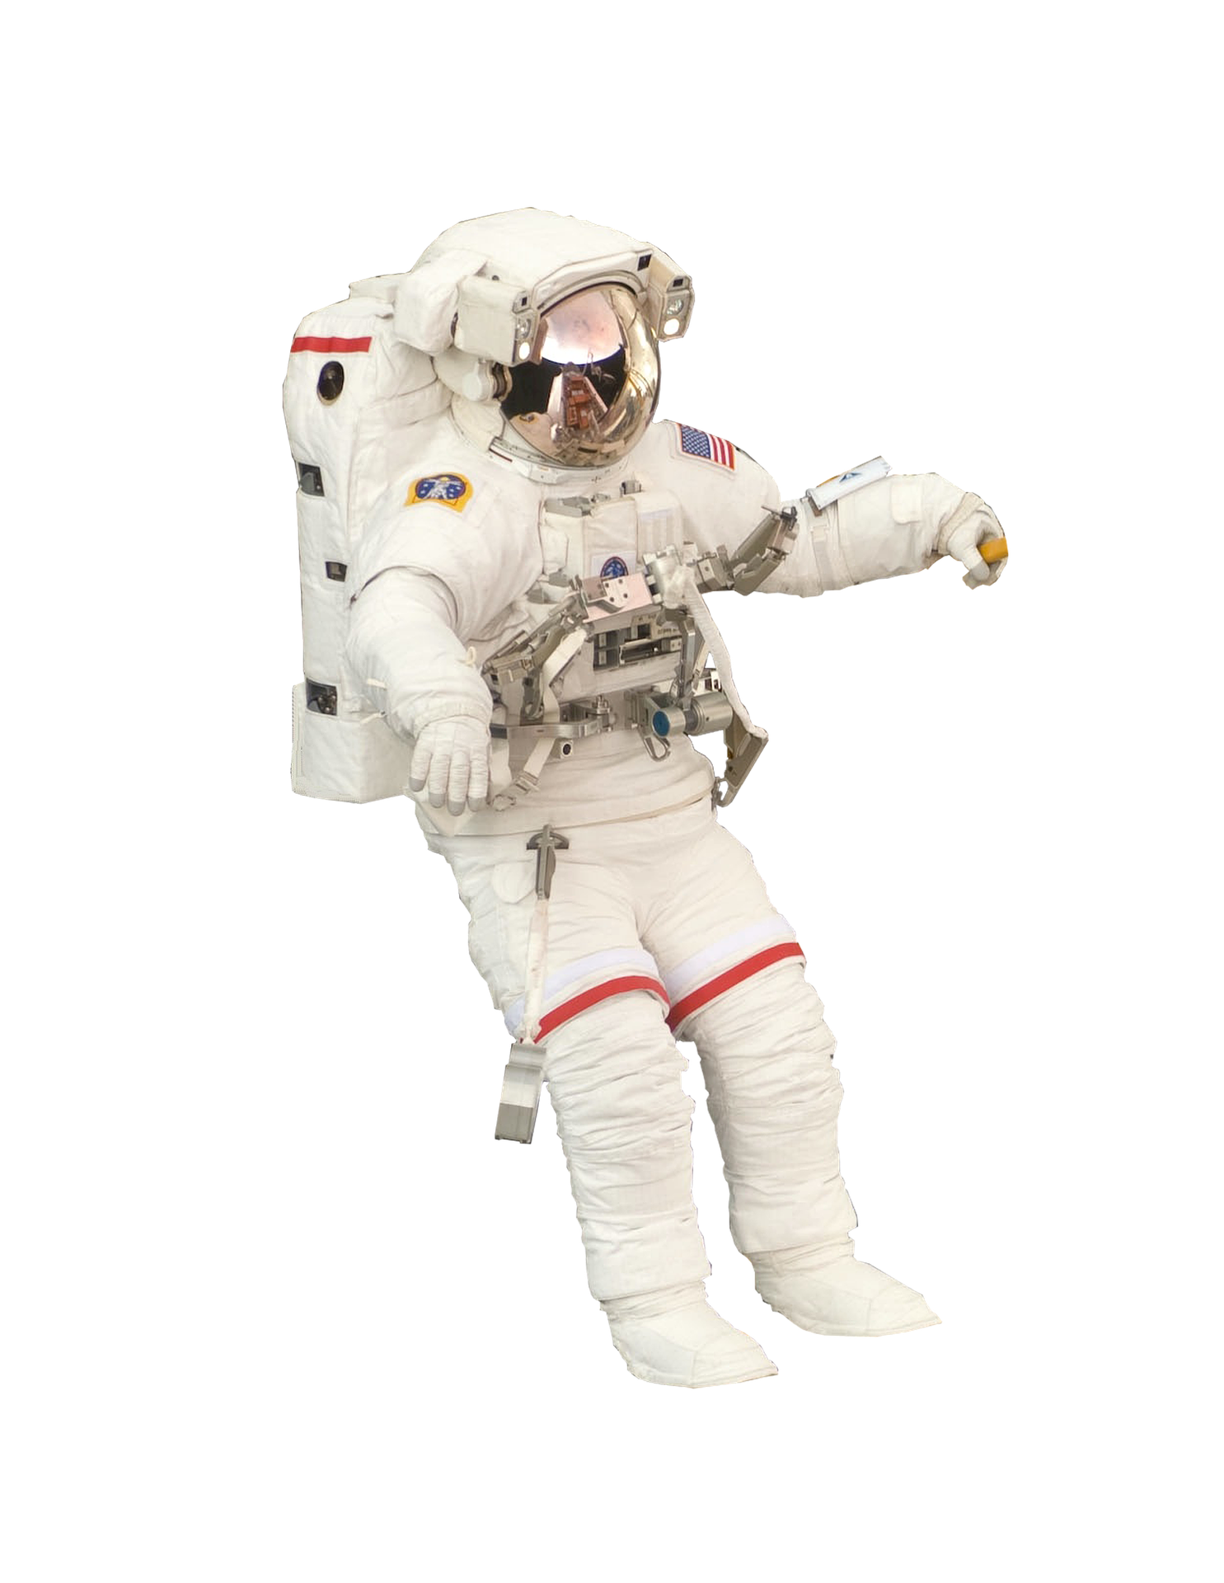

Breakfast

Lunch

Dinner

Snacks
Checklist
- Food provides the right amounts of energy and nutrients for their needs.
- Food that is lightweight and compact.
- Food that the astronauts enjoy eating.
- Food that is either ready to eat or can be prepared easily and quickly.
- Enough food that will last throughout the mission.

