

Food in Space

Teachers’ guide

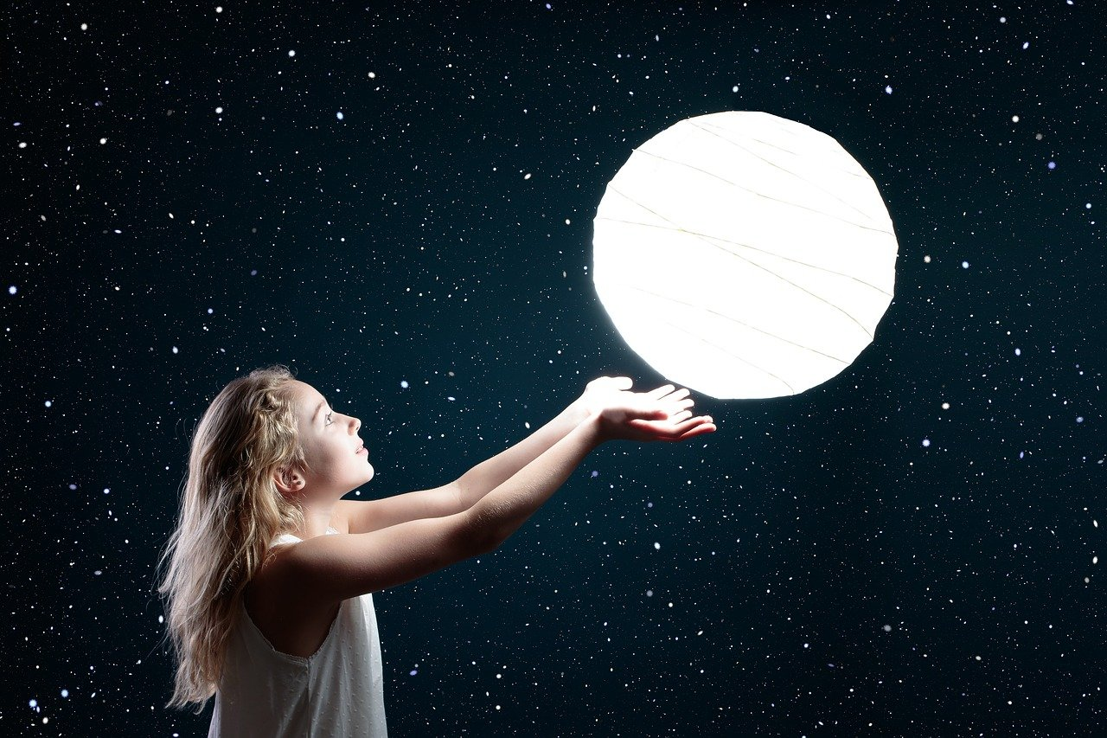
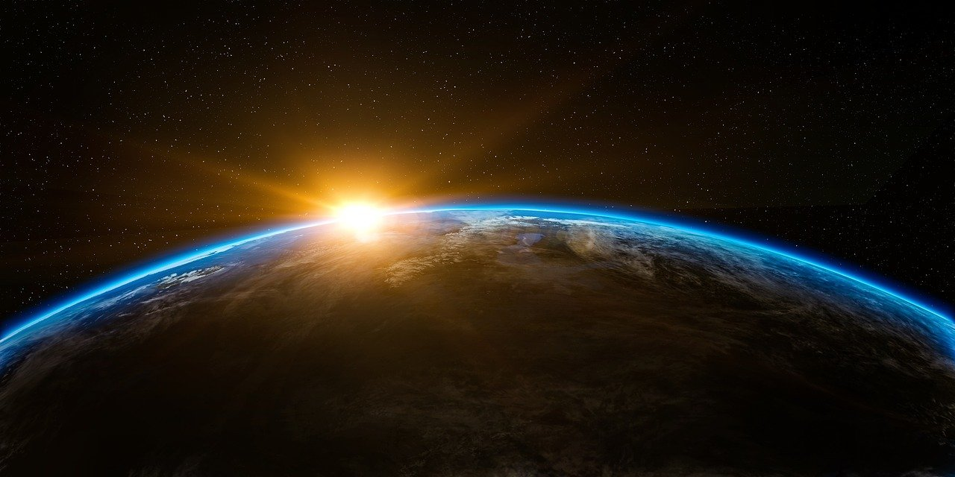

Thematic pack: Space

Teachers’ guide
This guide provides the key background information needed to deliver the activities in this pack about eating and drinking in space. It also lists and describes the available resources (page 5).

It is envisaged that teachers delivering a block of work about space will be able to use this pack to supplement their teaching, with a specific focus on eating and drinking in space.

Key information about food and eating in space

Surviving in space
Although humans were first able to travel into space in the 1950s and 60s, technology has now become so good people are actually able to live in space. Astronauts live on the International Space Station, or ISS for short. The ISS is an artificial satellite, where conditions are created to enable people to survive in space. In the year 2000, three people travelled into space and arrived at the ISS. Different people have been living up there ever since, changing around every six months. The longest any one person has stayed at the ISS is 437 days. There are around 6 people currently living on the ISS, brought in ‘crews’ of five to seven people. The ISS is usually found about 240 miles above the surface of the Earth, approximately the distance between London and Paris, but it can vary between 120 and 300 miles.

Living on the ISS is very different to living on Earth and requires years of training. As space can be dangerous, and humans are not able to survive the conditions, the ISS has to recreate the conditions of Earth in space. This includes ensuring there is air to breathe, water to drink and food to eat. Even sleeping is different on the ISS. Astronauts who live there have to be strapped down by attaching their sleeping bags to the floor and walls!

Meals in space
The food astronauts eat in space is different than the food they eat at home. This is similar to in an aeroplane, where passengers won’t be able to eat the same food they would at home but can eat some ready-to-eat foods. Even the food that is given to passengers on a flight has to be prepared and stored in a specific way to make sure it is safe to eat. This is the same for the food that is eaten in space, but the planning needs to be even better, as journeys into space last much longer than a flight.

When astronauts first went into space, the food available was in bite sized cubes, freeze-dried powders and thick liquids packaged in aluminum tubes, such as vegetable soup, and was usually quite unappetising. For the food stored in a metallic tube, astronauts had to squeeze it out, a bit like toothpaste! Astronauts reported that they disliked the squeezy tubes and that the freeze-dried foods were hard to rehydrate. However, as technology and understanding has improved, so have the types and varieties of food that astronauts can has become much nicer. Now the standard menu repeats every seven to eight days, and there is lots of variety!

As astronauts’ typically stay at the ISS for around six months, it is important to have food that will keep for a long period of time. New food supplies are sent into space for the astronauts every 90 days (approximately three months) and take about six hours to make the journey from Earth. The food needs to be light, so water is removed from food and drinks (called dehydration) and to help preserve them. It is also important to have food that can be easily prepared in space, as the kitchen on the international space station is very different. In space there is no hob, freezer or a sink. The kitchen on the ISS contains a food warmer; a hot and cold ‘tap’, or a special type of equipment called a water gun, to rehydrate food that has been dried; and a small fridge to chill drinks.

Astronauts can have condiments, such as ketchup, mustard, and mayonnaise, but salt and pepper in their usual form cannot be eaten in space. These are available but only in a liquid form, because normal salt and pepper would simply float away. Salt, pepper and any other food that leaves crumbs is strictly off the menu, as the small food particles could clog air vents, damage space equipment or get stuck in an astronaut's eyes, mouth or nose. Some food is coated with gelatine or oil to prevent it crumbling.

The types of food astronauts are able to eat is different than that on Earth, but the principles of healthy eating are the same. Whether astronauts are on Earth or living at the international space station, it is important to eat a healthy, varied and balanced diet and to get all the nutrients they need to stay healthy.

Think of this as a checklist for the food astronauts will need on their mission.
- Food provides the right amounts of energy and nutrients for their needs.
- Food that is lightweight and compact.
- Food that the astronauts enjoy eating.
- Food that is either ready to eat or can be prepared easily and quickly.
- Enough food that will last throughout their mission.

Staying hydrated in space is also not like on Earth! As water is heavy and expensive to transport into space, astronauts recycle their urine and other waste water into drinking water using purification machines, which makes the water as safe and clean as it is on Earth. Astronauts cannot have a drink from a glass or cup as we would on earth. Any of the drinks they have are usually kept in pouches, with a built in straw or special nozzle so that the drink goes straight into the astronaut's mouth, and drinks are stored in powdered form.

What food is suitable for in space?
There is lots of different food that is suitable for astronauts in space. The food that is taken on a mission is decided by the astronaut, along with a nutritionist to make sure it is healthy. It is important that all food is stored and prepared appropriately. Freeze dried food is commonly used, this is where food is quickly frozen after cooking, then dehydrated, meaning that the water is taken out. Some food is heat processed and canned, such as potatoes and prawns, and some food, such as meat, is processed, so it can be stored at room temperature. There is some fresh food, such as fruit and vegetables (e.g. apples, bananas and carrot sticks), which must be eaten within the first few days of its arrival in space before they spoil, but most of the food is either ready-to-eat or is dehydrated, e.g. macaroni and cheese, spaghetti. Overall, there are a large range of food and drinks an astronaut can have, including fruit, nuts, peanut butter, chicken, beef, seafood, sweets, brownies, coffee, tea, orange juice and lemonade.

Staying active in space
Staying active is just as important on the ISS as it is on Earth. In fact, because the gravity is less strong on the international space station compared with on Earth, bones and muscles can weaken as they are not working as hard. This means that everyone has to have a strict exercise schedule to give their muscles a workout and protect their bones. Astronauts exercise for at least two hours every day, in a special ISS gym, on equipment that they are strapped to, so they don’t float away.

References
Information in this teachers’ guide is from the following sources:
- Information from NASA for teachers about eating in space: https://www.nasa.gov/audience/foreducators/stem-on-station/ditl_eating
- Information from the Smithsonian National Air and Space Museum: https://airandspace.si.edu/exhibitions/apollo-to-the-moon/online/astronaut-life/food-in-space.cfm
- Information for children on food in space: https://www.spacekids.co.uk/spacefood/
- More detailed information from NASA for Q and As: https://www.nasa.gov/centers/johnson/pdf/569954main_astronaut%20_FAQ.pdf
- More detailed information from NASA: https://www.nasa.gov/pdf/71426main_FS-2002-10-079-JSC.pdf

Further sources of information
- A short video about eating in space: https://www.youtube.com/watch?v=HCs9-K3qBXg
- A short video about cooking is space: https://www.youtube.com/watch?v=2jhYIG1f9cc
- The UK space agency: https://www.gov.uk/government/organisations/uk-space-agency
- The European Space Agency: https://www.esa.int/Science_Exploration/Human_and_Robotic_Exploration/Lessons_online/Life_in_Space

Teaching resources
Resource name | Description
Food in space presentation | A presentation containing information about food in space to share with pupils.
A space menu that’s out of this world worksheet | A worksheet to support planning one days’ worth of food suitable for an astronaut in space.
Designing a space dish worksheet | A worksheet tasking pupils to design a dish for a special occasion in space.
Space food quiz | Quiz questions to test pupils’ knowledge about food and eating in space.
Space race game | A board game involving answering questions about food and eating in space.
Space race game question cards | Questions for use during the Space race game.
Space race game answers | Answers to the space race game question cards.
Vacuum packed or dehydrated food | A worksheet to record research about either vacuum packed or dehydrated food.
What can you eat in space worksheet | A worksheet asking pupils about food and drink that can and cannot be consumed in space.
What can you eat in space presentation (answers) | A presentation providing answers to the What can you eat in space worksheet.

Teaching tips
Use the Space food PowerPoint presentation to introduce pupils to food and eating space before they complete any of the activities above.

You may also find it useful to show the video clips below to support pupils’ understanding of food and eating in space, especially before they complete the worksheets A space menu that’s out of this world or Designing a space dish.

- A short video about eating in space: https://www.youtube.com/watch?v=HCs9-K3qBXg
- A short video about cooking is space: https://www.youtube.com/watch?v=2jhYIG1f9cc

