Practical food skills

Weigh |  | Weigh or estimate the weight of ingredients

Measure |  | Measure liquids

Blitz, purée and blend |  | Make food smaller, smoother or combined

Core |  | Remove the core of fruit or vegetables

Crush |  | Make food smaller

Cut, chop, slice, dice and trim |  | Cut food into pieces (different sizes)

Drain |  | Remove liquid

Grate |  | Make food smaller/finer

Juice |  | Squeeze the juice from fruit or vegetables

Peel |  | Remove the skin from fruit or vegetables

Prove |  | Allow a dough to rise

Sift |  | Remove lumps in dry food

Snip |  | Cut food into smaller pieces

Zest |  | Remove the zest of citrus fruit

Beat |  | Combine one or more ingredient

Cream |  | Cream together butter and sugar for a cake mixture

Fold |  | Gently incorporate ingredients

Knead |  | Stretch dough until it becomes elastic and smooth

Mash |  | Make food smoother

Mix, stir and combine |  | Blend ingredients

Rub-in |  | Coat flour particles with fat

Whisk |  | Incorporate air into a mixture

Cut-out |  | Create shapes

Form and shape |  | Create shapes

Roll-out |  | Flatten food

Layer |  | Different layers of ingredients

Portion/divide |  | Create smaller parts

Spread |  | Smooth a soft topping or mixture

Bake |  | Bake in an oven

Casserole | 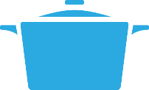 | Cook food in liquid in a lidded pan on the hob or in the oven

Fry or sauté |  | Cook on the hob (usually in oil)

Grill |  | Cook under direct heat

Melt, simmer and boil |  | Use the heat of the hob to melt or cook food

Microwave |  | Cook or reheat food in a microwave

Roast |  | Cook in an oven at higher temperatures

Stir-fry |  | Cook quickly on the hob

Chill |  | Cool in the fridge

Decorate and garnish |  | Make food more attractive/ interesting

Glaze and coat |  | Make food more attractive/ interesting

Pipe |  | Create shapes with thick mixtures

Serve | 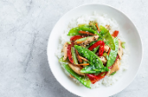 | Present the meal or dish

Clear away | 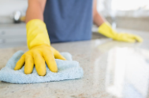 | Tidy up after preparing, cooking and eating/ drinking

Wash and dry up | 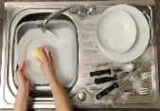 | Clean equipment used in preparation, cooking and eating/  drinking

Put away | 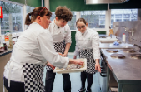 | Storing equipment used

Recycle | 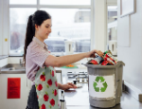 | Sort and recycle packaging

Compost | 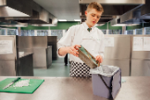 | Compost food waste

