Making our growing club happen
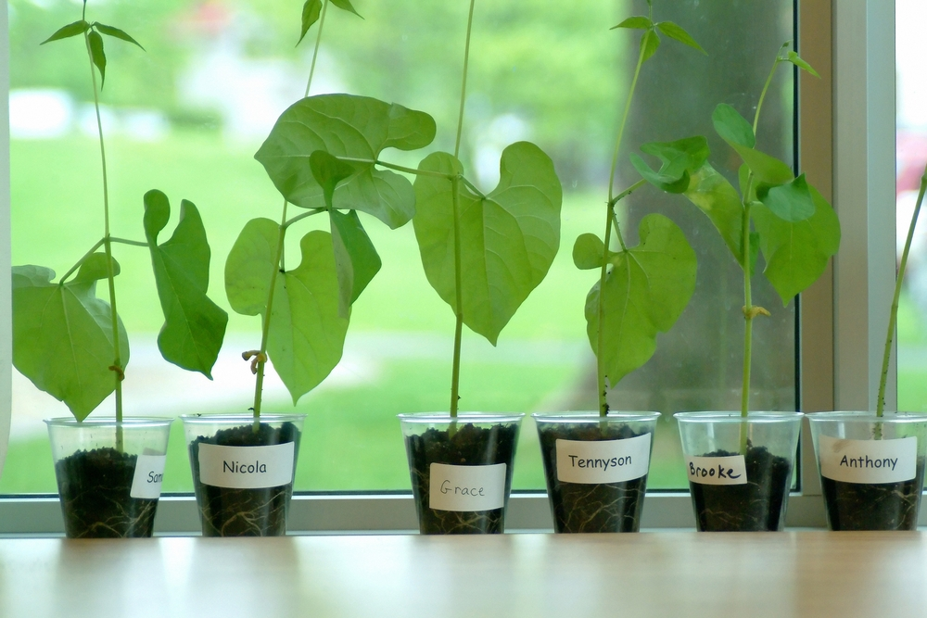
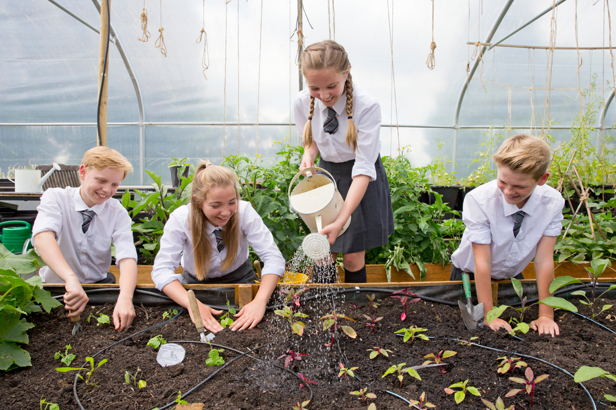
This resource was produced as part of the Food in Schools Programme (2006), it is provided under the Open Government Licence.

Taking
stock
Who’s
doing
what?
Let’s get growing!
Taking
stock
How’s it going?
What do we want from our Growing Club and when?
Who’s
doing
what?
Getting others involved
Start

