Growing club meeting

We are having a meeting about our growing club.
Why not come and join in?

Date:

Time:

Venue:

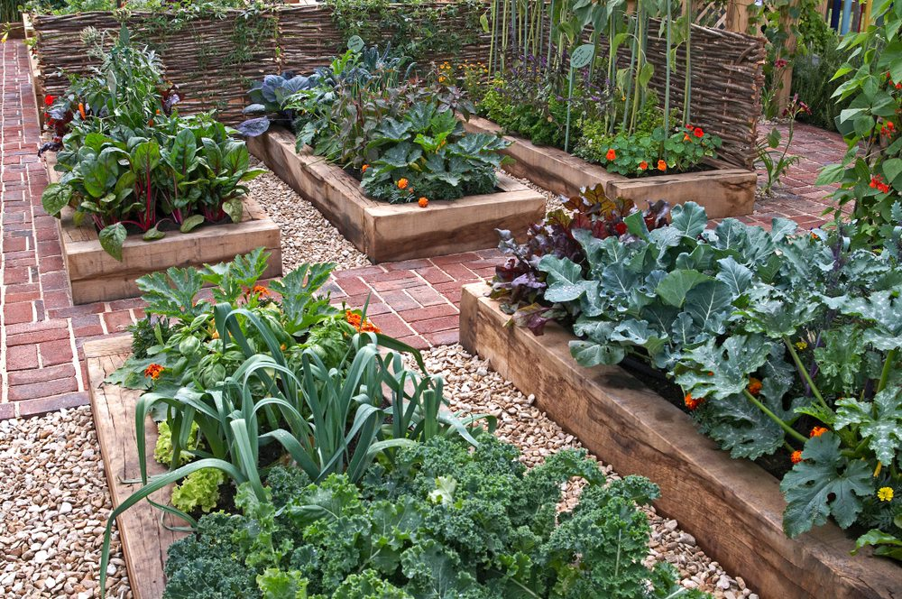

This resource was produced as part of the Food in Schools Programme (2006), it is provided under the Open Government Licence.

