

Growing clubs

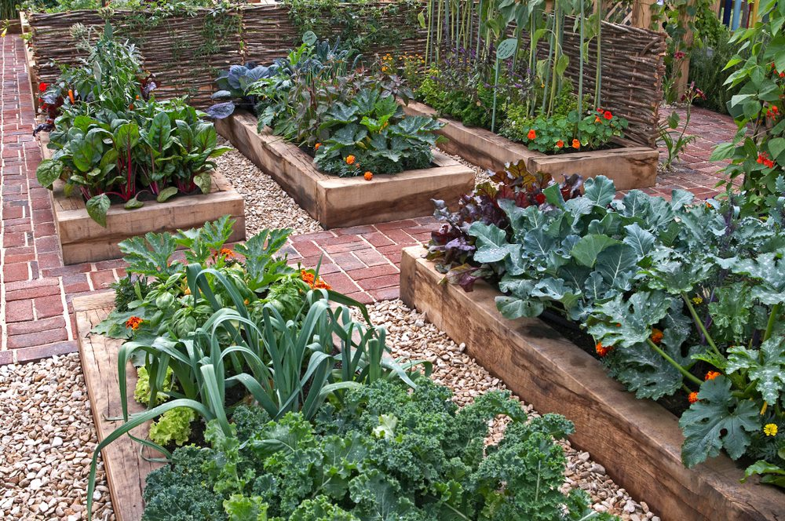


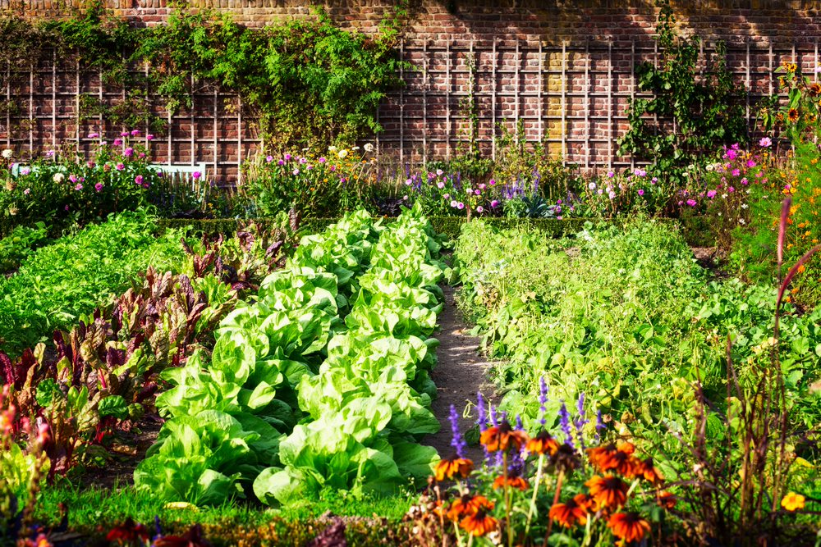

Growing clubs

Contents
- Welcome 2
- Benefits of a growing club 3
- What is a growing club? 3
- Step-by-step plan 4
- Growing club checklist 11
- Integrating other school activities 12
- Acknowledgement 12

Welcome

This Growing Clubs guidance gives practical advice on setting up, or improving, a growing club in your school and linking this with healthier eating messages.

Gardening interventions have found positive benefits, particularly in increasing younger children’s likelihood of trying new fruit or vegetables and all pupils’ understanding of healthy eating.

Benefits of a growing club

A growing club:

- contributes to pupils’ knowledge of healthier eating, e.g. 5 A DAY;
- offers pupils the chance to experience growing food;
- provides a context for looking at food chain issues and understanding where food comes from;
- provides real life experiences to the formal curriculum and activities;
- can increase the contact between the school and the local community;
- provides an opportunity to involve parents/carers and strengthen home-school links;
- acts as a focus in which the whole school can feel proud;
- boosts the confidence of the pupils who take part.

What is a growing club?

A growing club gives pupils the opportunity to plan, sow, tend and harvest a range of fruits and vegetables at school. It extends pupils’ understanding of food chain issues by bringing the process directly under their control. Whether the club is run as part of the formal school curriculum, or as an extra-curricular activity, it should be seen as a vital teaching and learning experience for pupils.

The growing club also makes use of the school grounds, which are additional learning spaces at school. It provides an area of interest for the entire school community and can be shown to guests and visitors as a key feature of the school. In addition, it provides an ideal vehicle to promote healthier eating and drinking messages for pupils. In time, the growing club will also produce a number of crops which can be eaten in school, perhaps in food and nutrition lessons, the school tuck shop or cookery club.

You do not need a big garden area to cultivate your favourite fruit and vegetables. A well-planned growing club can use containers, grow-bags and hanging baskets. This guidance shows how you can work together to make the best use of the resources and materials you have.

Case Study

The growing club at a girl’s secondary school forms part of the varied extra-curricular activities offered. The school used a large turfed quad area at the side of the main school building to create a growing area.

Many pupils expressed an interest in the club and eventually attracted two regular attendees. The citizenship class had been set the task of designing the garden area and costing the materials required. The garden designs incorporated themes of healthier eating and relaxation with the winning entries being announced at a celebration event during assembly.

Following the completion of several consultation exercises pupils had a clear idea about what they wanted to grow. Five raised beds were put in place to provide different areas to grow crops including tomatoes, lettuce, carrots, potatoes, sweetcorn and a variety of herbs.

Step-by-step plan

- Getting started

Before picking up a spade, ask yourself why you want to develop a growing club. What will its purpose be? What needs does your site have to fulfil? Write a statement of what you want your growing club to achieve, and the potential uses it will offer the school. For example, the growing club could be a useful resource for pupils and teachers, both for recreation and as an external teaching and learning resource.

Undertake a SWOT analysis for a growing club in your school. What are the strengths, weaknesses, opportunities and threats? This will help you to plan and understand the many opportunities that a garden area can bring, as well as the challenges ahead.

An example of SWOT analysis by a school:

Strengths
- Backing from the senior management team (SMT)
- Supportive teaching staff
- Enthusiastic pupils
- Good premises manager

Weaknesses
- Lack of space/equipment
- Little support from parents
- Financial constraints
- Little knowledge of gardening

Opportunities
- Draw in local community and parent interest
- Curriculum links, e.g. where food comes from
- Fund raising
- Raised beds, or adapted tools, for wheelchair users

Threats
- Safety
- Holidays – who will water the plants?
- Vandalism
- Vermin

A SWOT template can be found here.

A SWOT template can be found here.

- Setting up a growing club

You should share your early ideas and thoughts with the senior management team (SMT) and the School Council or School Nutrition Action Group (SNAG), linking it to a Whole School Food Policy. You will need the support from the head teacher, SMT and/or governors and premises manager to ensure success. The full participation of pupils should also be considered in all stages of consultation and decision making.

Setting up the growing club, i.e. physically building the garden area, will take several days of hard work, so advertise for willing volunteers to share the workload. Carry out a simple skills and equipment audit amongst the staff, governors and parents to establish what tools and expertise you already have.

Recruit help by:
- holding a special assembly;
- producing a flyer with an invitation for people to help out;
- starting a growing club notice board;
- advertising in the school newsletter to pupils and parents;
- promoting the idea on the school website or to the local media.

Advertising for support should enable you to establish a growing club team to help take the project forward and avoid all the responsibility being on the shoulders of just one person.

This is important for future sustainability. Ensure the group includes pupils, teachers and, where possible, parents.

An example parent/carer letter can be found here.

What support do you need?

- Ensure that you have SMT/governor commitment to the project.
- Consider whether external organisations are needed to help you make the growing club a reality.
- You may wish to visit other local schools that have gardens or growing clubs and find out what lessons they have learned from their experience.
- Determine the need for training and level of external support required to make your growing club a success.
- Ensure that the school’s public liability insurance is in place and that it covers your activities.
- Contact your local Healthy Schools coordinator, if appropriate, to find out what support is available in your area.
- Involve outside groups from your local area. Ask the local allotment group for help.
- Check for any local garden societies or local forums and ask for their support. Be specific with what you would like, e.g. “we are looking for someone to come into school for 30 minutes every Wednesday at 12.15 and help the teacher with 10 Year 4 children. We are aiming to grow 4 different types of tomatoes – can you help?”

What roles will people have in the growing club?

- Identify key job roles and responsibilities within the team.
- Define talents and expertise – is anybody a keen gardener? You may need to advertise for specific help.
- Emphasise the links the project has to the particular interest of the person you are trying to get involved, e.g. curriculum links for a teacher.
- Inform everybody about what you are doing and what stage the project is at.
- Contact your local Healthy Schools co-ordinator, if appropriate.
- Calculate the budget available. You may need to raise funds.
- Make links with local business or volunteer brokerage organisations who can come into school to help out set up the growing club area, e.g. erecting a greenhouse, making benches or raised beds.

Planning your club

Your growing club team should develop an action plan, including the likely time it will take to get the growing club established. Develop a month-by-month work plan, including what needs to be achieved, equipment and resources needed and who is going to undertake the task.

In addition, consider the following questions:

- What activities need to take place and when? Which of these activities can be completed by the school and for which activities will you need external support?
- Have you conducted a risk assessment for the growing club? What are the implications to health and safety?
- What are the objectives for the growing club?
- Do you have water and drainage?
- Is there support from your local community?
- Have you determined the budget available?

A planning sheet can be found here.

- Siting your growing club

Walk round your school grounds with your premises manager to identify a suitable area. Work with the growing club team and pupils to get their views. What exists at present and what has the space got to offer? How is the space being used now and in the future?

Important questions to consider include:

- Is it a sunny spot?
- Is it close to a water supply?
- What is the soil like?
- What ground preparation is needed?
- Is access easy for all users, e.g. wheelchairs?
- Are there other activities taking place in the area, e.g. ball games?

Do not be put off if your school grounds are tarmac. Raised beds (ready bought for home assembly or hand made by a local carpenter or parent) and container gardening work just as well or even better than a ground level bed. Remember to break drainage holes in tarmac before setting up the raised beds.

Be warned – do not take on too large an area, a raised bed and a few containers would be a great start. However, if you have a large enough space, and have secured adequate funding, work with the pupils to make effective use of the space you have. You might have enough room for herb and vegetable patches, as well as fruit trees and bushes. In addition, bear in mind the number of pupils who will potentially use the area.

Practical tools

Tools and equipment you may need include:
- fork;
- spade;
- hand tools for the pupils, e.g. trowel, hoe, rake;
- gloves;
- mini greenhouse;
- seed trays;
- labels and marker pen;
- compost;
- seeds and plants;
- watering can/s;
- hose;
- compost bin;
- project book and camera to record your work;
- raised beds or materials to make raised beds (wood, hammer, nail, plastic liner, linseed oil or wood protector and paint brush).

You will need a range of tool sizes, including junior spades and small hand trowels for very young children. For wheelchair and/or physically impaired pupils, purchase adapted tools. Some tools might be donated from the community.

An example list of tools and resources can be found here.

- Designing your growing club area

Once you have secured funding, established where the garden area will be and recruited people to help develop and maintain the site, you will need to design your growing club area.
- Develop a feel or theme to the area, e.g. multicultural or Victorian kitchen garden. Do you want to include individual beds, a tool shed, benches or a greenhouse.
- Work within the budget you have, but consider longer-term aspirations and plans.
- Sketch out the area, maybe as a pupil activity, looking at the possibilities available for the area. What would they like to see? A computer simulator could be used to give a rough concept.
- Help pupils to design how the area will look in the future and what vegetables/fruit will be grown and when.
- Include a composting area or wormery to encourage recycling and a greater understanding of lifecycles.
- Ensure that the area has wheelchair access.
- Consider what resources you need, e.g. containers, soil, tools, seeds, trees and storage.
- Consider water, drainage, maintenance and sustainability in the future.

Deciding what to grow

When deciding what to grow, consult the pupils with a tasting session and strike a balance between favourites such as tomatoes, strawberries and fruit and vegetables pupils are less likely to have tried. Once the pupils have decided what to grow, help them find the seeds in a mail order catalogue from which they can order the plants and have them sent to themselves at the school. Buy some small plants (tomatoes and courgettes for example) to add to your garden.

Pupils will want to see results quicker than nature allows. Keep interest with mustard and cress or red cabbage seeds (sown one week and eaten the next), lettuce leaves, peas and early varieties of potatoes (ready to harvest before the end of summer term) are all relatively quick growing. Minaret fruit trees produce fruit in the 2nd year after planting. Herbs grow well in containers, on the windowsill and in the garden.

- Running your growing club

- Timetable your activities to ensure that everyone knows the plan and can take on a specific role in order to get things done.
- Link the project to healthier eating and the curriculum.
- Ensure that the project will go from strength to strength in the future and can be sustained over time.

Managing your growing club

Once you have your equipment, make an inventory. Always ensure that the equipment is checked back in at the end of a session and leave time for tool cleaning.

Do not underestimate the enthusiasm of the children and the need to think through the growing club activity session in the same way as you approach a lesson plan. Ensure that you have adequate staff to monitor the space and the pupils involved (no more than 8–10 pupils per adult).

Week by week, month by month, you will need a range of outdoor activities, e.g. planting a fruit tree, filling a container for tumbler tomatoes, sowing seeds, weeding, watering, harvesting and a range of indoor activities, such as designing labels, creating art and writing poems about the garden, creating a scarecrow, writing to a garden centre for donations, making invitations for the open day, keeping records using a spreadsheet. Plan ahead to ensure that pupils have something to do.

Top Tips

- Leave plenty of time. Plan carefully before you start where, when and who will be involved.
- Start planning and preparing the area in the autumn term so when things warm up in the spring you can get your plants and seeds ready.
- Share the vision. Ask for specific help from the school community.
- Make sure there are at least 2 people in the coordinating team and ensure someone is allocated enough time to undertake the work involved.
- Organise regular work days.
- Ensure that you have plenty of volunteers. A rota template is available here.
- If you do not have space in your school grounds make links with local allotments.
- Grow potatoes – you get a lot for your money and you can do lots with them.
- Choose some fast growing crops, e.g. peas, runner beans and courgettes.
- Try growing seeds in the classroom, establishing window boxes, pots, hanging baskets, containers and grow-bags. If you have no grounds, it is amazing what you can grow in very little space!
- Make raised beds. They look great, are easy to maintain and can be placed in schools which only have tarmac. They are also wheelchair friendly.
- Plan the ‘growing’ into your school curriculum, e.g. science, food and nutrition, geography.
- Do not view it as an ‘add on’ to the school, but as something integral to its ethos.
- Start small and be realistic! Do not be too ambitious. Just one strip of carrots may be enough to get everyone excited.
- Do not be afraid to start even if you do not have a clear idea about what the club will look like in 6 months.
- Ensure that you have activities for rainy days. This could involve looking at and tasting different fruits and vegetables, planning growing areas and using the internet for inspiration.

Case Study

Although a north London primary school already had a small gardening club attempts to grow vegetables had been unsuccessful. Therefore it was decided a new space in the school grounds would be developed using money from internal funds thus establishing a new and improved growing club. The new club included more pupils as well as parents and staff. Pupils took ownership of the project influencing how it would be run and what would be grown.

By the end of the summer term, different types of vegetables and fruit and two varieties of herb had been planted and grown. Following the successful establishment of the growing area the school is now looking to ensure sustainability through linking the garden with the curriculum and expanding interest amongst different year groups.

- Promoting your growing club

To promote your growing club, you could:

- create a display in the school;
- keep a video diary to play in assembly;
- encourage visitors to visit the growing club area;
- invite parents and the local community to view, or take part in, the club;
- grow unusual fruits and vegetables to keep pupil interest;
- make a school growing club scrapbook;
- organise an open-house with local schools to help them look at the potential for their schools;
- write topical features in the school newsletter;
- promote the growing club in the school newsletter, website or prospectus;
- organise a lunch event to open the ‘garden’ area at school. You could invite the local mayor, MP or a celebrity.

- Evaluating success

It is important to review and monitor your growing club to evaluate its impact. You could:
- keep track of what you have done and compare it to your original statement of activity;
- look at what things are working and what are not and alter the project as appropriate;
- consider whether you need extra support with some aspects of the project;
- keep the project varied and interesting to maintain enthusiasm and motivation of all those involved.

Growing club checklist

- Have you identified the benefits of a growing club for your school?

- Are you clear about what you want to achieve?

- Have you involved the School Council or SNAG?

- Have you engaged the full participation of pupils at all stages?

- Have you talked to the senior management and got their support?

- Is the premises manager supportive of the growing club?

- Have you completed a SWOT analysis?

- Have you decided where the growing club will be located?

- Have you determined who will hold key jobs, roles and responsibilities?

- Have you identified sources of funding?

- Have you developed an action plan?

- Have you designed your growing club area?

- Have you conducted a risk assessment and chosen what to grow?

- Have you checked equipment and resources?

- Have you planned a strategy to promote your growing club?

- Have you planned how you will monitor and evaluate the impact of your growing club?

Integrating other school activities

There are many natural links which can be made to other activities, depending on what is taking place in your school. Links to growing clubs include:

- Crops grown could be used in food and nutrition lessons.
- Pupils attending breakfast club could help to water the garden in the morning.
- Some pupils could eat their lunch in the garden, if appropriate seating is available. The growing area could be used as a stimulus to inspire pupils about their own lunchbox.
- The garden could grow food exclusively for the school tuck shop. Small items, such as cherry tomatoes and carrot sticks could be sold.
- If you have a glut of fruit or vegetables, the cookery club could use these to make a variety of tasty dishes.
- Combine an outdoors garden feel to the dining room, e.g. photographs of fruit and vegetables could be used for decoration in the school dining room.

Acknowledgment

This resource was produced to assist schools as part of the Food in Schools Programme (2006), it is provided under the Open Government Licence.

Terms can be found at: http://www.nationalarchives.gov.uk/doc/open-government-licence.

