Fruit plait

Ingredients

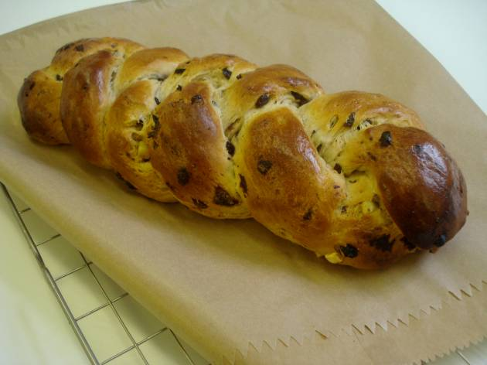
250g strong white flour
1 x 15ml spoon mixed spice or cinnamon
½ x 5 ml spoon salt
75g currants or sultanas
25g mixed peel
1 x 7g sachet of dried yeast
25g caster sugar
15g butter or soft baking spread
125ml milk
1 egg (medium)

Equipment
Baking tray, pastry brush, weighing scales, sieve, mixing bowl, measuring jug, palette knife, small bowl, fork, flour dredger, and cooling rack.

Method
- Preheat the oven to 200°C or gas mark 6.
- Grease or line the baking tray.
- Sift the flour, spice and salt into the mixing bowl.
- Stir in the currants/sultanas, mixed peel and yeast.
- Warm the milk gently in the microwave.
- Stir the sugar into the milk in the measuring jug. Stir until the sugar has dissolved.
- Make a well in the centre of the flour and pour in the milk.
- Melt the fat and add to the flour.
- Break the egg into the small bowl and beat with the fork.
- Add half the beaten egg.
- Mix to a soft dough using the palette knife.
- Turn onto a lightly floured surface and knead for 5 minutes.
- With lightly floured hands, divide the mixture into three portions and roll into sausage shapes the length of the baking tray.
- Place the lengths onto the baking tray and neatly plait together, tucking in the ends.
- Cover the plait with cling film and leave in a warm place to prove until doubled in size.
- Brush with the remaining egg.
- Bake for 10 minutes. Reduce the oven temperature to 170°C or gas 4, and bake for a further 10 - 15 minutes.
- Remove the plait and transfer to the cooling rack.

This recipe is from the original Licence to Cook programme and is provided under the Open Government Licence.

