Bread rolls
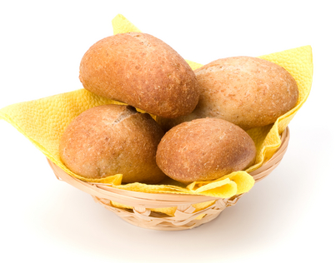
Ingredients
250g strong flour

½ x 5ml spoon salt
7g pack fast action dried yeast
150ml warm water

Equipment
Baking tray, greaseproof paper, sieve, mixing bowl, weighing scales, measuring jug, measuring spoons, flour dredger, oven gloves, cooling rack.

Method
- Preheat the oven to 220ºC or gas mark 7.
- Line the baking tray with greaseproof paper.
- Sift together the flour and salt into the mixing bowl.
- Stir in the yeast.
- Make a well in the middle of the flour mixture and add the warm water. Note: the water must not be hot. Mix to form a soft dough.
- Sprinkle a little flour onto a clean work surface and place the dough on the surface.
- Knead the dough for 10 minutes.
- Divide the dough into 4 pieces and shape into rolls.
- Place the rolls on the baking tray.
- Cover the dough and leave to prove for 30 minutes in a warm place, until they double in size.
- Bake for 10 - 15 minutes until golden brown.

