Savoury filled choux buns with a

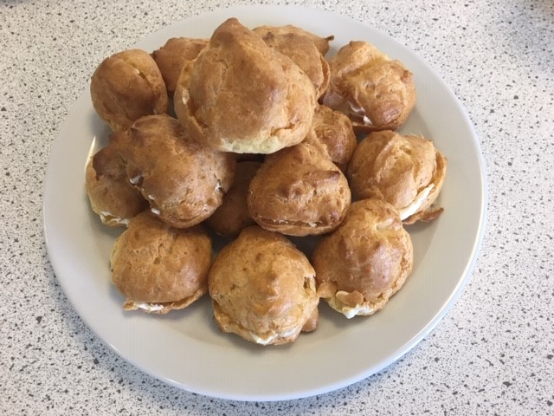
roux sauce filling

Ingredients

60g strong white flour

Pinch of mustard powder

Pinch of cayenne pepper

2 eggs (large)

50g butter or baking fat/block

150ml water

25g parmesan cheese

Twist of black pepper

Filling

25g butter or baking fat/block

25g plain flour
250ml semi-skimmed milk
50g mature Cheddar cheese
Black pepper

2 slices of ham

1 tomato

Equipment
Baking tray, pastry brush, weighing scales, sieve, greaseproof paper, 2 small bowls, fork, measuring jug, saucepan, wooden spoon, 2 x 10ml spoons, piping bag and nozzle, knife, chopping board, cooling rack.

Method
- Preheat the oven to 200°C or gas mark 6.
- Grease or line the baking tray.
- Grate the parmesan cheese.
- Sift the flour, mustard powder and cayenne pepper onto the piece of greaseproof paper.
- Beat the eggs in the small bowl with the fork.
- Melt the fat in the water in the saucepan.
- When it starts to boil, remove from the heat and shoot in the flour.
- Beat the mixture briskly until it is smooth and leaves the side of the pan.
- Stir in the egg, a little at a time, to form a smooth paste.
- Add the cheese and black pepper to the mixture and mix until combined.
- Fill piping bag with the mixture and pipe 16 small buns onto the baking tray.
- Sprinkle a little water on top.
- Bake for 10 minutes. Increase heat to 220 °C, gas mark 7, and bake for 15 minutes.
- Chop the ham and dice the tomato.

- Make the filling:
  - Grate the Cheddar cheese.
- Melt the baking fat/butter in a saucepan over a medium heat. Pour in the flour off the heat and stir well. This should make a thick paste. Cook paste for one minute or until it bubbles.
- Slowly add a little milk off the heat. Bring to the boil.
- Add a little more milk off the heat. Bring back to the boil again.
- Continue to add the milk in this way, making sure the mixture boils each time, until all the milk has been used.
- Remove the pan from the heat and add the grated cheese.
- Leave to cool.
- When the sauce is cool, stir in the chopped ham and tomato.
- Remove the choux buns from the oven. Slice the buns in half with the knife and place on the cooling rack.
- When the buns are cool, fill with the cheese, ham and tomato mixture.

