Savoury filled choux buns

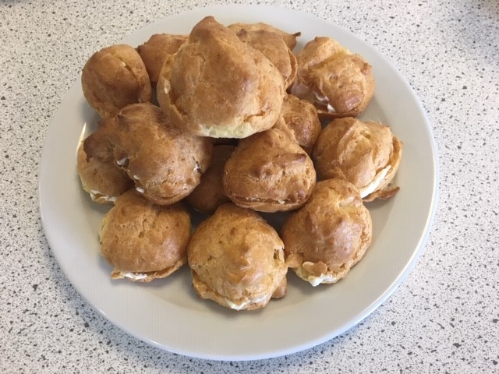
Ingredients

60g strong white flour

Pinch of mustard powder

Pinch of cayenne pepper

2 eggs (large)

50g butter or baking fat/block

150ml water

25g grated parmesan cheese

Twist of black pepper

100g cream cheese

Equipment
Baking tray, pastry brush, weighing scales, sieve, greaseproof paper, small bowl, fork, measuring jug, saucepan, wooden spoon, 2 x 10ml spoons, knife, chopping board, cooling rack.

Method
- Preheat the oven to 200°C or gas mark 6.
- Grease or line the baking tray, and sprinkle a little water on top.
- Sift the flour, mustard powder and cayenne pepper onto the piece of greaseproof paper.
- Beat the eggs in the small bowl with the fork.
- Melt the fat in the water in the saucepan.
- When it starts to boil, remove from the heat and shoot in the flour.
- Beat the mixture briskly until it is smooth and leaves the side of the pan.
- Stir in the egg, a little at a time, to form a smooth paste.
- Add the cheese and black pepper to the mixture and mix until combined.
- Place 16 small spoons of choux pastry onto the baking tray.
- Sprinkle a little water on top of the baking tray.
- Bake for 10 minutes. Increase heat to 220 °C, gas mark 7, and bake for 15 minutes.
- Slice the buns in half with the knife and place on the cooling rack.
- When the buns are cool, fill with the cream cheese.

