Apple and sultana crumble

Ingredients
100g plain flour
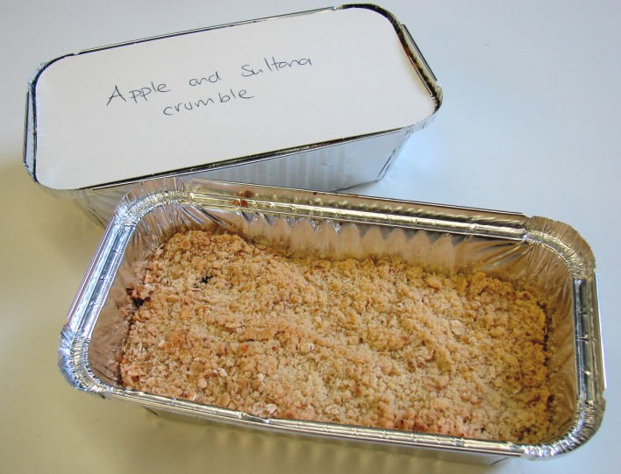
50g butter or baking fat/block
50g oats
25g sugar
2 eating apples
50g sultanas

Custard
1 x 15ml spoon custard powder
1/2 x 15ml spoon sugar
250ml semi-skimmed milk

Equipment
Weighing scales, mixing bowl, wooden spoon, chopping board, knife, ovenproof dish or foil tray, baking tray, measuring spoons, mixing bowl, wooden spoon, measuring jug, saucepan.

Method
- Preheat oven to 190°C or gas mark 5.
- Rub the fat into the flour until it resembles breadcrumbs.
- Stir in the oats and sugar.
- Cut the apples into quarters and remove the core. Slice thinly.
- Arrange the apple slices in an oven proof/foil tray dish on a baking tray, and then add the sultanas.
- Add 1 x 15ml water to the dish.
- Sprinkle the crumble topping over the apple slices.
- Bake for 25 – 30 minutes, until the apples are soft and the crumble is golden.
- Make the custard:
  - Put the custard powder and sugar in a bowl.
  - Mix into a smooth paste with a little (approx. 1 x 15ml) milk taken from the 250ml.
  - Heat the remaining milk to nearly boiling and pour onto custard mix, stirring well.
  - Return to the saucepan and bring to the boil over a gentle heat, stirring continuously.
- Serve the crumble and custard together.

