Apple and sultana crumble

Ingredients
100g plain flour
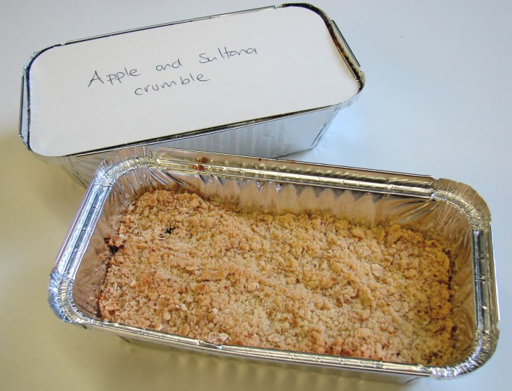
50g butter or baking fat/block
50g oats
25g sugar
2 eating apples
50g sultanas

Custard
600ml milk
1 vanilla pod or 1 x 5ml vanilla essence
3 eggs
25g caster sugar
2 x 5ml spoons cornflour

Equipment
Weighing scales, mixing bowl, wooden spoon, chopping board, knife, ovenproof dish or foil tray, baking tray, measuring spoons, mixing bowl, wooden spoon, measuring jug, saucepan, sieve.

Method
- Preheat oven to 190°C or gas mark 5.
- Rub the fat into the flour until it resembles breadcrumbs.
- Stir in the oats and sugar.
- Cut the apples into quarters and remove the core. Slice thinly.
- Arrange the apple slices in an oven proof/foil tray dish on a baking tray, and then add the sultanas.
- Add 1 x 15ml water to the dish.
- Sprinkle the crumble topping over the apple slices.
- Bake for 25 – 30 minutes, until the apples are soft and the crumble is golden.
- Make the custard:
- Heat the milk with the vanilla pod or vanilla essence until just boiling.
- Crack and separate the eggs.
- Mix together the egg yolks, sugar and cornflour in a bowl to get a smooth paste.
- Pour the milk into the paste and stir well.
- Strain the mixture back into a clean saucepan and, stirring constantly, cook gently until the custard thickens.
- Serve the crumble and custard together.

