Apple and sultana crumble

Ingredients
100g plain flour
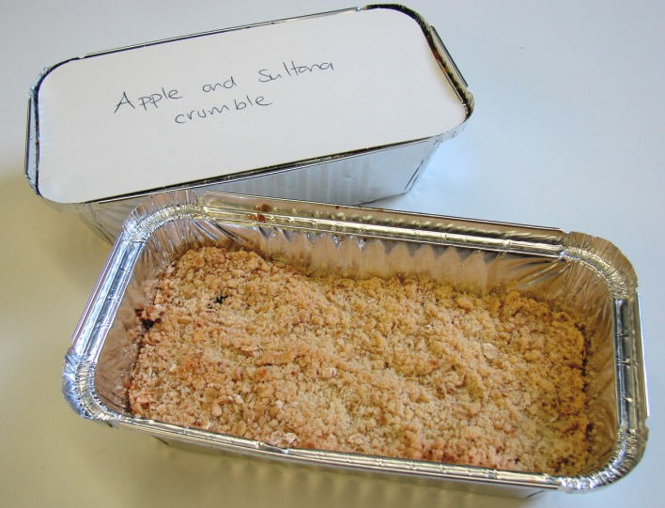
50g butter or baking fat/block
50g oats
25g sugar
1 x 385g canned apple slices
50g sultanas
Ready to eat custard

Equipment
Weighing scales, mixing bowl, wooden spoon, can opener, sieve, chopping board, knife, ovenproof dish or foil tray, baking tray, measuring jug.

Method
- Preheat oven to 190°C or gas mark 5.
- Rub the fat into the flour until it resembles breadcrumbs.
- Stir in the oats and sugar.
- Open the can of apples and drain half the liquid away.
- Arrange the apple slices in an oven proof/foil tray dish on a baking tray, and then add the sultanas and the remaining liquid.
- Sprinkle the crumble topping over the apple slices.
- Bake for 25 – 30 minutes, until the apples are soft and the crumble is golden.
- Warm the custard in the microwave.
- Serve.

