Scrambled eggs

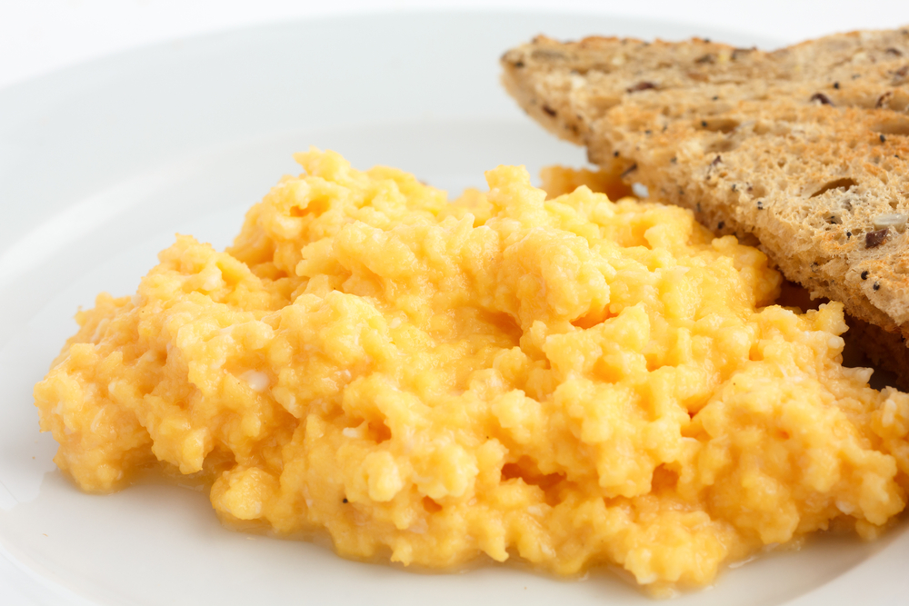
Ingredients

Butter or spray oil for the dish
2 eggs

Black pepper
1 x 15ml milk

Equipment
Measuring jug or microwavable bowl, 2 x forks

Method
- Oil or butter the jug or bowl you are planning on using.
- Crack the eggs into the bowl and season with black pepper.
- Add the milk (or water if you prefer) and whisk lightly with a fork.
- Microwave on high (800W or above) for 30 secs and then fork through the eggs using a clean fork.
- If they are done enough then stop cooking. If not, give them further 30-second bursts, forking between each cooking time until they are ready. Fork through at the end to break them up.

