Lamb and pepper kebabs

Ingredients
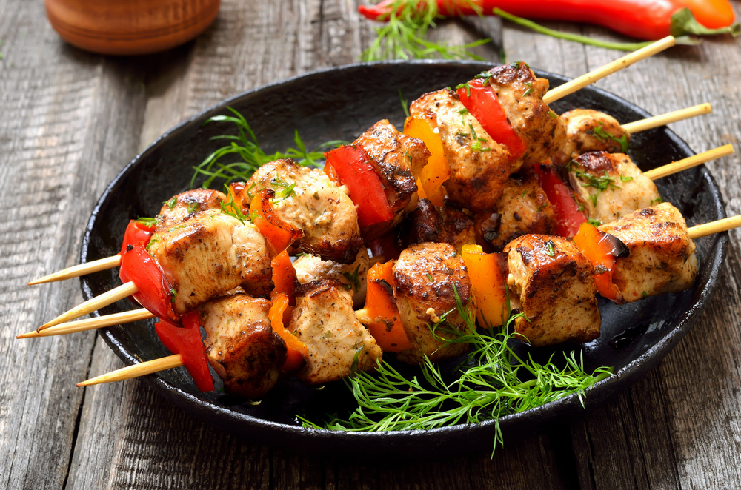
250g lean boneless lamb leg, shoulder or steaks
½ a yellow pepper
½ a red pepper

Equipment
4 small or 2 large wooden or metal skewers, chopping board, 2 x sharp knives, red chopping board.

Method
- Preheat the grill to medium heat.
- If using wooden skewers, soak these in water whilst preparing the ingredients.
- Using a clean knife and separate chopping board, ideally red, cut the lamb into 2.5cm/1 inch cubes. Thoroughly wash and dry hands after touching raw meat.
- Deseed and slice the pepper into 2.5cm cubes.
- Thread the lamb and pepper onto 4 short or 2 long wooden (previously soaked) or metal skewers.
- Cook the kebabs under the pre-heated grill for 12-16 minutes, turning occasionally until any meat juices run clear.

