Duchess potatoes

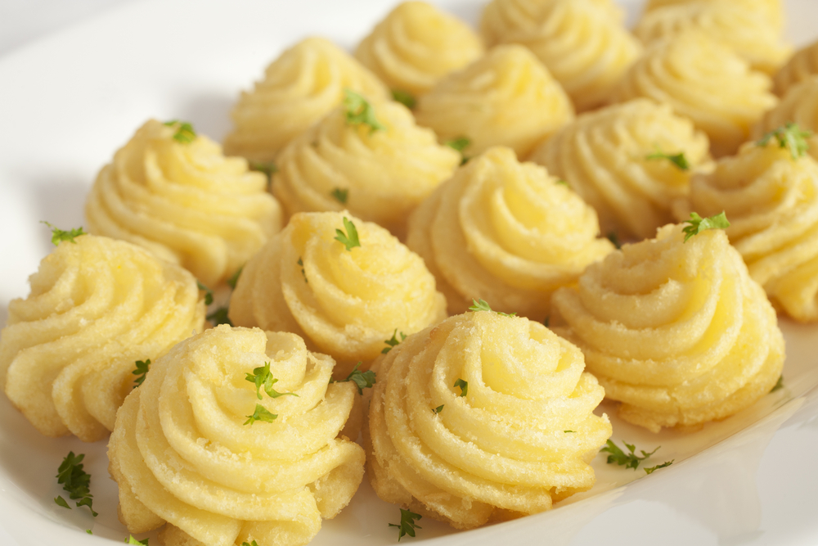
Ingredients

850g floury potatoes such as Desiree, Estima, King Edward or Maris Piper

3 eggs

60ml double cream

2 x 15ml parmesan cheese

¼ x 5ml spoon nutmeg

Equipment
Peeler, baking tray, large saucepan, colander, potato masher, measuring jug, fork, grater, wooden spoon, piping bag, 1.5cm star nozzle, pastry brush.

Method
- Pre-heat the oven to 180°C or gas mark 4.
- Grease or line a baking tray.
- Peel the potatoes and quarter.
- Place in a saucepan of cold water.
- Bring to the boil and cook for 10 minutes or until just tender.
- Transfer to the colander and drain well.
- Return to the pan and mash well.
- Crack two of the eggs into a measuring jug. Add the cream and whisk with a fork.
- Grate the parmesan and add to the jug.
- Grate the nutmeg if using fresh and add to the jug.
- Add to the mashed potato and mix well.
- Season with black pepper.
- Leave until just warm.
- Put the potato mixture in a piping bag and pipe the mixture in swirls, not too close together onto the baking tray.
- Crack and separate the extra egg. Whisk the egg yolk with a fork and brush all over the potato swirls.
- Bake for 15-20 minutes or until the potatoes are firm and golden.

