Mashed potatoes

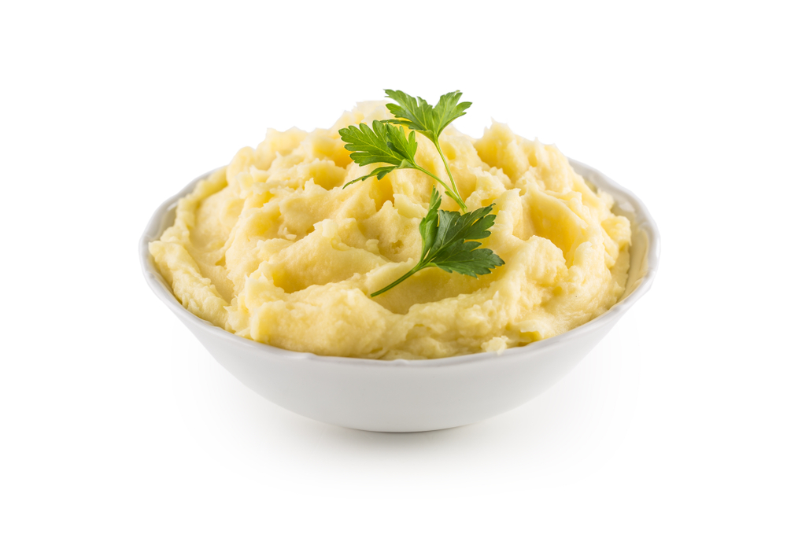
Ingredients

500g floury potato such as King Edward or

Maris Piper

50ml semi-skimmed milk

Black pepper

Equipment
Peeler, large saucepan, colander, potato masher, wooden spoon

Method
- Peel the potatoes and quarter.
- Place in a saucepan of cold water.
- Bring to the boil and cook for 15 minutes or until tender.
- Transfer to the colander and drain well.
- Return to the pan and add half the milk.
- Mash and then beat with a wooden spoon until creamy. Add more milk if necessary.
- Season with black pepper.

