Boiled new potatoes

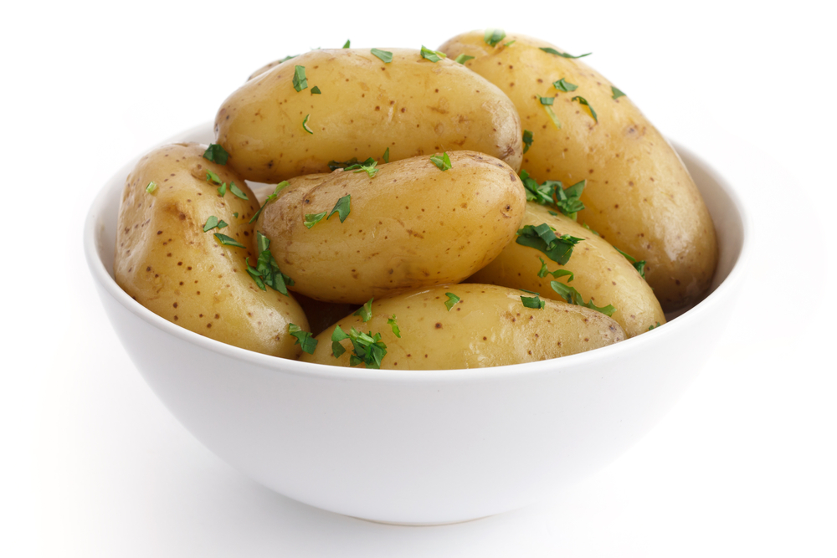
Ingredients
500g new potatoes

Equipment
Colander, large saucepan.

Method
- Rinse the potatoes under cold water in the colander.
- Place them in a pan of water.
- Bring to the boil and simmer until tender (about 10 minutes).
- Drain.

