Healthy eating
- A variety of food and drinks are needed for health, as depicted by the Eatwell Guide.
- Being active is important for health.

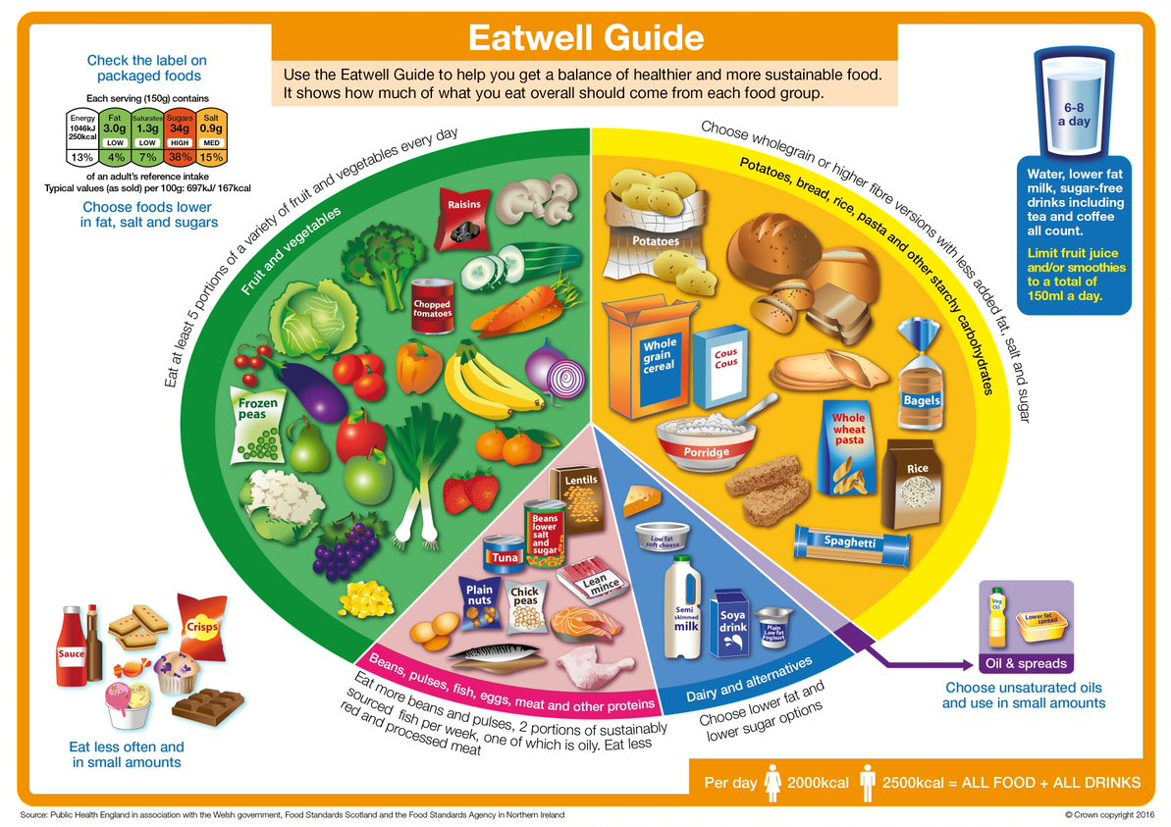

Foods high fat, salt and sugar
Eat less often and in small amounts.
Have some milk, cheese and yogurt.

Eat lots of fruit and vegetables.

Eat at least 5 portions every day.

Children should be active for 60 minutes a day.

Get active in different ways.

Most meals should include foods from the main four Eatwell Guide food groups.

Oils and spreads
Eat in small amounts.

Have lots of potatoes, bread, rice and pasta.

Drinks
Have 6-8 glasses a day.
Have some beans, pulses, fish, eggs and meat.

The UK’s healthy eating model is called The Eatwell Guide and it has five groups.

Different foods belong in different Eatwell Guide food groups.

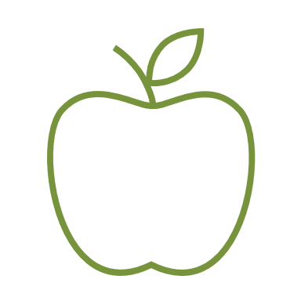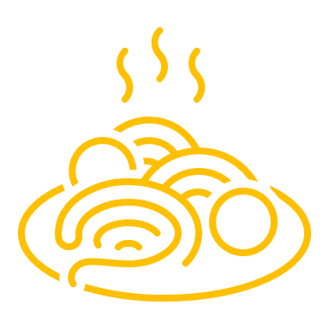
Activity should make:
- you feel warmer;
- you breathe harder;
- your heart beat faster.



This resource meets the Guidelines for producers and users of school education resources about food.

Task: Invent a break time game or activity that would count towards a child’s 60 minutes physical activity a day. Play it with your friends at break time.

