Food for life
- Food and water are a basic requirement for life.
- We choose different types of food for different reasons.

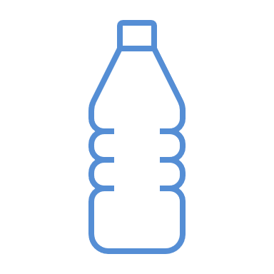

We all need to eat and drink every day to stay alive.

This is to help us:
- grow;
- be active;
- stay healthy.
We eat food and have drinks at different times of the day.

Breakfast

Lunch

Dinner
We eat different food depending on the occasion and lifestyle.
The food we like now might change as we get older.

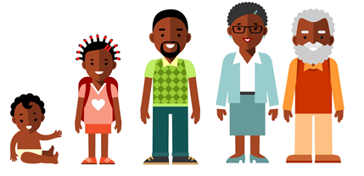
We eat different food according to what we like and dislike.

Our senses help us like or dislike a food.

Sound Smell Taste Feel Look

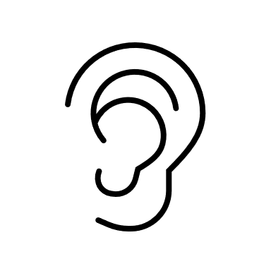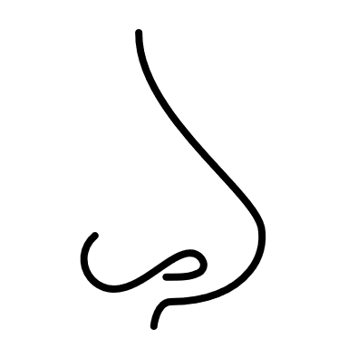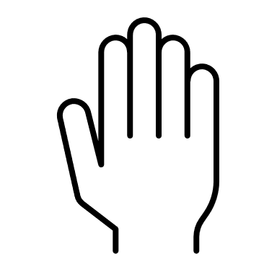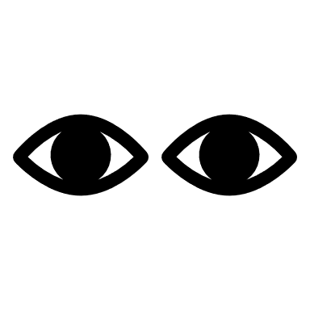

When we have feelings of hunger and thirst, it is our body reminding us that it needs food and water.
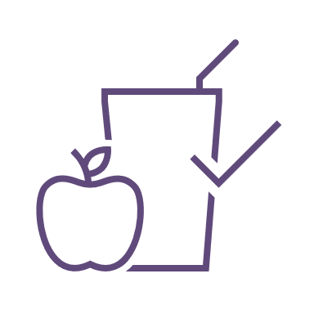
We eat different food on special occasions.

This could include:
- Christmas;
- Eid;
- Hanukah;
- parties;
- weddings.
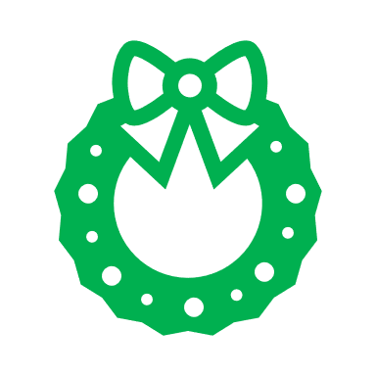
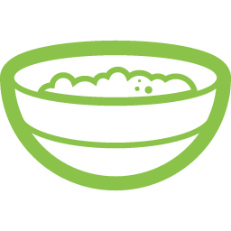
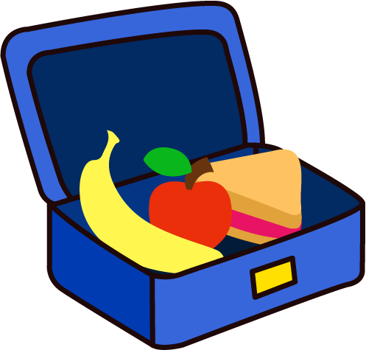
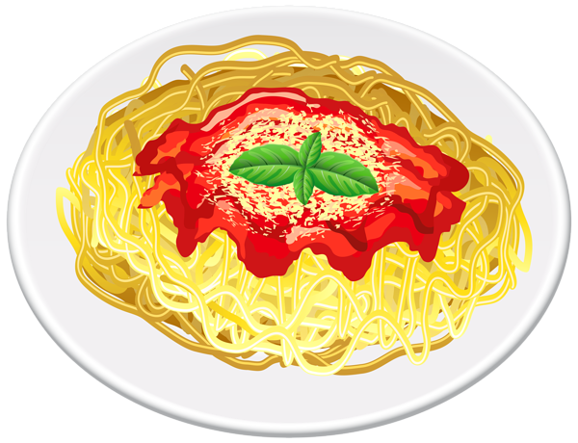
This resource meets the Guidelines for producers and users of school education resources about food.

Task
Draw a picture of three foods you like to eat. Write when you might have them and why you like them.

