Food hygiene and safety and cooking
- It is important to store, prepare and cook food hygienically and safely.
- There are a number of basic food skills, which enable a variety of dishes to be made.

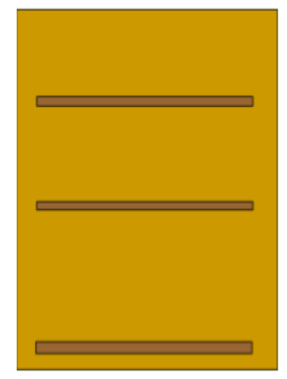
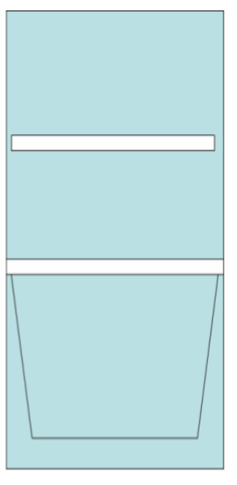
Different foods need to be stored differently.
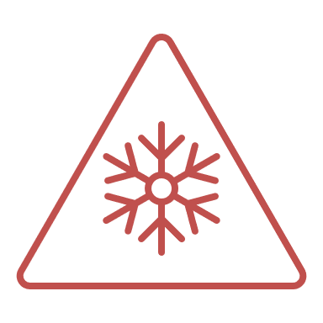
Cupboard:
Bread; lentils; oil; biscuits/crackers; pasta; dried apricots and canned sardines.

Fridge:
Top shelf – cheese and yogurt.

Bottom shelf – beef mince, eggs, uncooked chicken.

Salad drawer – lettuce and broccoli.
After cooking
- Wash equipment in warm water and washing up liquid and dry it thoroughly.
- Clean down surfaces.
- Put ingredients or food away appropriately, e.g. wrap, seal, refrigerate.
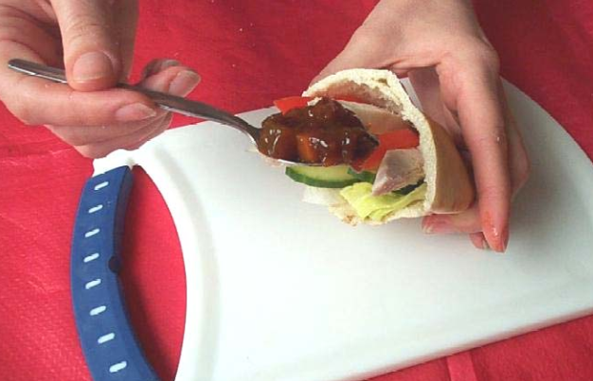
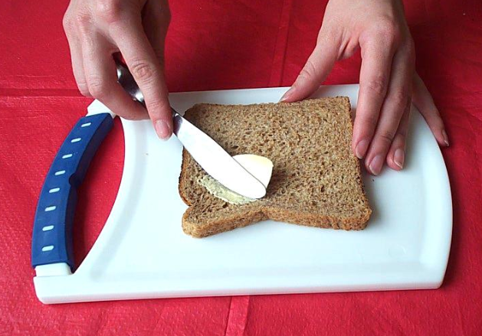


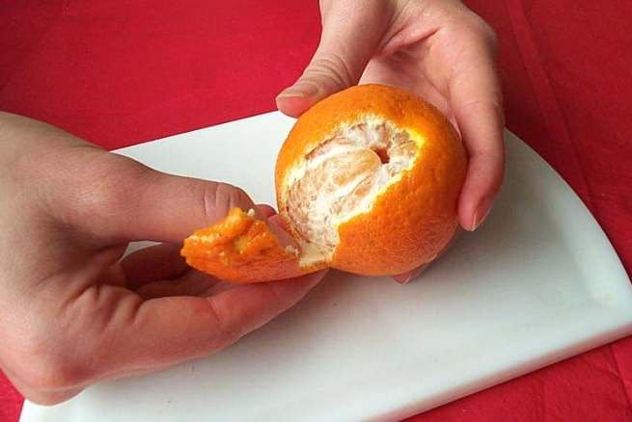
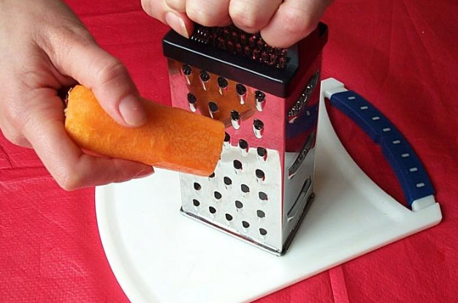
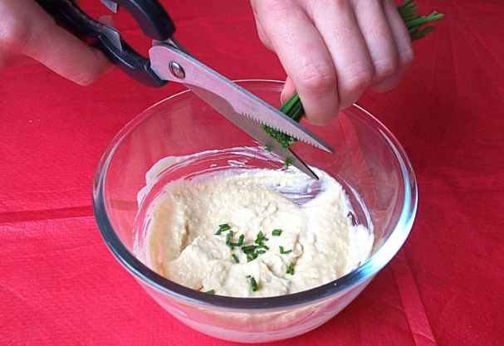
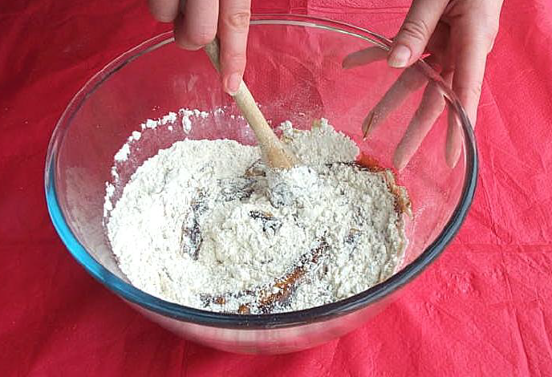
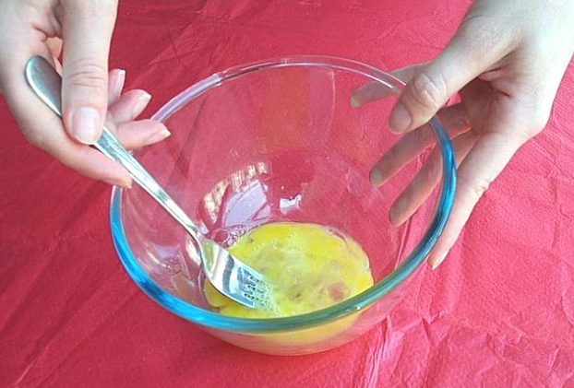
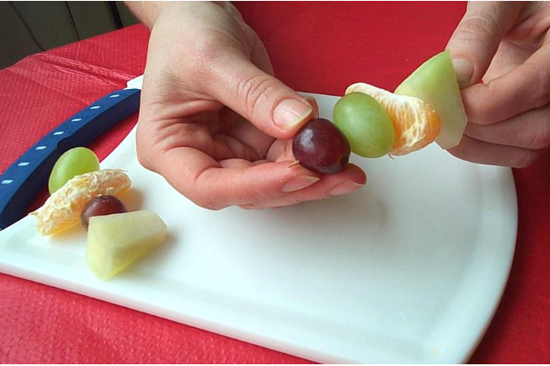
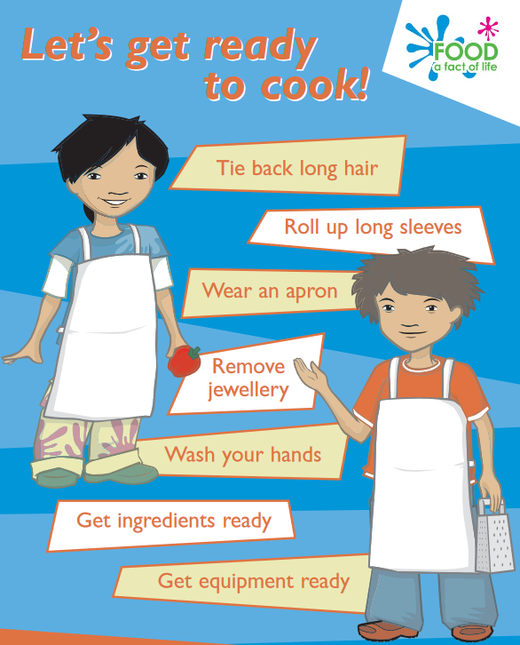
Task: Draw the inside of a cupboard, fridge and freezer. Cut images of food from magazines and stick them in the right place where they would be stored.
There is a range of basic cooking skills. These include:
- grating.
- juicing;
- peeling;
- snipping (with scissors);
- spooning;
- spreading;
- stirring;
- washing;
- whisking.

Basic cooking skills are required to make a dish.

Grate Mix

Peel Snip

Spoon Spread

Thread Whisk
Before
There are hygiene and safety rules which need to be followed before, during and after cooking.

During
When cooking, it is important to ensure that good food hygiene and safety is followed.
This will help minimise any risk of food poisoning and reduce accidents.

