Planning what to cook, ingredients and equipment
- When planning to cook, the time of day, person and occasion need to be considered.
- There is a variety of ingredients that can be used for cooking.
- There are lots of different pieces of equipment used in cooking, some of which have special jobs.
A lot of the food we eat is produced in the UK.

People eat different food and meals according to the time of day, who they are and the occasion.
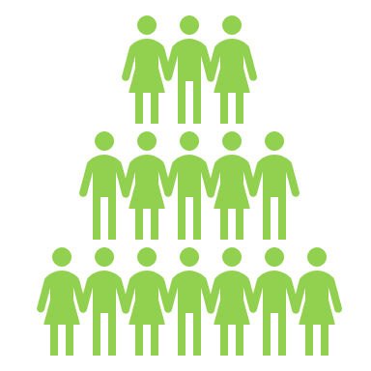
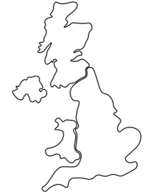
Task
Research what people in other countries eat at different times of the day and why.
Ingredients are available from different shops, markets or can be grown at home.
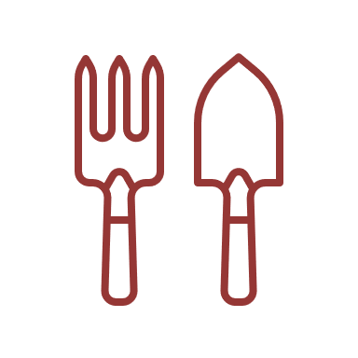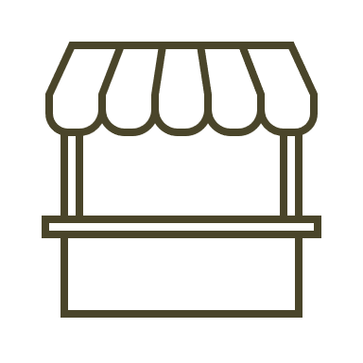
Equipment | Name
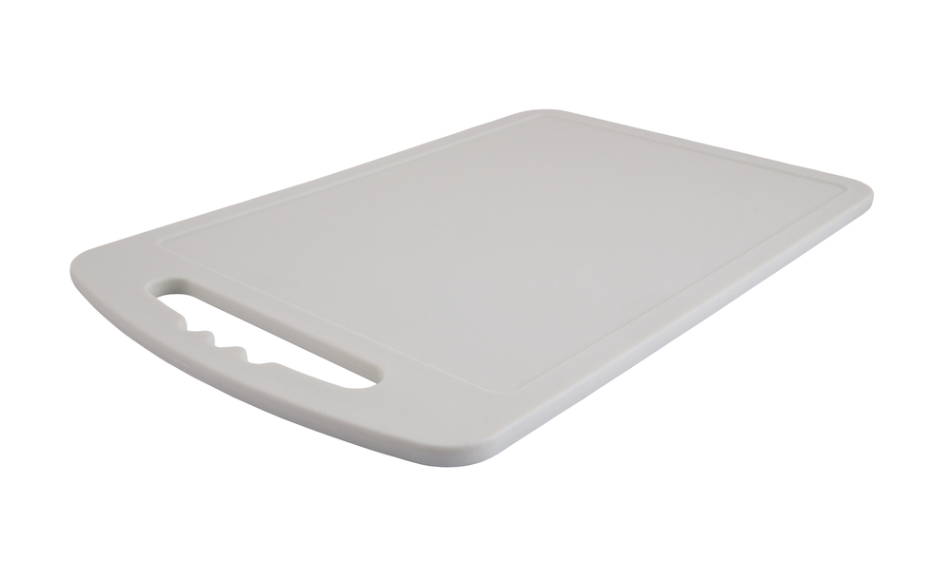 | Chopping board
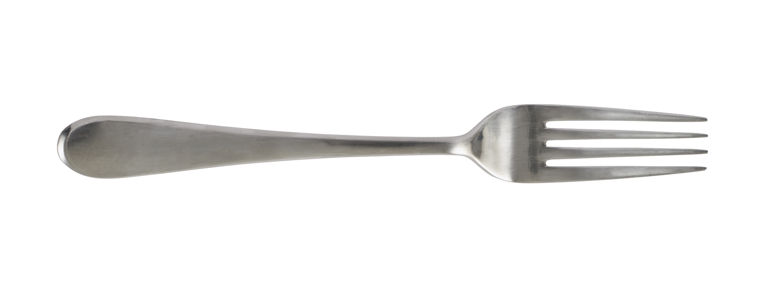 | Fork
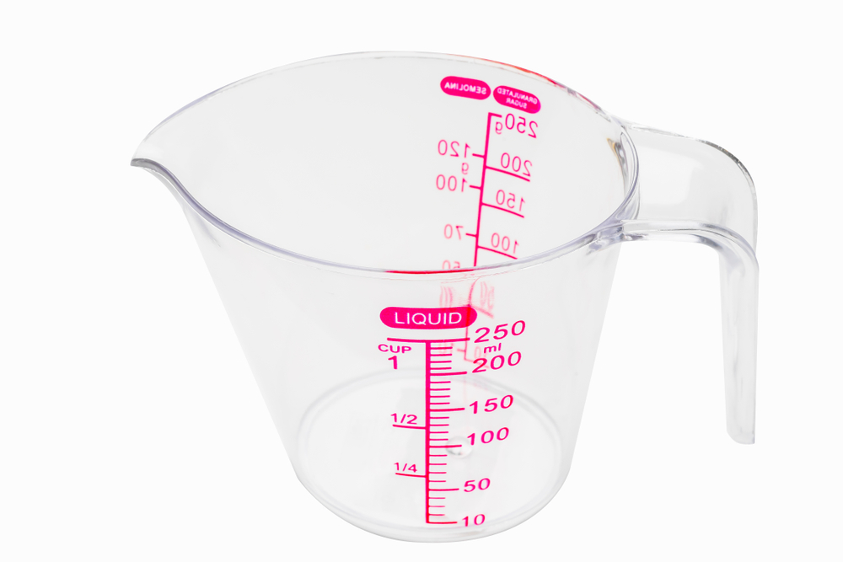 | Measuring jug
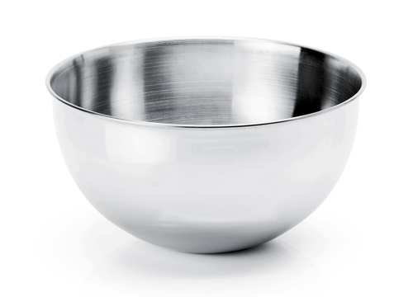 | Mixing bowl
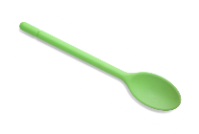 | Mixing spoon
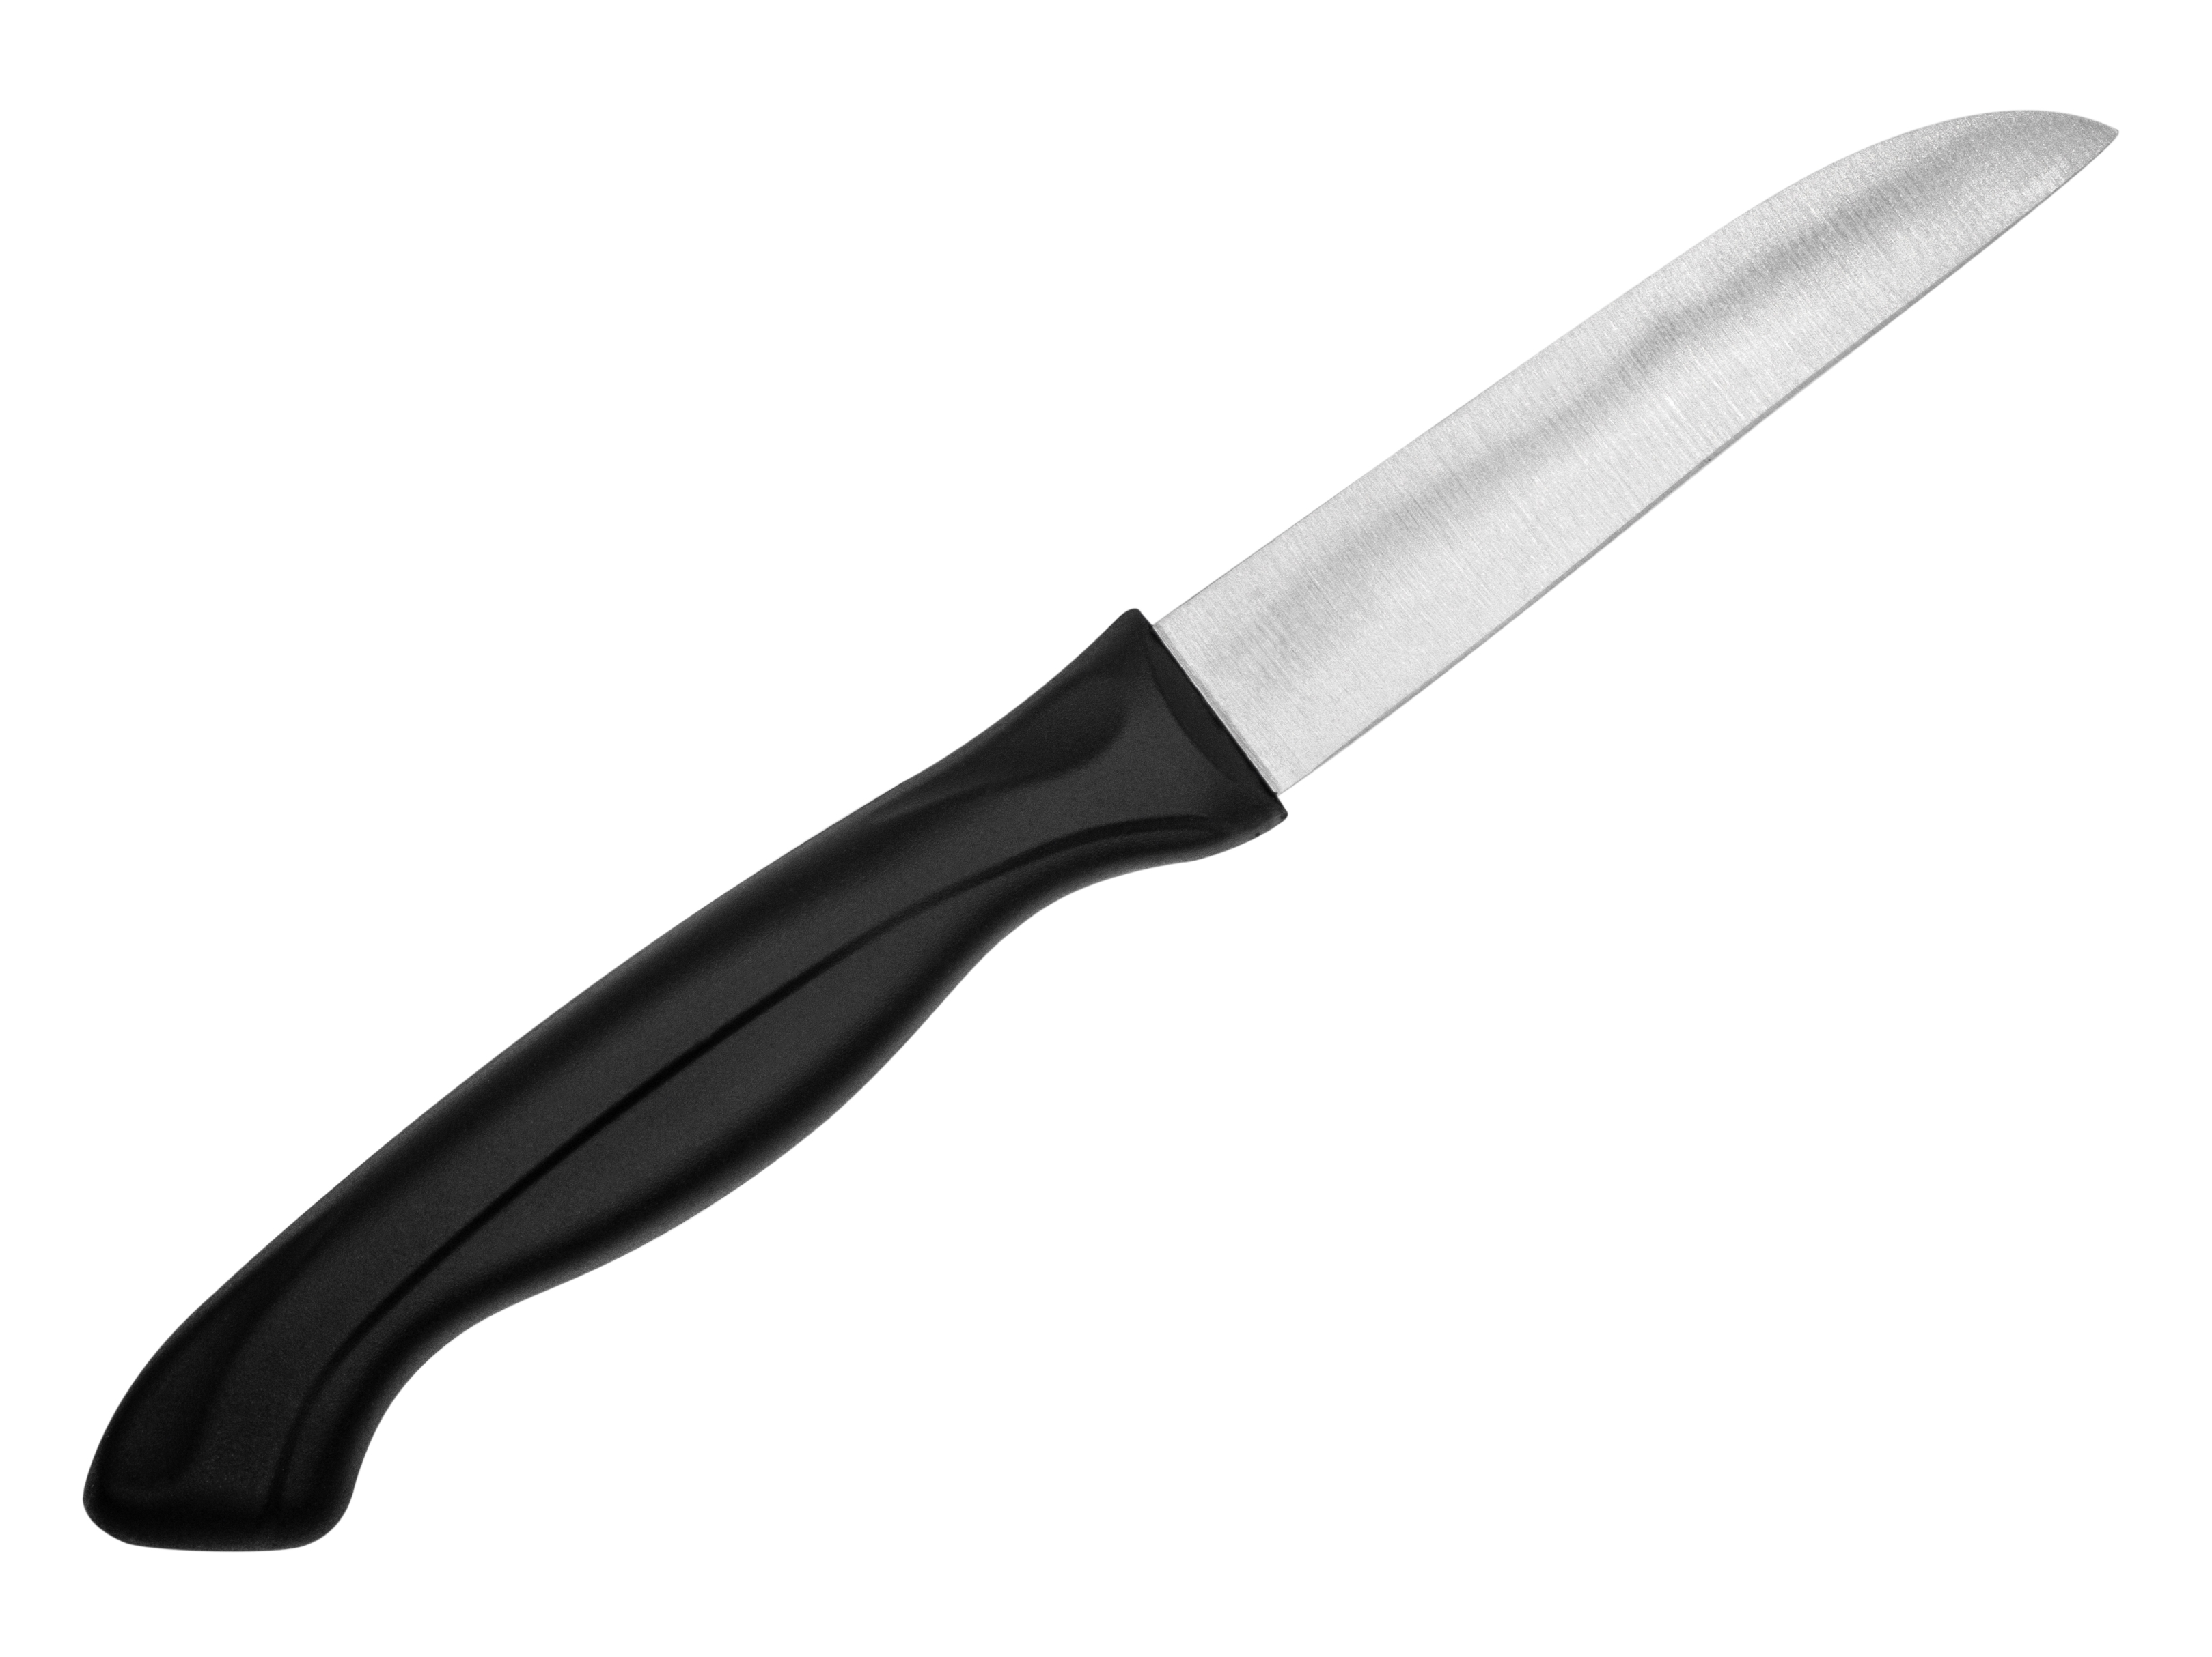 | Vegetable knife

Recipes can be modified to suit the time of day, person and occasion.

Different food and drinks are eaten at different times, for breakfast, lunch, dinner and snacks.

Some ingredients need to be prepared before they can be eaten.
There are lots of different pieces of equipment used in cooking and some equipment has a special job.
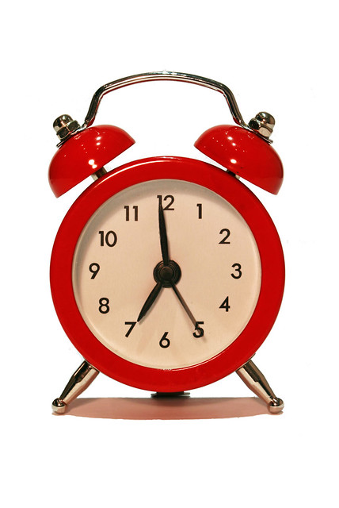
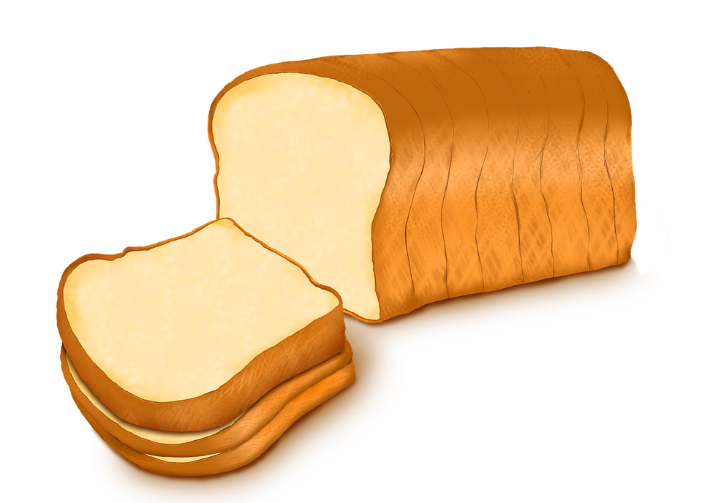
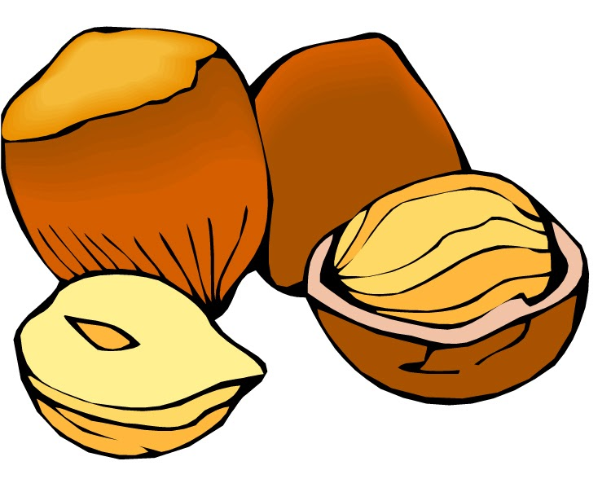
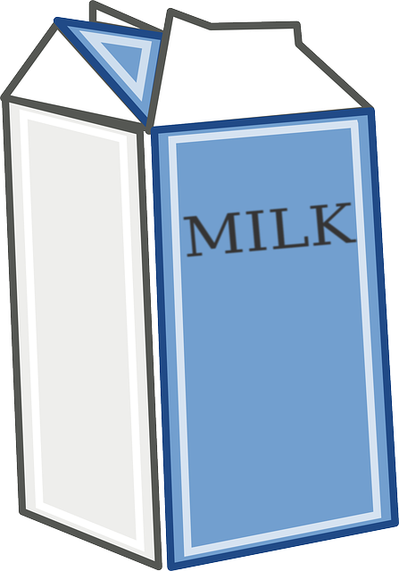

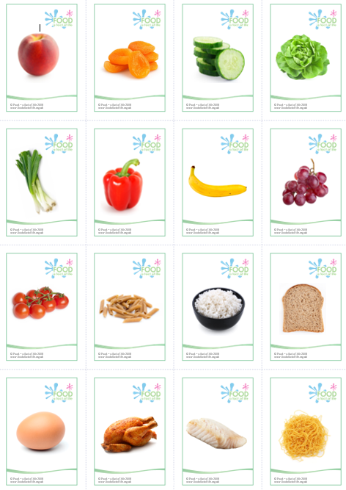
Some people can’t eat certain food as they are allergic, or intolerant, to it, such as dairy, nuts, wheat.
Use all the senses for tasting and use interesting words to describe what it is like.

When planning a recipe, consider the time of day, person and occasion for which it is needed.

It is important to be able to use a range of simple equipment.
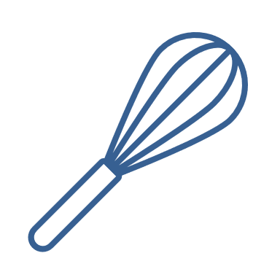
There are many different types of food.

