Food Commodities: Cereals, fruit, vegetables and potatoes
- Food is grown.
- Food is produced or processed in different ways.

Potatoes

Potatoes grow under the soil. They are usually planted in April. They are harvested from early June to the end of October.

Fruit and vegetables

Fruit and vegetables are from different parts of plants. Some grow above the soil, and some grow under the soil.

Cereals

Cereals include wheat, oats and barley. They are planted in winter and spring.
They are harvested in late summer to early autumn.
The grains from the cereals are used as food.

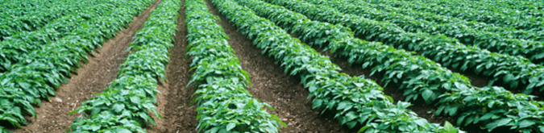
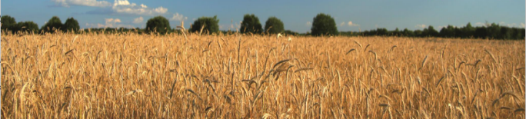
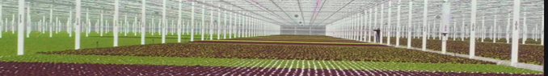

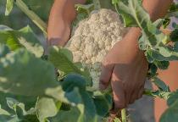
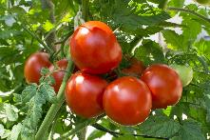
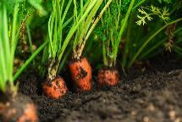
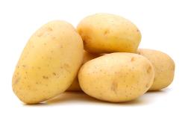
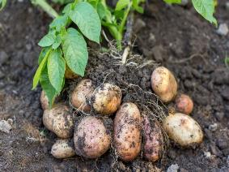

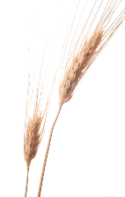
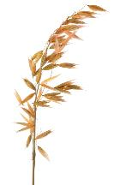
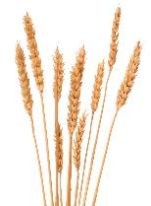
Carrots

Tomatoes

Cauliflower

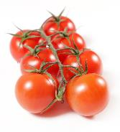
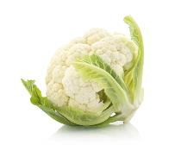
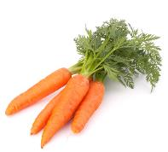
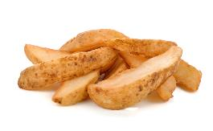
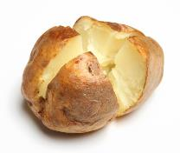
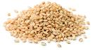
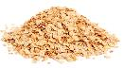
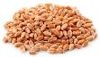
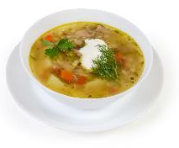
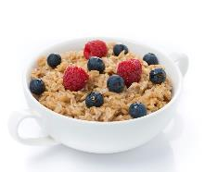
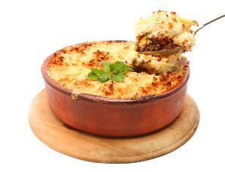
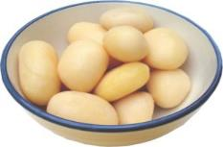
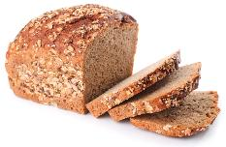
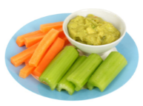
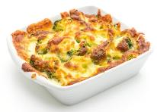
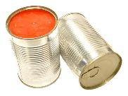
Task
Name two dishes that can be made from cereals, fruit, vegetables and potatoes.
This resource meets the Guidelines for producers and users of school education resources about food.

Potatoes are used in a wide range of different dishes and snacks.

Wheat is milled into flour to make bread.
Oats are used to make porridge.
Barley is added to stews, salads and soups.

Oats
Barley

Wheat
Some fruit and vegetables are cleaned and eaten raw. Others are prepared, cooked and eaten as part of a meal.

