Food Commodities: Dairy, meat and fish
- Food has to be reared and caught.
- Food is produced or processed in different ways.

0
Chicken

Chickens are reared for their meat and eggs.

Chicken and eggs are used in many dishes and meals.

Sheep

Sheep are mostly kept to produce meat and some for their milk.
Lamb is from sheep and is used in many dishes.

Dairy cows eat grass during the summer and silage in the winter. Cows are milked 2-3 times a day.

Milk is from a dairy cow. It can be made into cheese, yogurt and butter.

Beef cattle

Beef cattle are reared by farmers for meat.

Beef is from cattle and is used in a wide range of meals and dishes.

Pigs

Pigs are kept for meat, called pork.

Pork is used to make ham and sausages, and lots of other dishes.

Fish

Fish is either farmed or caught wild.
Lots of dishes and meals can be made with fish.

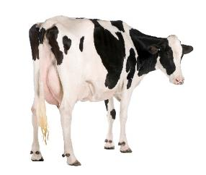
Dairy cow
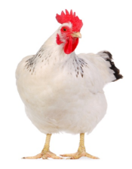
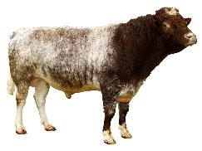
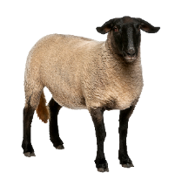
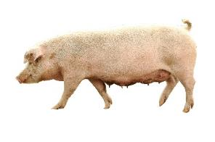
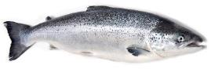


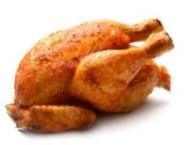
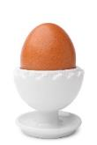
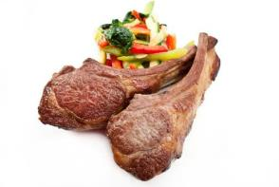
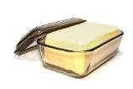
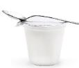
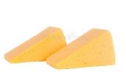
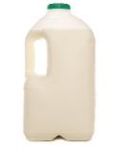
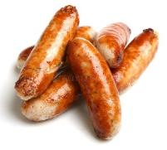
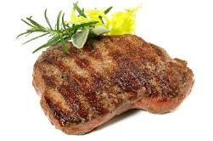
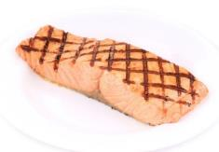
Task: Name two meals and dishes that can be made from:
- milk;
- beef;
- lamb;
- pork;
- chicken;
- eggs;
- fish.

This resource meets the Guidelines for producers and users of school education resources about food.

The farmer’s most important job
is to look after the health and
welfare of the animals.

They also look after the hedgerows
where birds and insects live.

