Where food comes from
- All food comes from plants and animals.
- Food has to be grown, reared or caught.

Fish are caught.
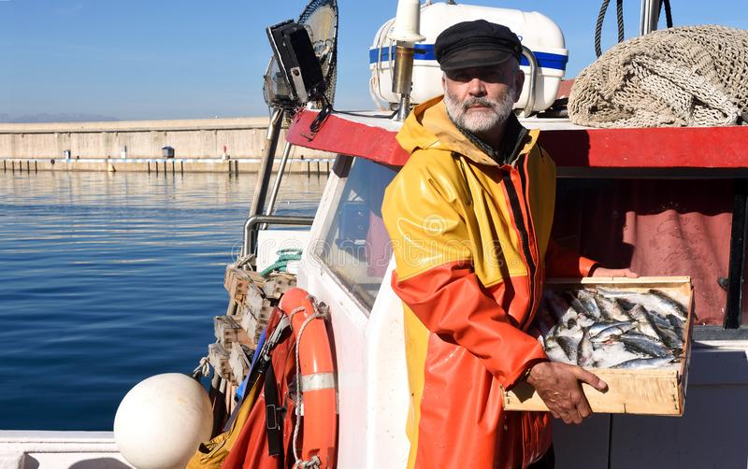

There are many types of fish, such as cod, salmon and prawns.

Fish is used in lots of dishes and meals.

Animals are reared.
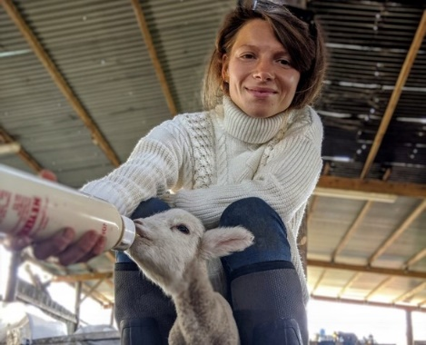

Cattle, dairy cows, sheep, pigs and chickens are reared for our food.
Dairy cows provide milk.
Cattle, sheep, pigs and chicken provide meat that can be made into lots of dishes.

Plants are grown.
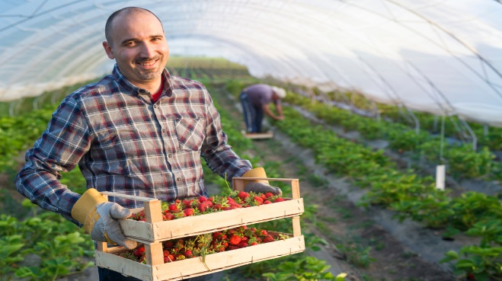

Fruit, vegetables, cereals and potatoes are all from plants.
Different parts of the plant are eaten:

- Flower
- Fruit
- Leaves

They are used in lots of dishes and meals.

A lot of the food we eat is produced in the UK.

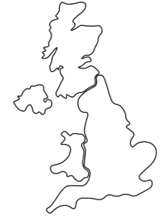

Some ingredients need to be prepared before they can be eaten.

- Stem
- Root/tuber

Ingredients are available from different shops and markets or can be grown at home.
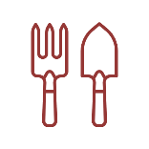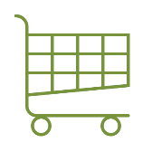

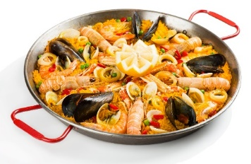
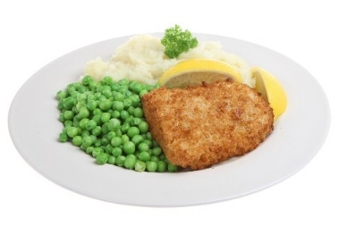
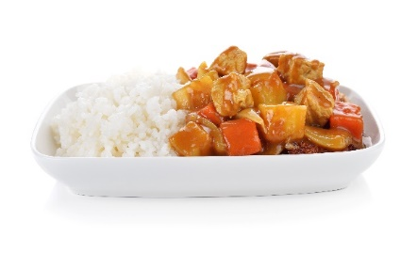
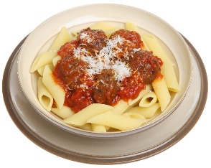
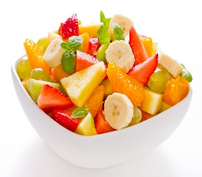
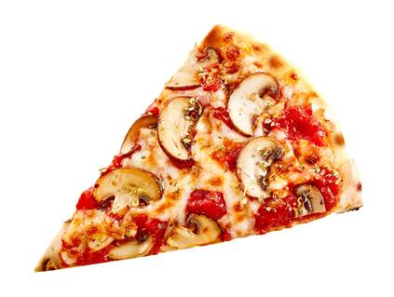

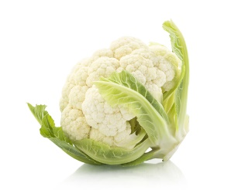
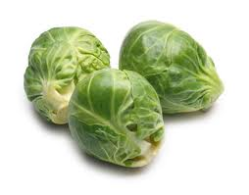
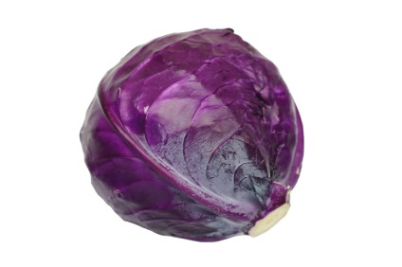
This resource meets the Guidelines for producers and users of school education resources about food.

Task
Name five examples of food from plants and animals.

Draw pictures to show your answers.
Some foods are seasonal – this means they are ready to eat at different times of the year.

Spring: March, April and May

Autumn: September, October and November

Summer: June, July and August

Winter: December, January and February

