Energy, nutrients and digestion
- A variety of food is needed in the diet because different food contains different substances that are needed for health. These are nutrients, water and fibre.
- The nutrients provided by the diet are released through the process of digestion.

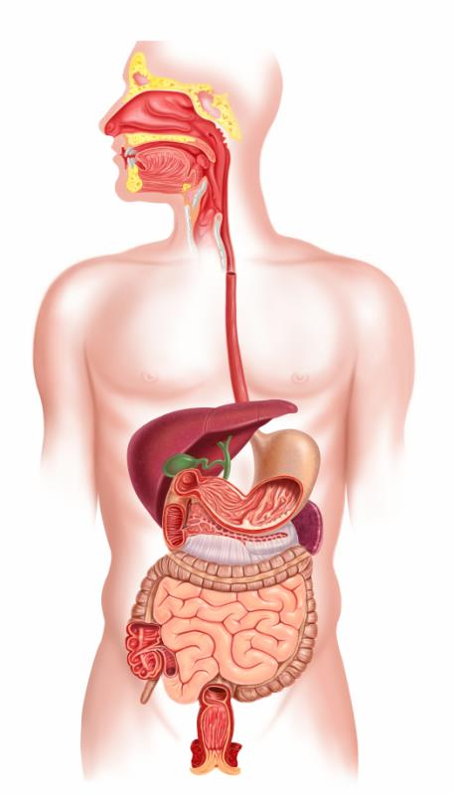
Tasks:
1. Write a healthy eating report for the school newsletter or website.
2. Produce a presentation about the nutrients provided by food.
Different amounts of energy are needed by the body for different activities.


Vitamins and minerals are needed for general good health.

Some have special jobs:
- vitamin A is needed for night vision;
- vitamin C is needed for the maintenance of healthy skin;
- iron is needed for healthy blood;
- calcium is needed for the growth and maintenance of strong bones and teeth.

A variety of food from different food groups is needed to get the range of nutrients needed by the body.

Food Group | Nutrient (main)
Fruit and vegetables | Vitamins, e.g. vitamin A and vitamin C
Potatoes, bread, rice, pasta and other starchy carbohydrates | Carbohydrate
Beans, pulses, fish, eggs, meat and other proteins | Protein  Minerals, e.g. iron
Dairy and alternatives | Minerals, e.g. calcium
Oil and spreads | Fat

Food and drinks provide nutrients, fibre and water.

The amount of a nutrient or fibre provided by a food or drink, depends on the serving size consumed.
To be healthy, energy balance should be achieved (over a period of time).

Energy in: food and drinks
Energy out: activity
Different amounts of food and drink provide different amounts of energy.

Mouth
Stomach
Intestines
Oesophagus
Different people need different amounts of energy and nutrients.
The amount of energy they need depends on their age, job, how active they are and their health.

Different types of food provide different amounts of energy.

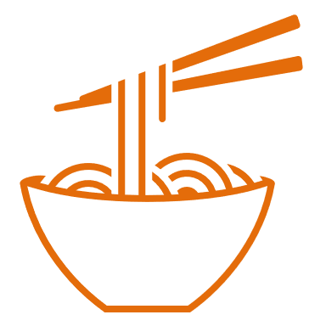

Digestion
Energy and nutrients are absorbed from food by the body in a process called digestion.
Energy in > Energy out = Weight gain
To find out more, go to: https://bit.ly/3eU8dRw
Energy is provided by carbohydrate, fat and protein.

Carbohydrate is the main source of energy for the body.

Fat is needed for health, but in small amounts.

Protein is needed for growth and repair.

.

