Food hygiene, safety and cooking
- Buying, storing, preparing and cooking food safely and hygienically are vital for health.
- There is a range of additional food skills and cooking techniques, which enable a wide range of dishes to be made.



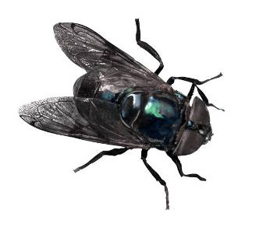
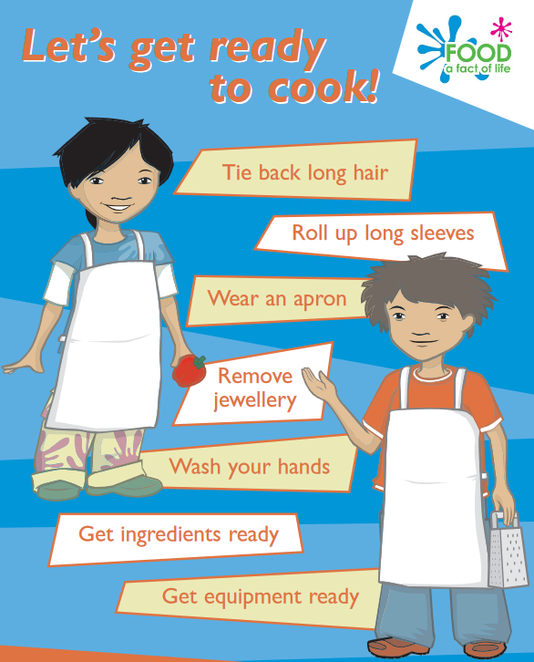
Task: Make a list of the steps you would take before, during and after cooking to make sure you follow good food hygiene and safety practices.

It is important to take care when using sharp and/or hot equipment so that you don’t hurt yourself or someone else.
Food needs to be stored properly and within its date mark.

There are lots of food skills which enable you to extend the range of dishes you can already cook.
Baby leaf salad
Keep refrigerated.
Once opened consume within 24 hours and by the ‘use-by’ date shown.
Food labels provide useful information to the consumer.

Food can be purchased from a variety of sources.


Food spoilage
When food spoils, the following may change:
- appearance;
- taste;
- texture;
- smell.
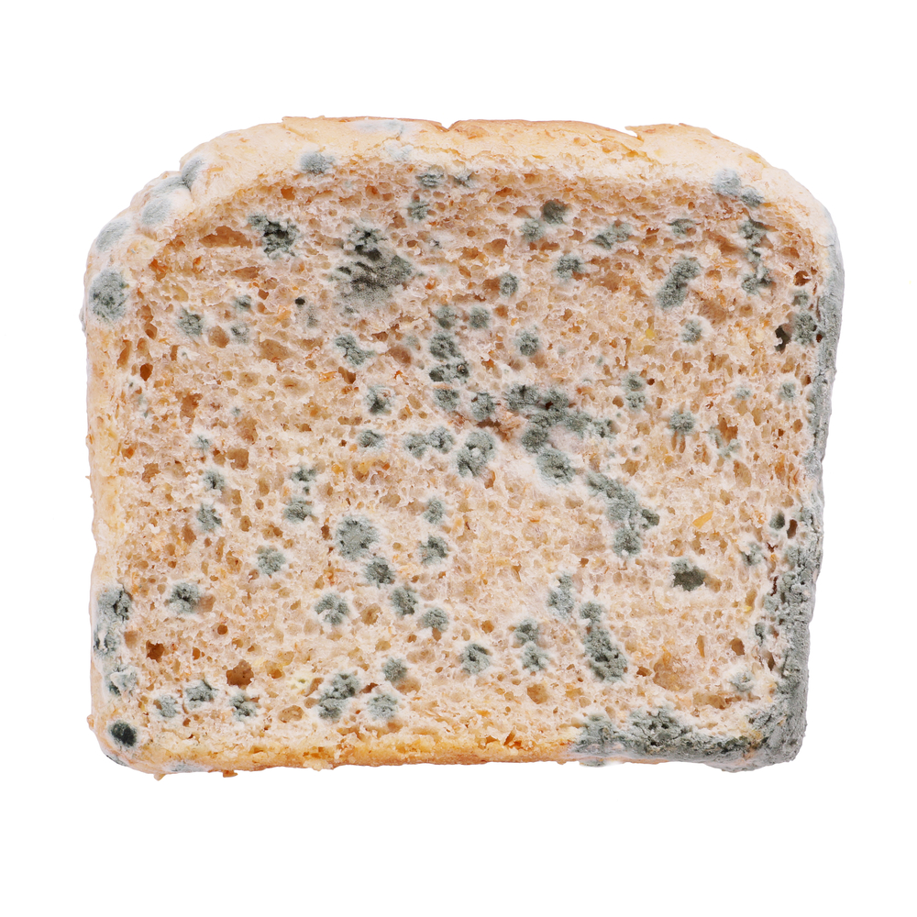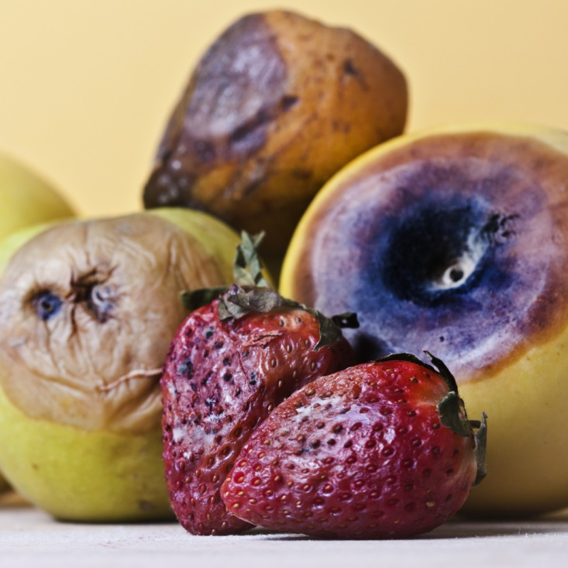
Good personal hygiene is vital when cooking to avoid the risk of food poisoning.
Microorganisms
Microorganisms are everywhere. They can be carried by food, people, dirty equipment, animals and pests. Most are harmless.
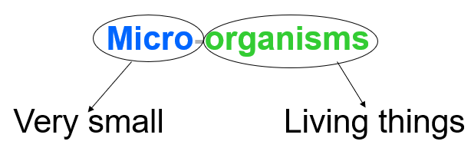
Food can spoil and decay due to the action of microbes, insects and other pests/pets.

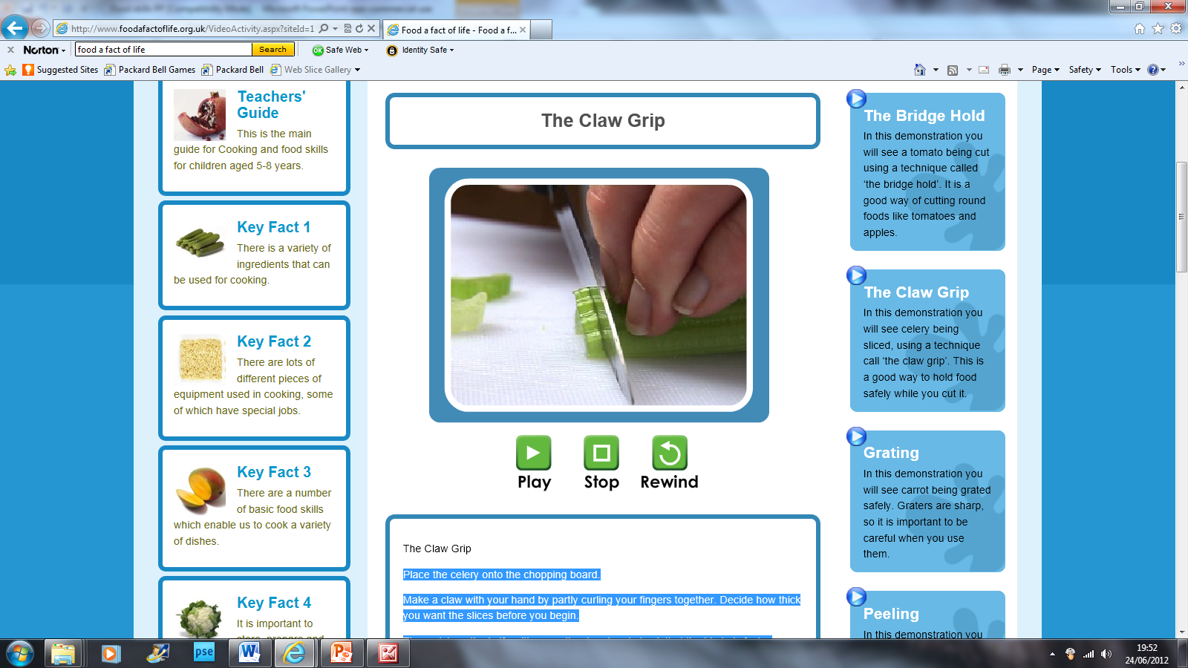


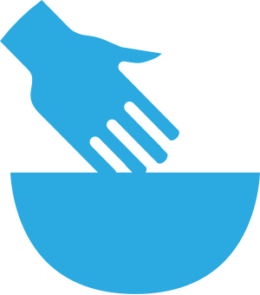




The bridge hold and claw grip should be used when cutting food to avoid harm.

Bridge hold Claw grip
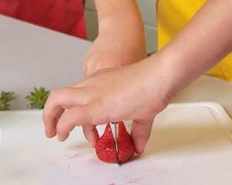

Basic cooking skills are required to make a dish.

Grate Knead

Measure/weigh Peel

Roll-out Rub-in

BEST BEFORE:

25/08/21

STORE IN A COOL DRY PLACE
USE BY:

25/08/20

KEEP REFRIGERATED
There are a number of basic food skills which enable you to prepare a variety of simple dishes.

These can include:
- cutting (with a knife);
- grating.
- juicing;
- kneading;
- measuring;
- peeling;
- rolling-out;
- rubbing-in;
- stirring;
- washing;
- weighing.

