Planning what to cook
- When planning to cook, it is important to select the most suitable ingredients, equipment and food skills for successful results.
- Around the world people use a range of different ingredients, equipment and cooking techniques to prepare food.
- When planning to cook, consideration should be given to current healthy eating advice, the needs of different people and occasion.

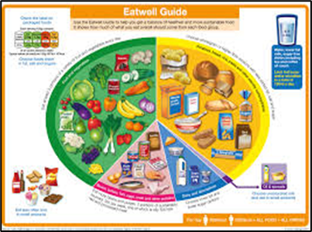
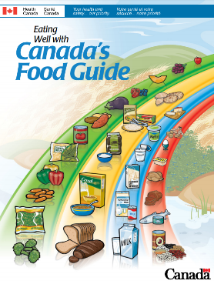
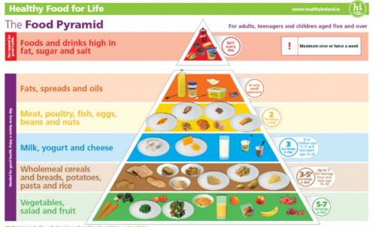
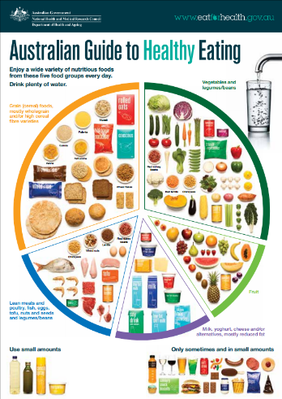
Food packaging has nutrition information which can help people make healthier choices.

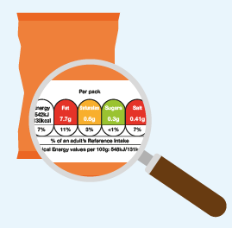

Many recipes can be adapted to produce exciting and original alternatives.

Healthy eating, as shown in the Eatwell Guide, along with people’s food needs, should be considered when planning and cooking.

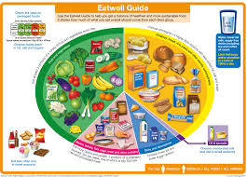
To ensure that a recipe works, it is important to weigh and measure ingredients accurately.

A recipe is made up of 3 parts:
- ingredients: a list of all the ingredients needed (metric);
- equipment: a list of all the equipment;
- method: how to make the dish.

Food is prepared in different ways due to a number of factors, including country, culture, custom and religion.

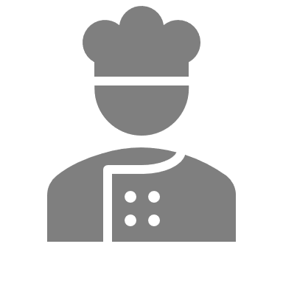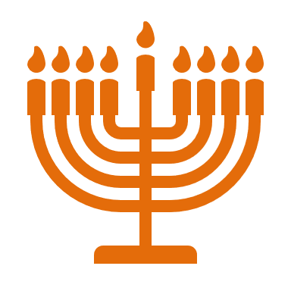
Diets around the world are based on similar food groups.

There is a vast range of ingredients used around the world for our food.

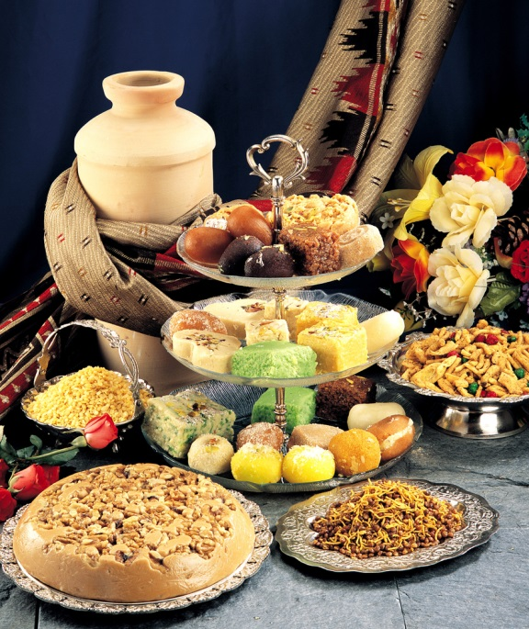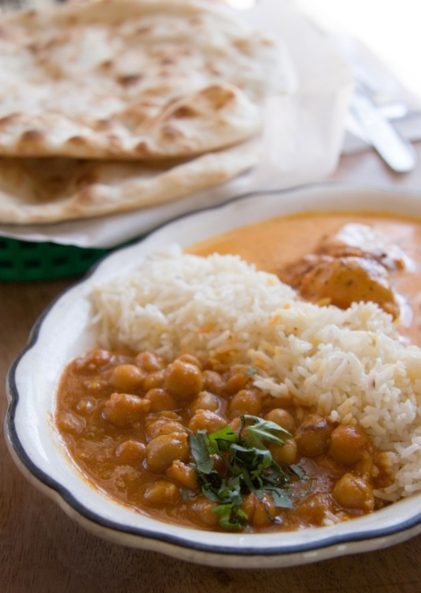

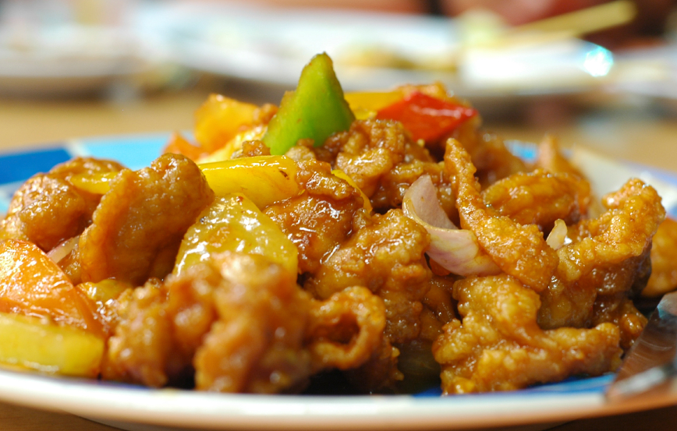



There are a number of simple healthier ways to prepare and cook foods.

Recipes can be made healthier by:
- changing the cooking method;
- not adding salt to food;
- adding fruit or vegetables;
- removing, adding or changing an ingredient;
- changing the portion size.
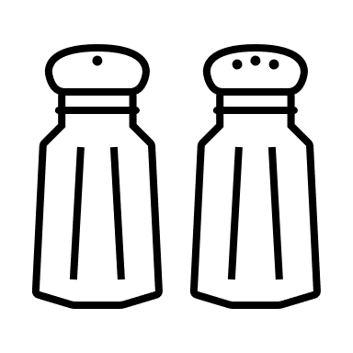
Task
Make a list of five different recipes and list the ingredients used and the country the recipes originate from.

This resource meets the Guidelines for producers and users of school education resources about food.

There are many different festivals and events which are celebrated with special food.
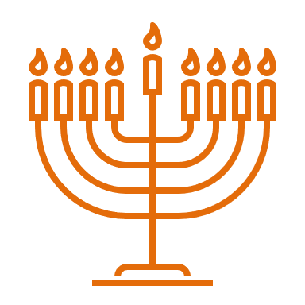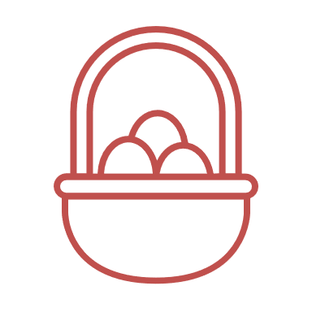
A range of factors determine what people eat.
The type people choose depends on:
- the food available;
- their likes and dislikes;
- time;
- culture and religion;
- whether they can cook.

