Food commodities: Dairy, meat, fish and shellfish
- Different types of food are reared and caught.
- There are a number of different stages in producing and processing food.

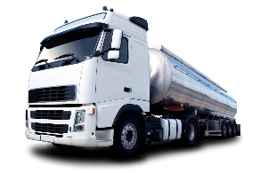
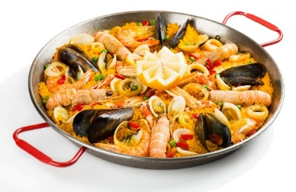
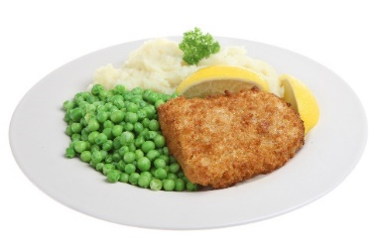
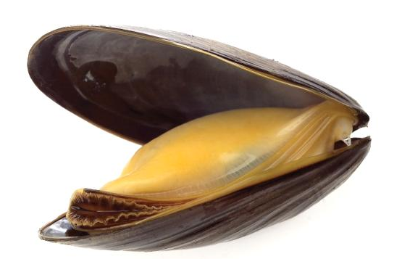
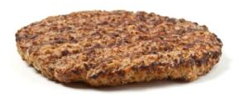
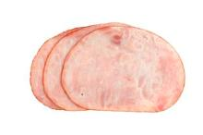
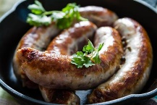
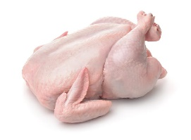
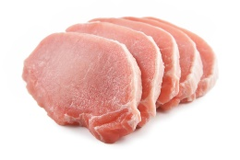
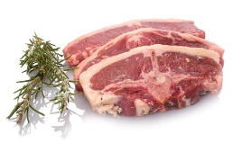
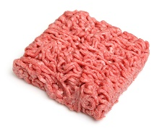
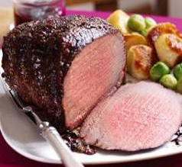
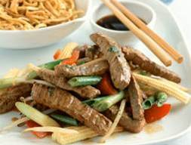
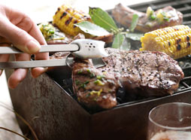
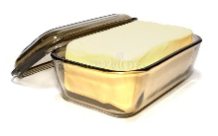
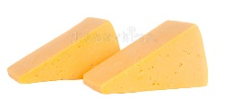
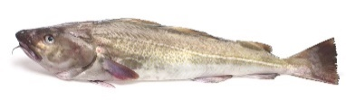
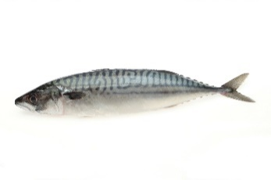
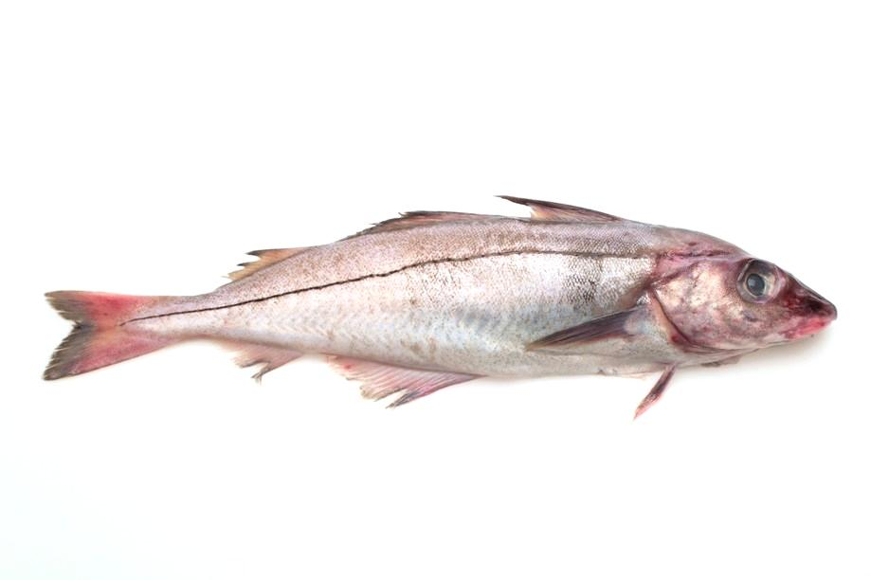
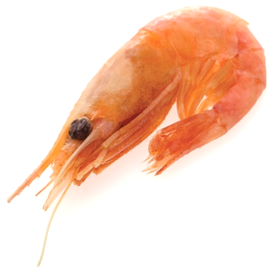
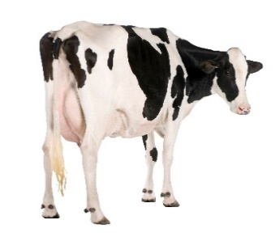
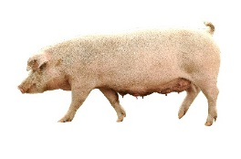
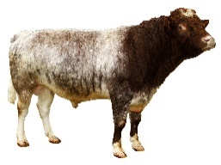
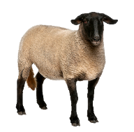
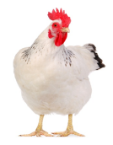
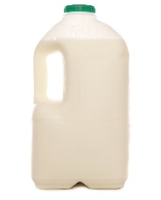
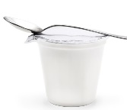
Task
Research the farm to fork journey for a type of meat, fish or shellfish of your choice.
Create a set of cards or a timeline to show the journey.
Example cards can be found here: https://bit.ly/326H7SX

Barbeque
This resource meets the Guidelines for producers and users of school education resources about food.

- somewhere comfortable to rest;
- company of animals of their own kind.
Burgers
Ham
Sausages
Chops
Whole
Steaks
Mince
Roasting
Stir-fry
To find out more, go to: https://bit.ly/3eP0qWb

Dairy
Dairy cows are reared by farmers
around the UK.

In the summer most dairy cows eat grass in the fields and in the winter they eat pickled grass called silage.
Dairy cows drink 60-80 litres of water per day.

Cows are milked 2-3 times per day.
The milk is chilled and stored ready for
the tanker to take it to be processed.

The milk is treated to make it safe to drink, it is then put into bottles or cartons and sold in shops.

Milk is also used to make cheese, yogurt and butter.

Meat
Animals are reared by farmers for our food.

Cuts of meat are prepared by butchers in shops and supermarkets. Cuts include:

Meat is also bought ready prepared.

Meat can be cooked in many different ways.

Animal welfare
It is important that animals are cared for and have everything they need, including:
- the right food and fresh water;
- being treated by a vet if ill or injured;
- space to move around and to be able to do the things they like;
- gentle and caring handling and treatment;
Fish and shellfish
There are lots of different types of fish.

Fishers catch the fish and it is sold at market.

The fish is bought by fish processing companies, fishmongers and restaurants.

Fish can be cooked in many different ways.

Mussels are a type of shellfish.

They are grown at the bottom of the sea on ropes (droppers).

Mussels are in season from
September to April.

