Food hygiene
- Good food safety and hygiene practices are essential to reduce the risk of food poisoning.
Allergen and food intolerance awareness
There are 14 ingredients (allergens) that are the main reason for adverse reactions to food. Cross-contamination of food containing these allergens must be prevented to reduce the risk of harm. They must also be labelled on pre-packaged food and menus so that consumers can make safe choices. The 14 allergens are:
Temperatures to remember
To reduce the risk of food poisoning, good temperature control is vital:

Food poisoning
Food poisoning can be caused by:
- bacteria, e.g. through cross-contamination from pests, unclean hands and dirty equipment, or bacteria already present in the food, such as salmonella;
- physical contaminants, e.g. hair, plasters, egg shells, packaging;
- chemicals, e.g. cleaning chemicals.
Bacterial contamination is the most common cause.
Microorganisms occur naturally in the environment, on cereals, vegetables, fruit, animals, people, water, soil and in the air. Most bacteria are harmless but a small number can cause illness. Harmful bacteria are called pathogenic bacteria.
The process of food becoming unfit to eat through oxidation, contamination or growth of micro-organisms is known as food spoilage.
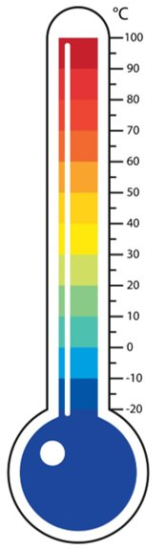

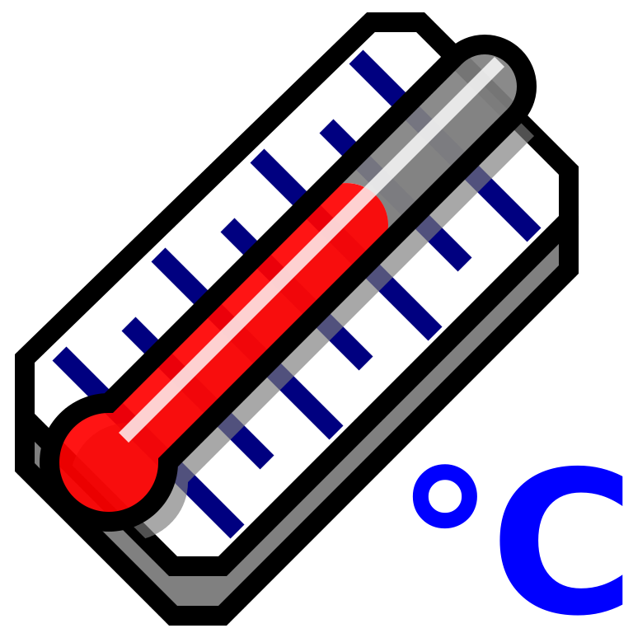

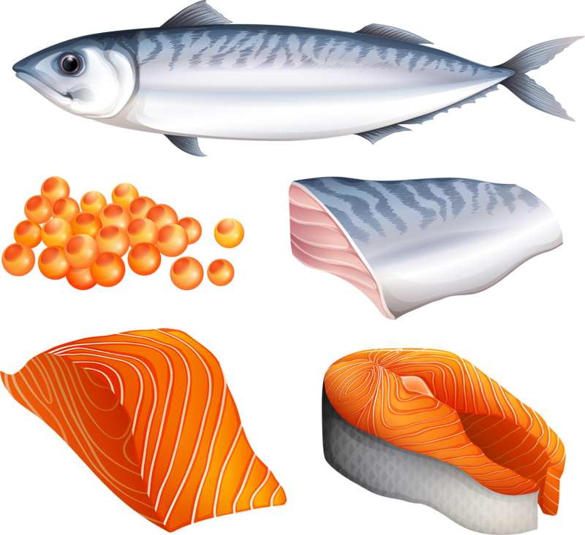
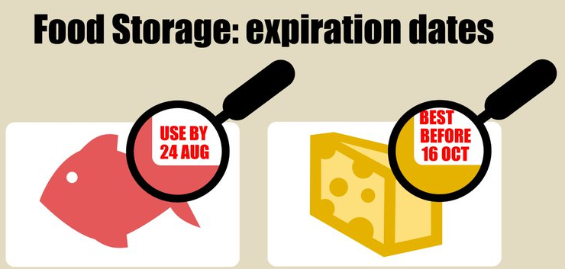
This resource meets the Guidelines for producers and users of school education resources about food.

To find out more, go to: https://bit.ly/2Z97B5f
Task
Create a poster highlighting the top tips for ensuring food is safe to eat. Include personal hygiene, safe storage, preparation and cooking of food.
Key terms
Allergens: Substances that can cause an adverse reaction to food. Cross-contamination must be prevented to reduce the risk of harm.
Bacteria: Small living organisms that can reproduce to form colonies. Some bacteria can be harmful (pathogenic) and others are necessary for food production, e.g. to make cheese and yogurt.
Cross-contamination: The transfer of bacteria from one source to another. Usually raw food to ready-to-eat food but can also be the transfer of bacteria from unclean hands, equipment, cloths or pests. Can also relate to allergens.
Food poisoning: Illness resulting from eating food which contains food poisoning micro-organisms or toxins produced by micro-organisms.
High risk ingredients: Food which is ready to eat, e.g. cooked meat and fish, cooked eggs, dairy products, sandwiches and ready meals.
- 5-63°C – the danger zone where bacteria grow most readily.
- 37°C – body temperature, optimum temperature for bacterial growth.
- 8°C – maximum legal temperature for cold food, i.e. your fridge.
- 5°C (or below) – the ideal temperature your fridge should be.
- 75°C – if cooking food, the core temperature, middle or thickest part should reach at least this temperature.
- 75°C – if reheating food, it should reach at least this temperature. In Scotland food should reach at least 82°C. Remember to reheat food only once!

Celery (and celeriac)
Cereals containing gluten
Crustaceans
Eggs
Fish
Lupin

Milk
Molluscs
Mustard
Nuts
Peanuts
Sesame
Soybeans
Sulphur dioxide

Bacterial growth and multiplication
All bacteria, including those that are harmful, have four requirements to survive and grow:
- food;
- moisture;
- warmth;
- time.

Best-before-date
You can eat food past this date but it might not be at its best quality.
Use-by-date
You’ve got until the end of this date to use or freeze the food before it becomes too risky to eat.

Getting ready to cook
- Remove blazers/jumpers and roll up long sleeves.
- Tie up long hair and tuck in ties or head coverings.
- Thoroughly wash and dry hands.
- Put on a clean apron.

Why clean?
To remove grease, dirt and grime, and prevent food poisoning and pests.
Where should food be stored in the fridge?

Cheese, dairy and egg-based products
The temperature is usually coolest and most constant at the top of the fridge, allowing these foods to keep best here.

Cooked meats
Cooked meats should always be stored above raw meats to prevent contamination from raw meat.

Raw meats and fish
Raw meats and fish should be below cooked meats and sealed in containers to prevent contamination of salad and vegetables.

Salad and vegetables
These should be stored in the drawer(s) at the bottom of the fridge. The lidded drawers hold more moisture, preventing the leaves from drying out.

Time
When bacteria spend enough time on the right types of food, at warm temperatures, they can multiply to levels that cause illness.

Reheat food only once and eat leftovers within 48 hours.

People at risk
Elderly people, babies and anyone who is ill or pregnant needs to be extra careful about the food they eat.

Symptoms of food poisoning
The symptoms of food poisoning include:
- nausea;
- vomiting;
- stomach pains;
- diarrhoea.

Moisture
Bacteria need moisture to survive. Dried foods, such as powdered milk, cereals or dried egg do not support bacterial growth, if properly stored. However, if moisture is added, any bacteria still alive can quickly begin to multiply.

High risk food
Bacteria easily multiply on foods known as ‘high-risk food’. These are often high in protein or fat, such as cooked meat and fish, dairy foods and eggs. Cooked pasta and rice are also regarded as high risk foods if they are not cooled quickly after cooking and stored below 5°C.

