Food labelling
- Food labels provide information, which helps people to know when to eat food, and how to store it safely.
- Nutrition and allergy information on food labels help to make informed food and drink choices.

Allergen labelling
There are 14 ingredients (allergens) that are the main reason for adverse reactions to food. They must be labelled on pre-packaged food and menus so that consumers can make safe choices.
From summer 2021 new legislation will tighten the rules requiring food that is prepared for direct sale, e.g. in a coffee shop, to carry a full list of ingredients.

The 14 allergens are:
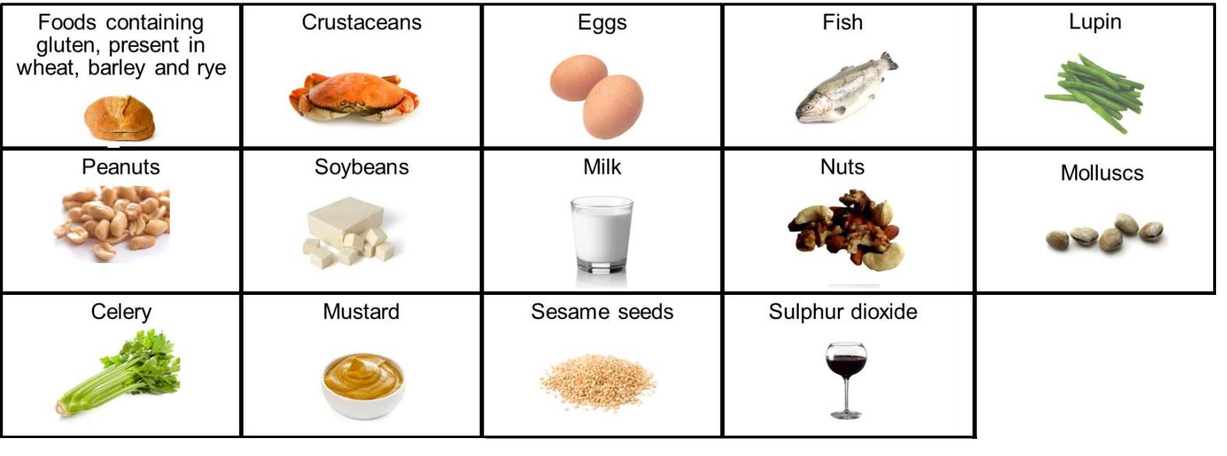
Nutrition information
Nutrition information can help consumers make healthier choices. Back-of-pack nutrition information is legally required.

Food labelling
Information on the labels of pre-packed food and drink products can be legally required or just for consumer information.
Legally required information:
- country of origin and place of provenance;
- date mark;
- list of ingredients (including additives and allergens);
- name and address of the manufacturer, packer or seller;
- name of food or drink;
- nutrition information;
- storage and preparation instructions;
- weight or volume.

Consumer information:
- front-of-pack nutrition label;
- price;
- serving suggestions/image.

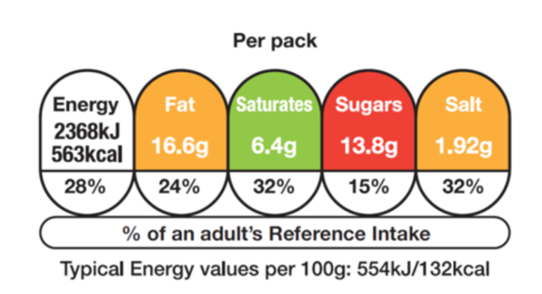
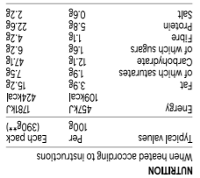
Task
Produce a food label for a dish you have made. Ensure that the label includes the information required by law that relates to food hygiene and safety, i.e. a date mark, ingredient list (with allergens identified) and storage instructions.

Date marks/shelf life
‘Use by’ dates relate to the safety of the food and’ best before’ dates relate to quality. Eating foods after their ‘use by’ date could lead to food poisoning.

Baby leaf salad
Keep refrigerated. Once opened consume within 24 hours and by the ‘use by’ date shown.
Ingredients
It is a legal requirement to include an ingredients list on packaged or pre-prepared foods. The ingredients must appear in descending order and with the allergens identified in bold, highlighted, underlined or in italics.

INGREDIENTS
Water, Carrots, Onions, Red Lentils (4.5%), Potatoes, Cauliflower, Leeks, Peas, Cornflour, Wheat flour, Cream (milk), Yeast Extract, Concentrated Tomato Paste, Garlic, Sugar, Celery Seed, Sunflower Oil, Herb and Spice, White Pepper, Parsley
ALLERGY ADVICE
For allergens, see ingredients in bold

Front-of-pack labelling
Front-of-pack nutrition information is voluntary. If a food business chooses to provide this, only the following information may be provided:
- energy only;
- energy along with fat, saturates, sugars and salt.

Red, amber and green colours, if used, show at a glance whether a food is high, medium or low for fat, saturates, sugars or salt. The colour coding can be used to compare two products.

BEST BEFORE:

25/08/21

STORE IN A COOL DRY PLACE
USE BY:

25/08/20

KEEP REFRIGERATED

Key terms
Allergen: An ingredient that may cause an adverse reaction to food.
Back-of-pack labelling: Is legally required and can help consumers make healthier choices.
Front-of-pack labelling: Is voluntary but must provide certain information and can use red, amber and green colour coding.
Use-by-date: Relates to the safety of the food. Food must be eaten by this date.
Best-before-date: Relates to the quality of the food. Food may still be eaten beyond this date.

