Food commodities: Potatoes
- Food is sourced, processed and sold in different ways.
- Food production and processing ensures that food is edible and safe.

What is a potato?
Potatoes are tubers, a fleshy swelling on roots that grow underground. There are over 4,000 edible varieties in many different colours, shapes and sizes.
Specialist breeders develop new varieties.
They strive for:
- better resistance to pests and diseases;
- better storage;
- greater nutrition;
- increased yields;
- consistency for better processing;
- improved quality and appearance;
- reduced need for inputs such as water and fertiliser.
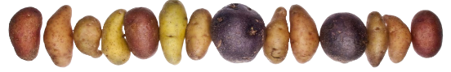
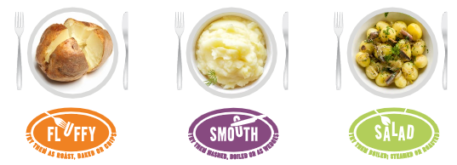
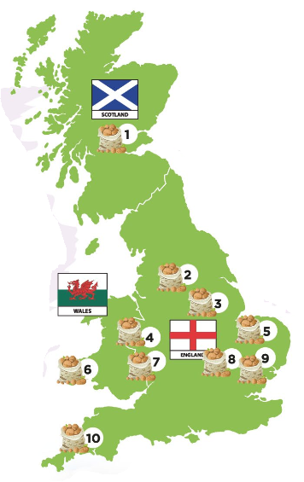
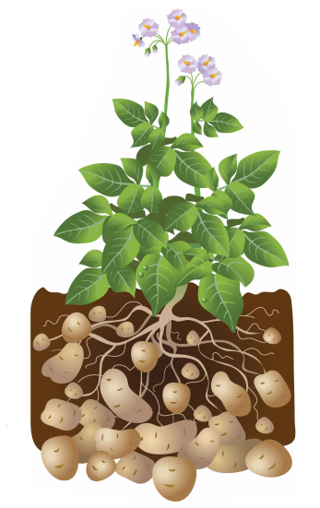
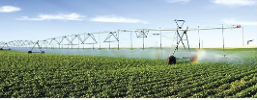
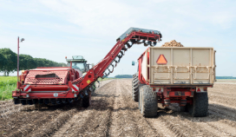
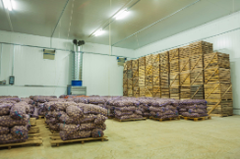
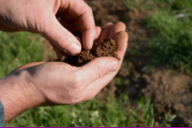
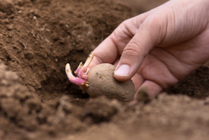
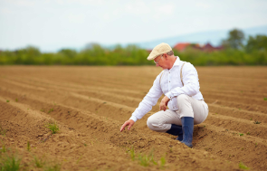
Key terms
Chitting: Seed potatoes (tubers) are left to sprout in a warm place to help them grow faster and produce a bigger crop.
Destoning: The process used to remove stones from the soil so potatoes have more room to grow.
Earthed up: Soil is pulled up around growing potatoes protecting them from frost and weeds.
Grading: The process following harvesting, anything that is not a potato is removed and potatoes are sorted into sizes ensuring quality standards are met.
Plant protection products: Used by farmers to protect crops from insects and diseases, e.g. pesticides.
Potato rotation: The system used by farmers to replenish nutrients and improve soil health in fields.
Seed potatoes: A potato that is grown to be planted to produce a future crop of potatoes.
Uses of potatoes
Not all potatoes go straight to the shops, some are used as future crops where part of the crop is set aside for next years' planting and is used as seed potatoes.

Some potatoes are manufactured into potato products:
- crisps – potatoes are delivered to factories and washed, peeled, sliced, fried, flavoured, packaged and sent to retailers;
- ready prepared potatoes – British manufacturers of frozen potato products are the largest purchasers of British potatoes, e.g. chips, potato waffles, mashed potato.
Task
Research the farm to fork journey of potatoes.
Prepare a presentation to share with the class next lesson. Include your favourite recipe and explain which variety to use.

To find out more, go to: https://bit.ly/39MyArZ

Seed potatoes (tubers) are chitted before they are planted in rows 15-17 cm deep.
Planting usually takes place in spring. Different climates from north to south mean harvesting happens at different times, so GB potatoes are available all year round.
Farmers plough the ground to turn the soil.
Later, in the spring, fertiliser is added to the soil.
Finally, stones are removed using a destoner, as modern automatic harvesters cannot tell the difference between stones and potatoes.
Ideal for roasting, baking and chipping,
e.g. Maris Piper.
Ideal for boiling, steaming, roasting and salads, e.g. Charlotte.
Ideal for mashing, boiling and wedges,
e.g. Desiree.
Potato characteristics
Although every variety is different, potatoes can be divided into three groups or types.

Potato growing in Britain
Britain is one of the largest producers of potatoes in the world:
- 5.4 million tonnes are grown per year;
- there are 2,500 specialist potato farmers;
- potatoes are grown on 110,000 hectares;
- 40% of potatoes grown in Scotland are sed potatoes for growing not eating;
- 80% of potatoes grown are eaten in Britain.
4. Protecting the crop
As the potatoes grow, they are ‘earthed up’ to protect them from the elements.

Plant protection products are used to care for the crops as they grow. These guard against insects and diseases.
5. Harvesting
After five months, the harvester lifts and separates the potatoes from the soil.

Test digs take place before harvest to make sure the potatoes are ready.

They are then lifted and graded.
6. Storage
Harvested potatoes are placed in bulk storage or weighed and bagged ready for distribution.
They can also be stored in boxes in insulated potato stores.

Farmers check and grade the potatoes throughout the storage season.

Soil is tested for nutrients and moisture content to see if it is suitable for growing potatoes.

Potatoes will only be grown in the same field once every five years to replenish nutrients and improve the soil.
3. Planting
2. Preparing the soil
Potato farming: The journey from farm to fork
Potatoes are usually planted in spring and harvested just five months later.
- Choosing where to plant

