Food commodities: Cereals and rice
- Food is sourced, processed and sold in different ways.
- Food production and processing ensures that food is edible and safe.

Secondary processing

Flour into bread
The four basic ingredients to make bread are:

- flour;
- yeast (make the bread rise);
- salt (adds taste and aids proving);
- warm water.

Fat can sometimes be added to make the loaf lighter and extend the shelf life.

Malted ingredients
Malt is used in a wide variety of food and drinks to add flavour, colour, aroma, and texture. It can help extend the shelf life of foods (from cookies and cakes to drinks and baby foods).

Primary processing

Milling
- The grain from the cereals is used to make flour and milling is the process that turns wheat and oats into flour.
- The harvested grain is delivered to the mill where it is cleaned and conditioned.
- The grain is then passed through rollers and sieves to open and separate the different parts of the grain. Grains like oats are rolled and cut to produce flakes and oatmeal.

Malting
To make malt, cleaned barley, water, air and heat are needed. The main stages to malting barley are:
- steeping – soaking the grains in water;
- germination – allowing the grains to grow;
- kilning – drying the grains.

What are cereals?
- Wheat, barley and oats are all types of cereals grown in the UK.
- Grains grow at the top of the plant, closely packed together called ‘ears’.
- Each ear of wheat is made up of 45-50 grains, it is these starchy grains that we eat.

There are three parts to wheat grains:
- bran layers – the course outer layer;
- wheat germ – a new plant would grow from this part;
- endosperm – the starchy store of food which the germ feeds on while it grows. The white flour we use to make many products comes from the endosperm.
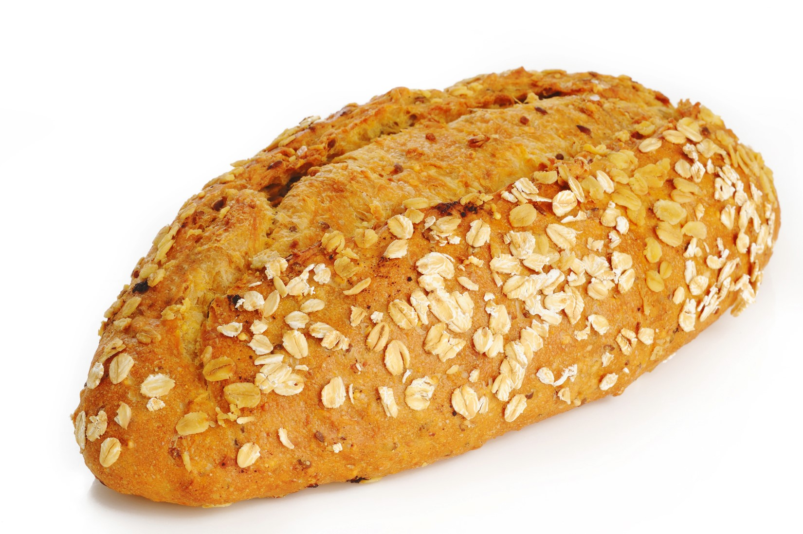
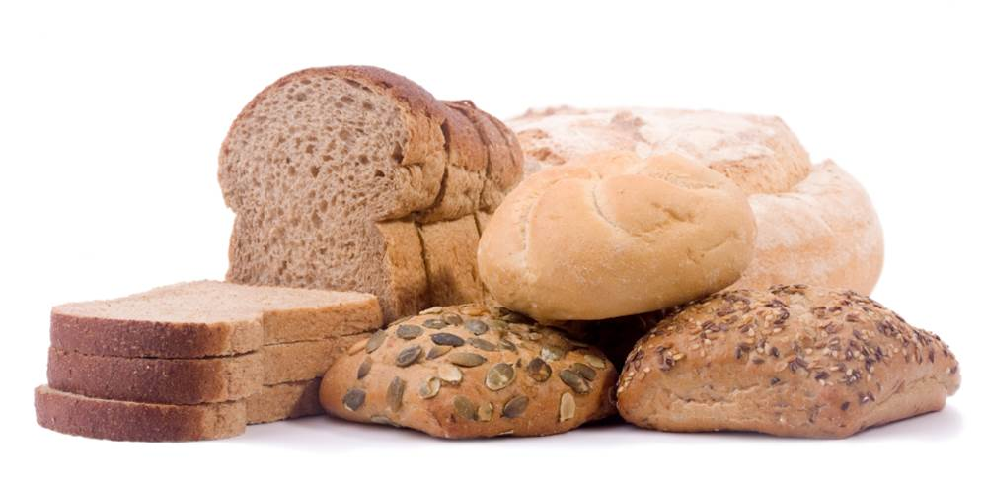
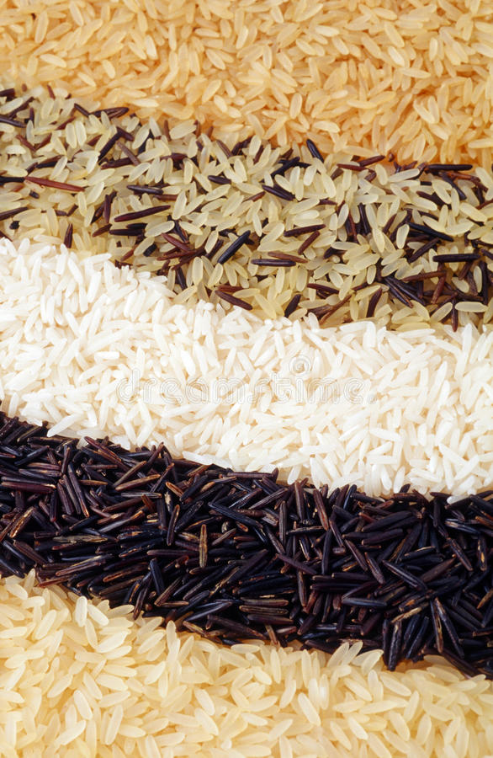
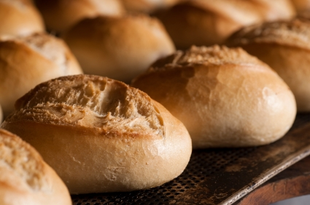
Types of flour
- White – usually contains 75% of the grain and most of the bran and wheatgerm are removed.
- Brown – usually contains about 85% of the original grain and some of the bran and wheatgerm are removed.
- Wholemeal – made from the whole wheat grain.
- Malted wheatgrain – brown or wholemeal flour with malted grains added after milling.
- Wheatgerm – white or brown flour with at least 10% made up of wheatgerm added during milling.
- Strong – contains a higher gluten content to make a range of different breads, pizzas and crumpets.
- Plain – contains a lower gluten content and used to make biscuits, pastry, sauces, pancakes, batters and Yorkshire puddings.
- Self-raising – baking powder is added as part of the milling process and mainly used to make cakes and scones.

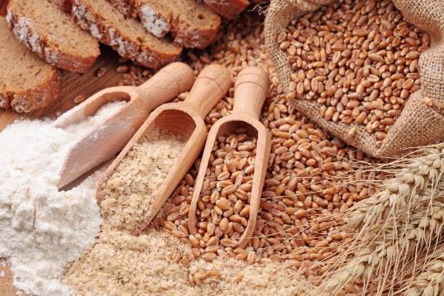

Bread in the UK
All white bread commercially sold in the UK is made with white flour fortified with calcium, iron and B vitamins. It is a legal requirement to fortify flour in the UK.

Key terms
Fortify: Adding nutrients to food.
Gluten: Part of the grain that provides the elastic texture of dough.
Harvesting: Gathering crops when ready or ripe.
Malting: The process where barley grains are soaked and dried for malt.
Milling: The process to separate different parts of the grain.
Threshing: The method to remove the outer husk layer from rice grains.

Around the world other flours are used which are not made from wheat. Some of the less common types include flour made from coconut, potato, peas and chickpeas. Other grains such as rye, oats and spelt are also used.

Tasks
- Create a display showing the stages for malting barley.
- Research five different types of bread from around the world that are baked and eaten for different occasions.
What is rice?
Rice is a short living plant that requires a substantial amount of water when growing. When farming rice, the fields are flooded and drained before harvest. The rice, once harvested, is known as a paddy grain. The paddy grains are sent to a mill to be threshed and turned into grains of rice for cooking.

Rice varieties can be divided into 3 groups:
- long grain – all purpose and can be used as an accompaniment e.g. basmati;
- medium grain – used in risottos and puddings as it is creamy when cooked e.g. Arborio;
- short grain – used to make sushi and puddings as it tends to be stic kier when cooked e.g. bomba.

Growing wheat, barley and oats
- Wheat is grown worldwide, different varieties are grown depending on the climate and geography of the country. In the UK 11-16 million tonnes are grown per year. It is planted in early autumn and harvested the following summer.
- About half the crop of wheat is made into food for human consumption, and some is used for animal feed (e.g. to feed chickens, cattle and pigs). About 3% of the crop is used as seed to plant for the following year.
- Other crops grown in the UK include barley with 6-8 million tonnes harvested and oats about 1 million tonnes.

