Food science

Why is food prepared and cooked?
Food is prepared and cooked to:
- make the food more palatable – improves flavour, texture and appearance;
- reduce the bulk of the food;
- provide variety and interest to meals.

Coagulation
Coagulation follows denaturation. For example, when egg white is cooked it changes colour and becomes firmer (sets). The heat causes egg proteins to unfold from their coiled state and form a solid, stable network.

Raising agents
Raising agents include anything that causes rising within foods, and are usually used in baked goods. Raising agents can be:
- biological, e.g. yeast;
- chemical, e.g. baking powder;
- mechanical, e.g. adding air through beating or folding.

Gelatinisation
When starch is mixed with water and heated, the starch granules swell and eventually rupture, absorbing liquid, which thickens the mixture. On cooling, if enough starch is used, a gel forms.
Functions of ingredients
Ingredients provide a variety of functions in recipes.

Key terms
Conduction: The exchange of heat by direct contact with foods on a surface.
Convection: Currents of hot air or hot liquid transfer the heat energy to the food.
Functional ingredients: Included in food for additional health benefits.
Heat transfer: Transference of heat energy between objects.
Radiation: Energy in the form of rays.

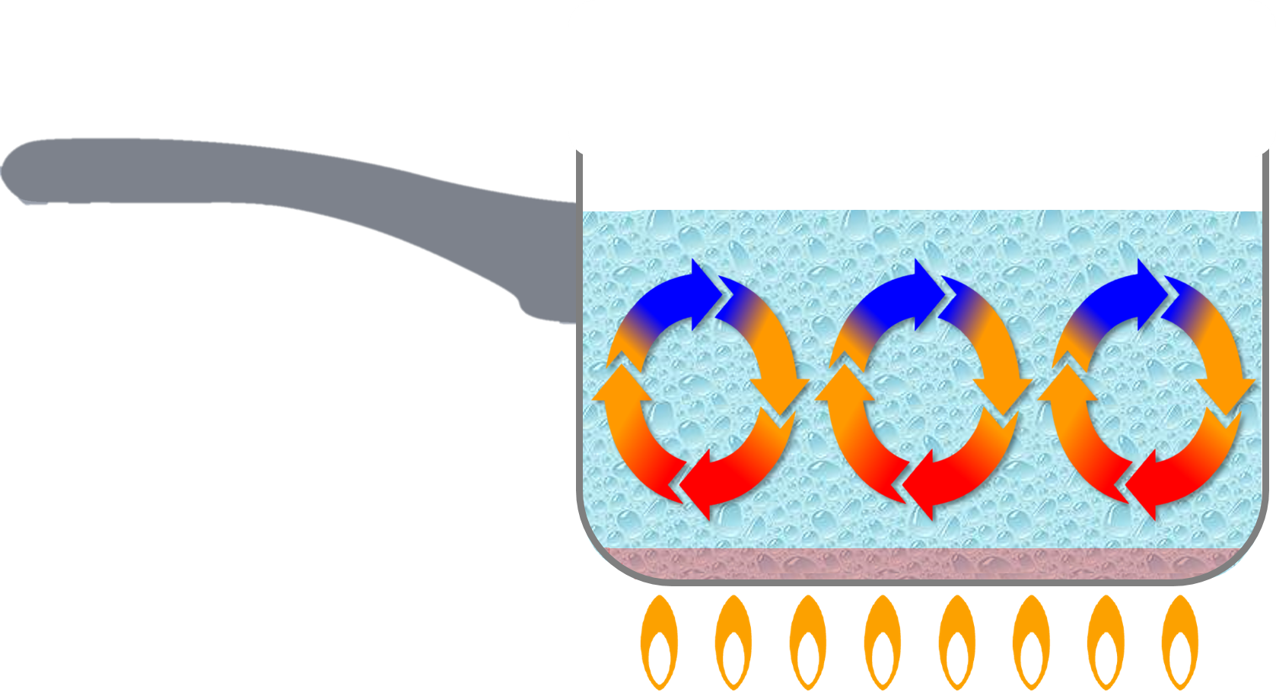
Methods of cooking food
The methods of cooking are divided up into groups. These are based on the cooking medium used.
They are:
- moist/liquid methods, e.g. boiling;
- dry methods, e.g. grilling;
- fat-based, e.g. frying.

Selecting the most appropriate way of preparing and cooking certain foods is important to maintain or enhance their nutritional value.
- Vitamins can be lost due to oxidation during preparation or leaching into the cooking liquid.
- Fat-based methods of cooking increase the energy (calories) of the food.
- The use of different cooking methods affects the sensory qualities of the food.

Denaturation
Denaturation is the change in structure of protein molecules. The process results in the unfolding of the protein’s structure. Factors which contribute to denaturation are heat, salts, pH and mechanical action.
Aeration
Products such as creamed cakes need air incorporated into the mixture in order to give a well-risen texture. This is achieved by creaming a fat, such as butter or baking spread, with sugar.
Small bubbles of air are incorporated and form a stable foam.
Fats performs different functions in food.
They help to:
- add ‘shortness’ or ‘flakiness’ to foods, e.g. shortbread, pastry;
- provide a range of textures and cooking mediums;
- glaze foods, e.g. butter on carrots;
- aerate mixtures, e.g. a creamed cake mix;
- add a range of flavours.

Plasticity
Fats do not melt at fixed temperatures, but over a range. This property is called plasticity.

Carbohydrate, protein and fat
Carbohydrate, protein and fat all have a range of properties that make them useful in a variety of food products.

Tasks
- Choose a recipe that you enjoy or have made recently and explain in detail the functions of the ingredients.
- Explain the function of raising agents, giving examples of recipes.

There are three ways that heat is transferred to food.

- Conduction – the exchange of heat by direct contact with foods on a surface.
- Radiation – energy in the form of rays.
- Convection – currents of hot air or hot liquid transfer the heat energy to the food.

Tenderisation
- Mechanical tenderisation – a meat cleaver or meat hammer may be used to beat the meat. Cutting into small cubes or mincing can also help.
- Chemical tenderisation (marinating) –the addition of any liquid to flavour or soften meat before cooking.

Functional ingredients
These are ingredients that are specifically included in food for additional health benefits. They include:
- probiotics – ‘good’ bacteria that may have a positive impact on human health;
- prebiotics – food ingredients that promote the growth of beneficial microorganisms in the gut;
- sterols/stanols – compounds that can lower cholesterol;
- healthy fats (e.g. omega-3);
- added vitamins and minerals (more than in the original food).

Colloidal systems
Colloidal systems give structure, texture and mouthfeel to many different products.
System | Disperse phase | Continuous phase | Food
Sol | Solid | Liquid | Unset jelly
Gel | Liquid | Solid | Jelly
Emulsion | Liquid | Liquid | Mayonnaise
Solid emulsion | Liquid | Solid | Butter
Foam | Gas | Liquid | Whipped cream
Solid foam | Gas | Solid | Meringue

To find out more go to: https://bit.ly/2SPqWEG
Gelation
Gelatine is a protein which is extracted from collagen, present in animal connective tissue. When it is mixed with warm water, the gelatine protein molecules start to unwind.
On cooling, a stable, solid network is formed, trapping the liquid.
Gluten formation
Two proteins, gliadin and glutenin, found in wheat flour, form gluten when mixed with water. Gluten is strong, elastic and forms a 3D network in dough. In the production of bread, kneading helps untangle the gluten strands and align them. Gluten helps give structure to the bread and keeps in the gases that expand during cooking.

Proteins perform different functions in food products.
They:
- aerate foods, e.g. whisking egg whites;
- thicken sauces, e.g. egg custard;
- bind ingredients together, e.g. fishcakes;
- form structures, e.g. gluten formation in bread;
- gel, e.g. lime jelly.
Caramelisation
When sucrose (table sugar) is heated above its melting point it undergoes physical and chemical changes to produce caramel.
Dextrinisation
When foods containing starch are heated they can also produce brown compounds due to dextrinisation.
Dextrinisation occurs when the heat breaks the large starch polysaccharides into smaller molecules known as dextrins which produce a brown colour.
Maillard reaction
Foods which are baked, grilled or roasted undergo colour, odour and flavour changes. This is primarily due to a group of reactions involving amino acids (from protein) and reducing sugars.
Carbohydrates perform different functions in food.
They can:
- help to cause the colour change of bread, toast and bakery products (dextrinisation);
- contribute to the chewiness, colour and sweet flavour of caramel;
- thicken products such as sauces and custards (gelatinisation).

