Digestion

The mouth: Mastication is the action of the teeth and the jaw working together to break food down. Breaking the food down also gives the digestive enzymes a larger surface area which to work.

Saliva: Saliva contains the enzyme amylase which breaks down starch into simple sugars. It also moistens the food to allow easier passage through the body.

Saliva is secreted from salivary glands around the mouth.

Food as fuel
The body requires energy from food and drink.

Our bodies release energy and nutrients from food through the process of digestion.

Sometimes food can take 2 or 3 days to be fully digested and absorbed by the body.
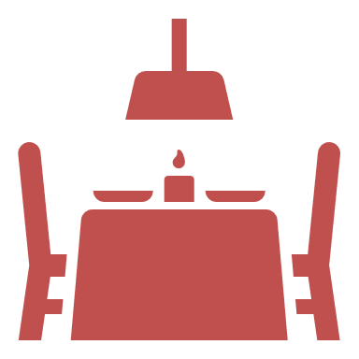
The small intestine

The small intestine is a tube about
6 metres long.

The small intestine is divided into three sections:
- duodenum;
- jejunum;
- ileum.

The inner surface of the small intestine is folded into finger-like structures called villi, which greatly increase the surface area available for absorption.
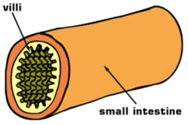

In the duodenum, chyme is diluted with bile salts (from the gall bladder) and pancreatic juices (from the pancreas).
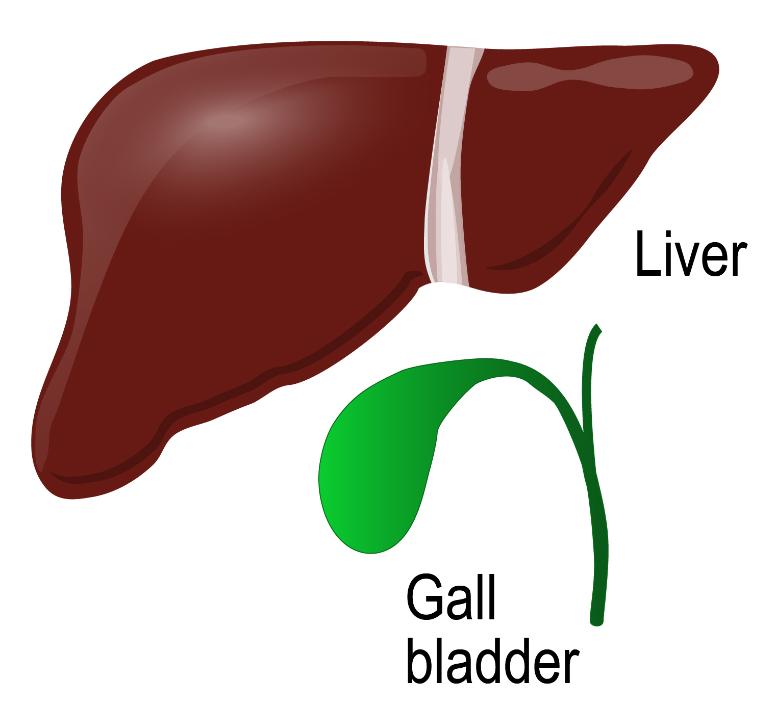

Colon (Large intestine)
The colon is a tube just over 1.5 metres long and is inhabited by bacteria.
The main function of the colon is to absorb water into the bloodstream and to process waste products.

Oesophagus: Circular muscles in the wall of the oesophagus relax in front of the bolus (a ball like mixture of food and saliva) while circular muscles behind the food contract, pushing the food bolus onward. This is called peristalsis.
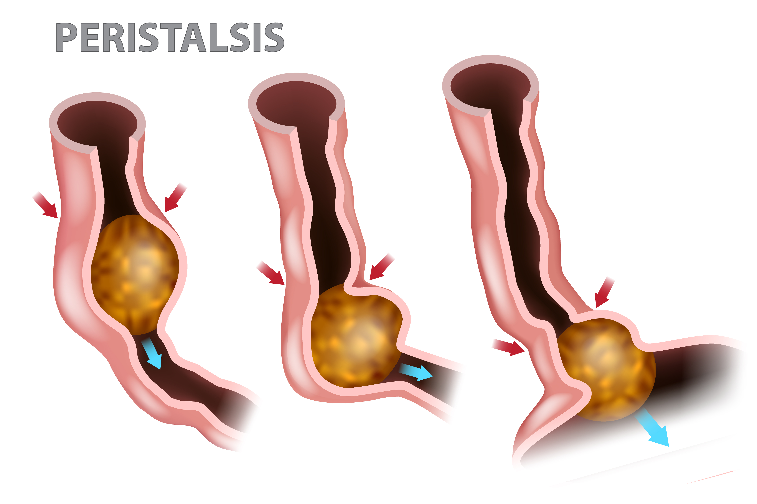

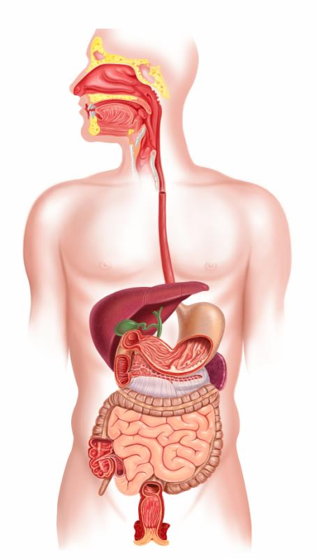
Pancreas
Mouth
Stomach
Oesophagus
Small intestine
Colon
Anus
Rectum
Task
Draw the digestion process and label each part of the body. List the stages of digestion, giving information on which part of the body is used for each stage.
Key terms
Bile: Bile is a fluid produced in the liver and stored in the gall bladder. This contains bile salts which emulsify fat, which is normally insoluble in water.
Digestion: The process by which food is broken down in the digestive tract to release nutrients for absorption.
Passive absorption: Through the process of osmosis, the nutrients pass through the wall of the small intestine into the blood supply. Active absorption: A carrier transports nutrients through the wall of the small intestine into the blood supply.
Villi: Finger-like structures along the small intestine, which greatly increase the surface area available for absorption.
Bolus: A ball-like mixture of food and saliva.

Pancreatic juices
The pancreas secretes alkaline pancreatic juices that contain sodium bicarbonate to neutralise the hydrochloric acid mixed into the chyme from the stomach and provide an optimum pH level for the enzymes to work.

Pancreatic juices also contain digestive enzymes to break down nutrients:

Protein Peptides + Amino acids
Trypsin and Chymotrypsin

Starch / Glycogen Maltose
Pancreatic amylase

Fat Fatty acids + glycerol
Pancreatic lipase
The key organs involved in the digestive process
For more information, go to: https://bit.ly/36KUnji
Stages of digestion
- Ingestion - the intake of food into the gastrointestinal tract.
- Digestion - a series of physical and chemical processes which begin in the mouth, but take place mainly in the stomach and small intestine.
- Absorption - the passage of digested food substances across the gastrointestinal lining into the bloodstream and lymphatic system.
- Elimination - the excretion of undigested food substances (such as cellulose) or waste in faeces.
The stomach: The stomach is an expandable sack made up of three different layers of muscles where the bolus will be churned for a few minutes or up to a few hours. The bolus is mixed with hydrochloric acid (HCl) which helps to kill any bacteria present.
