Energy and activity

Body Mass Index (BMI) can be used to identify if an adult is a correct weight for height.

BMI = weight (kg)
(height in m)²

Basal metabolic rate (BMR)
Basal metabolic rate (BMR) is the rate at which a person uses energy to maintain the basic functions of the body when it is at complete rest, such as:
- breathing;
- keeping warm;
- keeping the heart beating

Physical activity level (PAL)
In addition to their BMR, people also use energy for movement of all types, expressed as PAL.
The amount of energy a person uses to perform daily tasks varies.

Energy requirements vary from person to person, depending on BMR and PAL.

Total energy expenditure
= BMR x PAL

Energy is the power to do work. Energy is essential for life, and is required to fuel many different body processes, growth and activities.

These include:
- keeping the heart beating;
- keeping the organs functioning;
- maintenance of body temperature;
- muscle contraction.

Moderate activity
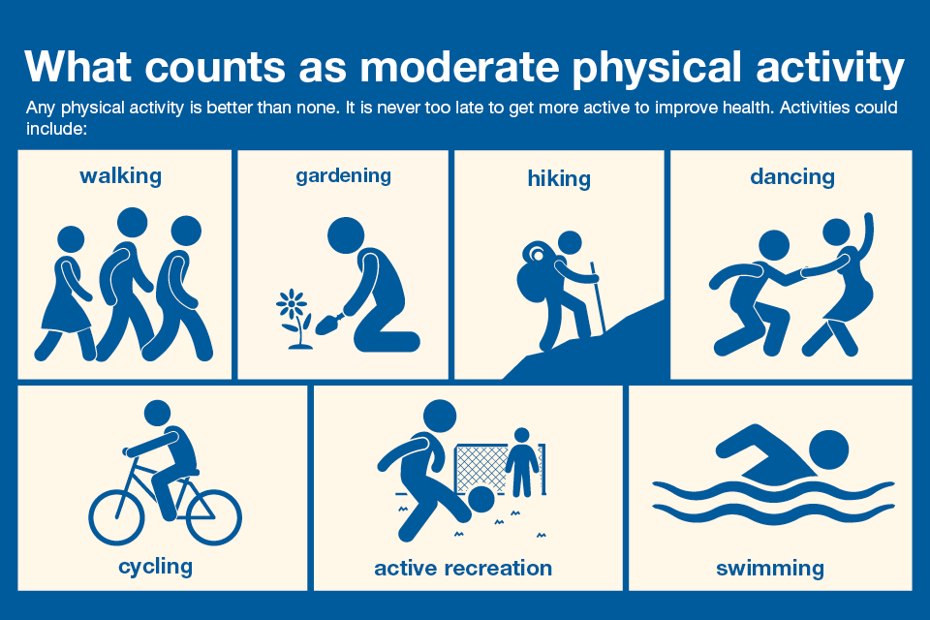

Vigorous activity

Muscle strengthening activities
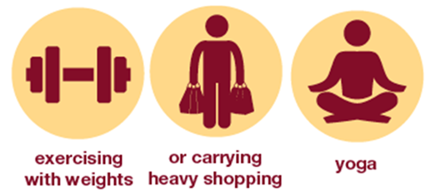
Key terms
Basal metabolic rate (BMR): The rate at which a person uses energy to maintain the basic functions of the body when it is at complete rest.
Body Mass Index (BMI): An equation that can be used to identify if an adult is a correct weight for their height.
Dietary reference values: Estimated dietary requirements for particular groups of the population.
Energy: The power the body requires to stay alive and function.
Physical activity level (PAL): The amount of energy a person uses to perform daily tasks varies.
Estimated Average Requirements (EAR): An estimate of the average requirement of energy or a nutrient needed by a group of people.

Physical activity
Physical activity should be an important part of our daily energy expenditure.

Many different types of activity contribute to our total physical activity, all of which form part of everyday life.

Inactivity
It is also important that the amount of time being sedentary is reduced.

Over time, sedentary behaviour can lead to weight gain and obesity, which can increase the risk of developing chronic diseases in adulthood.

1 in 4 women and 1 in 5 men are classified as inactive (<30 mins per week).

Undernutrition and obesity
Managing energy intake and expenditure, and maintaining energy balance can help reduce the risk of overweight/obesity and being underweight.

People who are obese are more likely to suffer from coronary heart disease, type 2 diabetes, gall stones, arthritis, high blood pressure and some types of cancers, i.e. colon, breast, kidney and stomach.

Being underweight is also linked with health problems, such as osteoporosis (low bone mass), infertility (difficulty to conceive) and even heart failure.

Benefits of physical activity
Physical activity is beneficial because
it can:
- help to manage the balance between energy in and energy out, to maintain a healthy weight;
- improve heart health and strengthen muscles and bones;
- improve sleep, relieve stress and lift mood.

Energy balance
To maintain body weight it is necessary to balance energy intake (from food and drink) with energy expenditure (from activity).

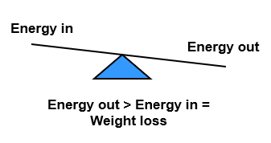
Different people need different amounts of dietary energy depending on their:

- age;
- gender;
- body size;
- level of activity;
- genes.

The figures determined are known as Estimated Average Requirements (EAR) for energy.
for energy.
For more information, go to: https://bit.ly/36KUnji
Tasks
- Create an infographic on either energy or physical activity.
- Keep a food diary for four days and calculate the energy provided per day. http://explorefood.foodafactoflife.org.uk

Activity recommendations
We are all advised to minimise inactivity. In addition, there are specific age-related recommendations.

Pre-schoolers (3 to 4 years): 180 minutes (3 hours) spread throughout the day, including at least 60 minutes of moderate-to-vigorous intensity physical activity.

Children and young people (5-18 years): At least 60 minutes of physical activity every day and engage in a variety of types and intensities of physical activity across the week.

Adults (19-64 years): At least 150 minutes each week (moderate intensity), or have 75 minutes of vigorous activity a week and do muscle strengthening activities on two days or more each week.

Energy intake is measured in joules (J) or kilojoules (kJ), but many people are more familiar with Calories (kcal).

1 kilojoule (kJ) = 1,000 joules
1 megajoule (MJ) = 1,000,000 joules
1 kilocalorie (kcal) = 1,000 calories

To convert from one unit to another: 1 kcal = 4.184 kJ

 | Energy per 100g
Carbohydrate | 16kJ (3.75 kcals)
Protein | 17kJ (4 kcals)
Alcohol | 29kJ (7kcals)
Fat | 37kJ (9 kcals)

Energy from food
- Energy intake is measured in joules (J) or kilojoules (kJ), but many people are more familiar with Calories (kcal).
- Different macronutrients, and alcohol, provide different
amounts of energy.

