Food choice
Personal preferences
A number of factors can influence personal preferences, including:
- colour, size and shape of crockery and cutlery used;
- portion size;
- serving style;
- taste, aroma, texture, appearance, shape and colour of food.

Food choice
Food choices for a balanced diet depend on many factors, such as:
- advertising and other point of sale information;
- cost and economic considerations;
- cultural or religious practices;
- environmental and ethical considerations;
- food availability;
- food preferences;
- food provenance;
- health concerns;
- individual energy and nutrient needs;
- portion size;
- social considerations.

Budgeting
There are many things that we can do to spend money wisely on food. Examples can include:
- eating the seasons;
- stocking up on food with a long shelf-life;
- taking time to plan meals and write a shopping list;
- cooking using one pot;
- making fake-aways rather than buying takeaways;
- using leftovers;
- replacing branded items with cheaper items;
- comparing prices and shop around to find the cheapest items;
- growing your own food.

Key terms
Advertising: Advertising is a form of communication for marketing and used to encourage, persuade, or manipulate an audience to continue or take some new action.
Ethical: Relating to personal beliefs about what is morally right and wrong.
Food certification and assurance schemes: Defined standards of food safety, quality or animal welfare.
Food provenance: Knowing where food was grown, caught or reared and how it was produced.
Marketing: Promoting and selling products or services, including market research and advertising.
Religion: A particular system of faith and worship.
Seasonal food: Food grown at a particular time of year.

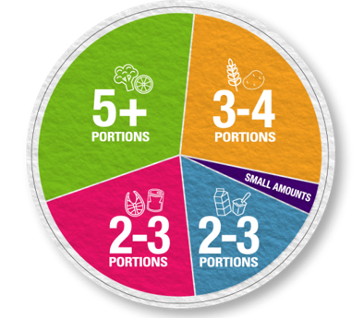
Food provenance
Food provenance is about where food is grown, caught or reared, and how it was produced. Food certification and assurance schemes guarantee defined standards of food safety or animal welfare. There are many in the UK, including:

Health concerns
People may choose their food based on their own or their family’s health and wellbeing:
- allergy and intolerance, e.g. lactose intolerance, coeliac disease, wheat allergy, diary allergy;
- body image;
- health issues, e.g. coronary heart disease, type 2 diabetes, inflammatory bowel disease, over or under malnutrition;
- mental health.

Individual energy and nutrient needs
The amount of energy and nutrients needed differs between different age groups and between males and females.
Energy needs also depend on activity levels. For example, athletes will have much higher energy requirements due to their high level of physical activity.

Social considerations
- Body image and peer pressure.
- Development of ready meals and a wider range of convenience foods.
- Development of labour saving devices.
- Lack of competence and confidence in the kitchen.
- Lack of time.
- Living arrangement (e.g. living alone).

Tasks
- Consider your own household and create a mind map of the social and economic considerations that affect your food choice. Explain how different this might be to your grandparents at your age.
- Explain why food provenance is important to some consumers. Include examples of UK food certification and assurance schemes.

Portion size
Having a healthy, balanced diet is about getting the right types of foods and drinks in the right amounts.

To find out more, go to: https://bit.ly/3dpC9Fj
Food availability
Buying food when it is in season will often mean that the price is lower. Technology and the importation of food has allowed food to be available all year round.

Environmental and ethical considerations
Some considerations when buying food might be:
- fair trade;
- local food;
- genetically modified (GM) food;
- organic food;
- free range.
Cultural or religious practices
People around the world choose to eat or avoid certain food due to their cultural or religious practices.

Religion | Pork | Beef | Lamb | Chicken | Fish
Islam | x | Halal only | Halal only | Halal only | ✔
Hinduism | x | x | ✔ | ✔ | ✔
Judaism | x | Kosher only | Kosher only | Kosher only | ✔
Sikhism | x | x | ✔ | ✔ | ✔
Buddism (strict) | x | x | x | x | x
Seventh-day Adventist Church | x | x | x | ✔ | ✔
Rastafari movement | x | x | x | x | x

Food prices
Food prices can and do change throughout the year and over time. This may be due to a variety of reasons, including:
- climate and weather patterns;
- crop failure;
- crop disease;
- seasonality;
- consumer demand;
- agricultural costs increase;
- fuel prices go up;
- increased use of bio fuels.
Cost and economic considerations
The cost of food and money available will influence people’s food choices. If money is limited, people may choose to buy more basic items. Luxury items might then be selected for special occasions.
Consumer information
Information can help consumers make informed choices, including:
- advertising and marketing;
- media, online blogs/forums;
- packaging, nutrition and health claims;
- point of purchase information and product placement;
- recipe ideas.

