Food commodities: Potatoes

Science behind cooking potatoes
Potatoes vary from having a smooth to fluffy texture when they are cooked; the different textures are due to changes that happen to potato cells during cooking.
During cooking, the starch in the potato begins to absorb water and swells in size. Potatoes need to be cooked for long enough to gelatinise the starch otherwise they will be ‘undercooked’. The starch cells of new potatoes are less mature which means they hold their shape well.

Farming potatoes
There are around 2,500 specialist potato farms within the UK. Potatoes will usually be grown in the same field for only one out of every six years, or even longer. This is known as a rotation.

- Choosing where to plant
Soil is tested for nutrients and moisture content to see if it is suitable for growing potatoes.
- Preparing the soil
The farmer ploughs the ground to turn the soil, before adding fertiliser in the spring.
Stones are removed using a destoner, as automatic harvesters cannot tell the difference between stones and potatoes.
- Planting
Seed potatoes are chitted before being planted in rows 15-17cm deep. This happens in spring, which can be as early as January in southern counties, meaning potatoes are available all year round.
- Protecting the crop
As the potatoes grow, they are ‘earthed up’ to protect them from the elements. They are also sprayed with plant protection products e.g. pesticides, to guard against insects and diseases.
- Harvesting
Five months after planting the potato harvester lifts and separates the potatoes from the soil. They are then graded for size and quality.
- Storage
Once harvested they are placed in bulk storage or weighed and bagged ready for distribution.
The potato plant
The potato is a starchy crop, which grows underground as a product of the potato plant. It is classified as a tuber, which is the fleshy swelling at the tip of an underground stem.

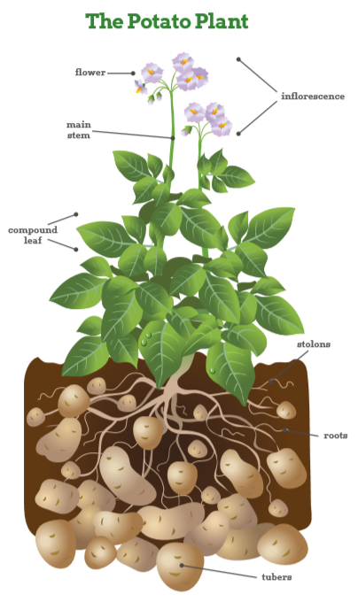

Key terms
Crop rotation: Growing different crops in a field to replenish nutrients and improve the soil.
Chitting: A method of preparing potatoes or other tubers for planting by putting them in a light and cool place but shielded from direct sunlight.
Earthed up: A technique where soil is drawn up around the potato plants to protect them from the weather.
Potato rotation: The system used by farmers to replenish nutrients and improve soil health in fields.
Pre-prepared: Prepared in advance.
Tuber: The ends of a potato plant’s underground stems (or stolons), that thicken to form potatoes.

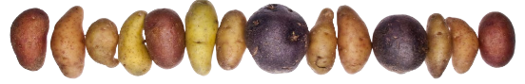
- Baking – the process of cooking food surrounded by heat. As the potato cooks, the skin acts as a seal, trapping water that expands and steams the potato as it cooks. When potatoes are baked the starch below the skin converts to sugar, which browns in heat and makes the skin crispy.
- Roasting – the process of cooking food in the oven with the addition of fat. Basting the potatoes by spooning over hot oil adds moisture while cooking. Roast potatoes should be served immediately, as the potatoes will continue cooking inside and the skins will go soft.
- Boiling – potatoes are covered in liquid and heated to boiling point. The heat is then reduced for the remainder of the cooking time. When potatoes are boiled, the starch in the potato absorbs water and swells; this gives the potato a better texture and flavour, and makes it easier to digest.
- Steaming – a process using the steam from boiling water. Evenly sized potatoes should be used to ensure they cook in the same amount of time. The steaming process preserves nutrients, especially when the skin is left on.
- Shallow frying (sauté) – the process of cooking food quickly in a shallow pan with a minimum of fat. The potatoes are in direct contact with the fat, so they cook rapidly. The high temperature seals the surface of the potato almost instantly and prevents the natural juices from escaping.
- Deep-frying – the process of cooking food immersed in hot oil or fat.

Cooking cut potatoes in small quantities will allow the oil to regain its temperature more quickly, so the chips cook faster and absorb less fat. The ideal temperature for the oil is 175°C. If the oil is too hot, the food will brown, but be raw on the inside
- Mashing – the process of reducing a food to a pulpy mass by crushing it. When the potato is mashed, the cells break open, releasing starch, which makes them creamy and smooth. The slower the potatoes are cooked, the better for the starch as it has more structure in the final mixing process.

Task
Research potato recipes and identify at least three recipes for each potato variety. Explain why the particular variety is used.
History of potatoes
Potatoes were first discovered growing in the Andes in Peru more than 6,000 years ago.

Today around 300m tonnes of potatoes are grown around the world and they are central to the diets of many countries.

Choosing the right variety
Potatoes can be classified by their characteristics; and can be divided into three major groups.
The different characteristics influence the performance of the potato when cooked in different ways:
- Fluffy potatoes: Have a fluffy middle when cooked and are good for jacket potatoes and chunky chips.
- Smooth potatoes: Hold their shape when boiled or cooked in a sauce. They are also good for mash as they have a smooth texture when cooked.
- Salad potatoes: Are firm to the bite and hold their shape when cooked. They can be boiled or steamed or roasted whole in their skins but do not mash well.

Pre-prepared potatoes

These come in a variety of forms, but whether chilled or frozen, whole, diced or wedged, they help caterers to ensure a consistent year-round product in their kitchens, taking away additional preparation time and costs. Pre-prepared potatoes can often be used as an ingredient to add variety to menus and can offer versatility to chefs to adapt menus.

Pre-prepared potatoes are most commonly chilled and frozen. This allows caterers to use products to suit the particular operation. Some pre-prepared potato products also come as ‘dual storage’, meaning they may be delivered frozen, but can then be stored and used from a chilled state.

Pre-prepared potatoes are also very useful for consumers to use at home.

Storage

Potatoes should be stored in a dry, dark and cool environment.

For short-term storage, they should be kept at a temperature of 7-10°C. Exposure to light should be avoided, as this will encourage sprouting and eventually a greening effect.

When stored at a constant temperature of 4°C, they can be kept for several months without affecting quality. However, temperatures below 4°C will convert the potato’s starch into sugar and will affect the taste and cooking qualities.

For more information, go to: https://bit.ly/31Tr4aA
Potato varieties
Around 5.4m tonnes of potatoes are grown in Britain each year. There are around 100 different varieties grown, but only around 20 are available in shops depending on the region (reflecting what is grown locally). British ‘home-grown’ potatoes account for around 80% of all the potatoes eaten. Potatoes are often referred to as ‘new’ (harvested in early summer) and ‘old’ (harvested in autumn).

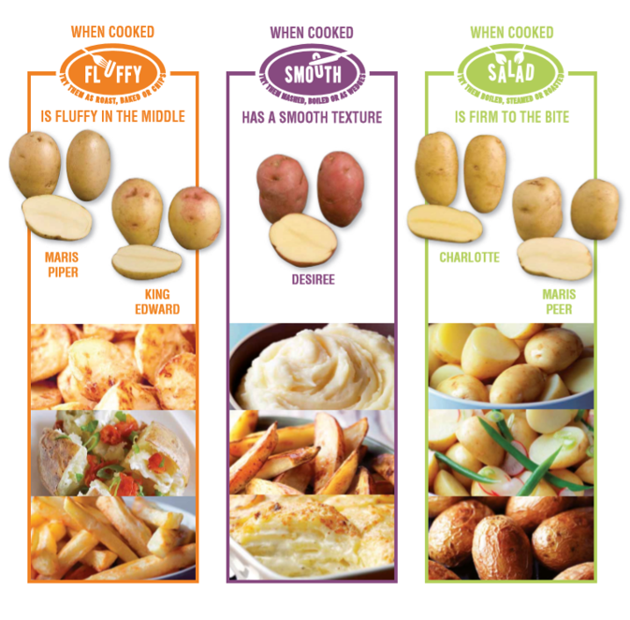
The name ‘potato’ can refer to both the plant and the tuber.

