Food commodities: Cereals, fruit, vegetables and potatoes
- Different types of food are grown.
- There are a number of different stages in producing and processing food.


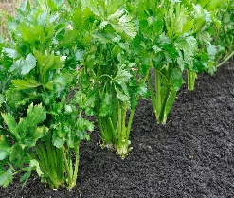

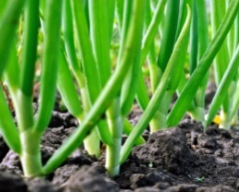


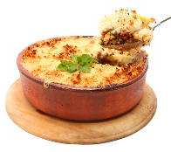
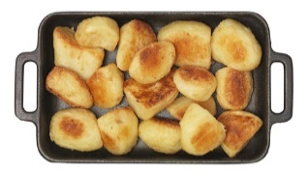
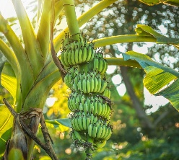
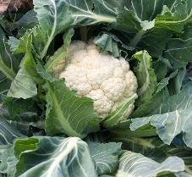
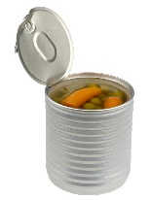
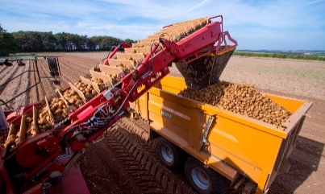
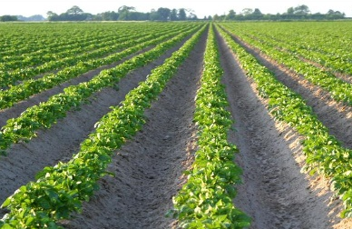
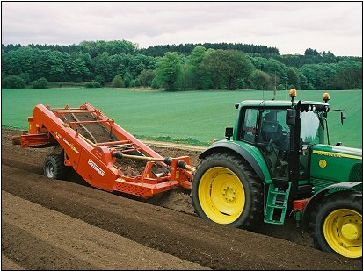
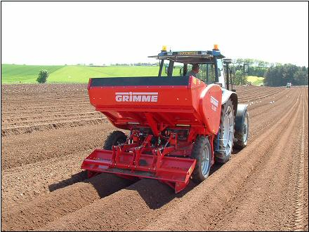
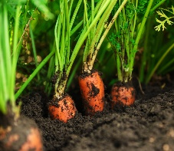

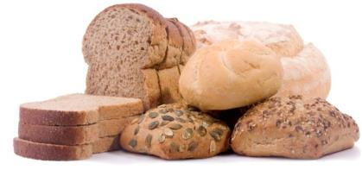
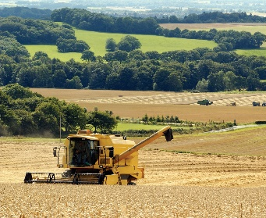
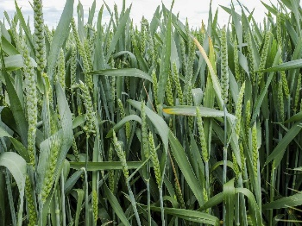
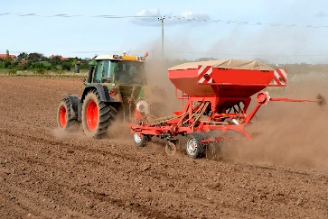
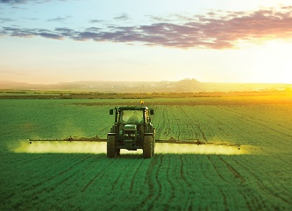
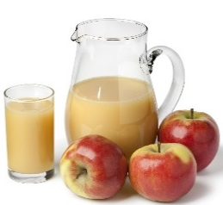
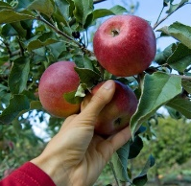
Winter: The wheat grows slowly. It is sprayed to protect it from weeds,
pests and diseases.
Potatoes are a tuber. They grow under the ground.

This resource meets the Guidelines for producers and users of school education resources about food.

Carrots are a root vegetable that grow under the ground.
They can be bought as fresh, canned, juiced or frozen.
Cauliflower is a plant that grows above the ground. We eat the flower of the plant. They can be bought fresh or frozen and eaten raw or cooked.
Bananas are a fruit, they grow above the ground in hot climates.
They can be eaten raw or cooked.
Celery is a plant that grows above the ground. We eat the stem or stalk of the plant.
Celery can be eaten raw or cooked.
Onions are a plant that grow under the ground. We eat the bulb of the plant. They can be bought fresh, frozen or dried and are eaten in many dishes.
Potatoes can be eaten in lots of different ways.

Task
Create a poster to explain how wheat or potatoes are grown and what happens in each season.

Apples are a fruit that grow on trees.
They can be bought as fresh, canned, dried, pureed, juiced or frozen.

Some potatoes are stored to be eaten later in the year. While others are processed into food like frozen chips or crisps and sold in shops, restaurants and supermarkets
As the potatoes grow they are ‘earthed up’ to protect them from the frost and diseases.
When they are ready the harvester lifts and separates the potatoes from the soil.
The grain is then dried and stored
before being sent to the flour mills.
Some of the grain is used as animal feed for pigs, chickens and cows.
Summer: The grains ripen and are harvested by the combine harvester.
Fruit and vegetables grow above and below the ground.
Cereals include wheat, oats and barley. Wheat is the most widely grown crop in the UK.

To find out more, go to: https://bit.ly/3lCnvxL

Seed potatoes are chitted before being planted into warm soil in April time.
A destoner gets the field ready for planting.
Stages of growing potatoes
A year growing wheat
Spring: The wheat grows fast and produces ears of grain.
Autumn: The farmer ploughs the field and plants the wheat seed.

