Simple spring rolls
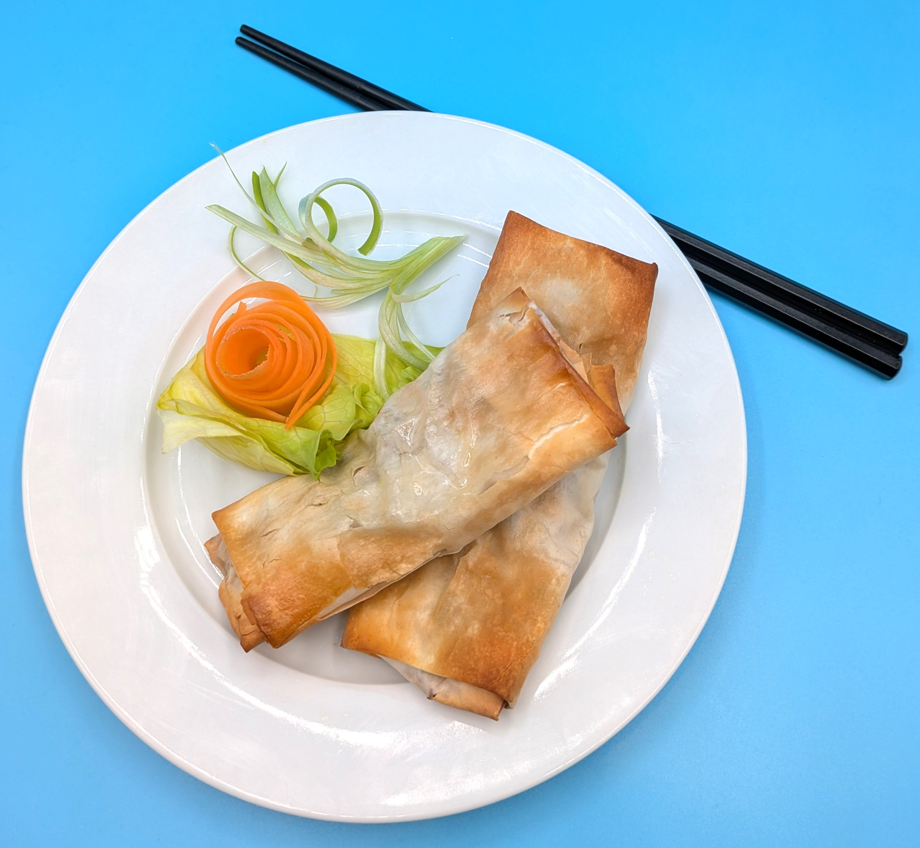
Complexity: medium
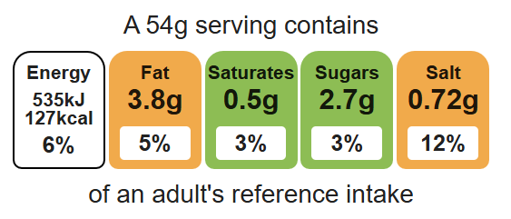

Ingredients (serves 2)

Equipment

Chopping board

Sharp knife

Vegetable peeler

Grater

Mixing bowl

Measuring spoons

Metal spoon

Baking tray

Pastry brush

1 carrot
2 spring onions
40g beansprouts
25g frozen peas
1 x 15ml spoon oyster sauce
4 filo pastry sheets
1x 15ml spoon oil or spray oil

Method
- Preheat the oven to 200°C or gas mark 6.
- Prepare the spring roll filling:
- top, tail, peel and grate the carrot;
- slice the spring onions into rings.
- In a large mixing bowl add the grated carrot, spring onions, beansprouts, peas and oyster sauce.
- Mix the ingredients together.
- Place the filo pastry sheets on the work surface.
- Halve the pastry sheet and work on one half at a time.
- Spoon a little vegetable mixture along the top edge.
- Fold over twice.
- Fold in the two edges.
- Continue to roll up the spring roll.
- Place on the baking tray.
- Brush with a little oil or spray with oil.
- Bake for 15 minutes, until golden.

Top tips
- Reduce food waste: Try adding different vegetables that need to be used up, e.g. finely diced celery, peppers, cabbage.
- Focus on fibre: Sprinkle seeds on top of the spring rolls before you bake them. Be ingredient aware!
- The spring rolls could also be cooked using an air-fryer for 15 minutes at 180°C.

Food skills
Weigh, measure, grate, cut, chop, slice, dice and trim, mix, sir and combine, portion, divide, fold, glaze and coat, bake.

