Cheese and corn empanadas

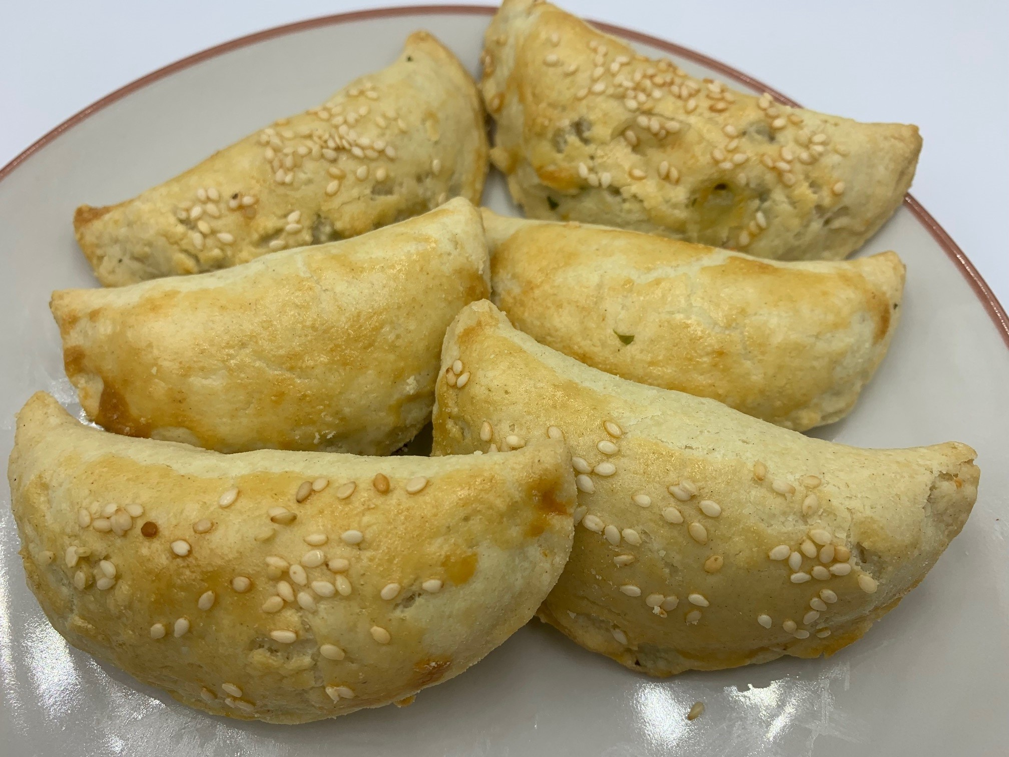
Ingredients
Complexity: medium-high
110g pain flour
25g lard or white baking fat
25g butter or hard baking fat
1 small egg or 2 x 15ml milk
25g reduced fat extra mature Cheddar cheese
or white cheese, such as feta
2 x 15ml spoon canned or frozen sweetcorn
½ small onion
½ green chilli
Small handful coriander, leaves and stalks
1 x 5ml sesame seeds (optional)

Equipment
Baking tray, greaseproof paper, sieve, large mixing bowl, knife, measuring spoon, rolling pin, pastry cutter, chopping board, grater, vegetable knife, small bowl, fork, pastry brush.

Method
- Pre-heat the oven to 200C or gas mark 6.
- Line a baking tray with greaseproof paper.
- Make the shortcrust pastry:
  - Begin by sifting the flour into a large bowl, holding the sieve above the bowl so that the flour gets a really good airing before you begin.
  - Chop the fat into smallish lumps add to the flour then take a knife and begin to cut the fat into the flour. Go on doing this until it looks fairly evenly blended, then begin to rub the fat into the flour using your fingertips only and being as light as possible. As you gently rub the fat into the flour, lift it up high and let it fall back into the bowl, which again means that all the time air is being incorporated, but do this just long enough to make the mixture crumbly with a few odd lumps here and there.
  - Sprinkle in 1 x 15ml water, then start bringing the dough together, using the knife to make it cling.
  - Discard the knife and, finally, bring it together with your fingertips. When enough liquid is added, the pastry should leave the bowl fairly clean. If this hasn't happened, then add a little more water.
  - Cover the dough and leave it in the refrigerator to rest whilst you are preparing the filling.
- Prepare the filling ingredients:
  - grate or crumble the cheese;
  - drain the sweetcorn;
  - peel and finely dice the onion;
  - finely chop the chilli;
  - chop the coriander;
  - crack the egg into a small bowl and beat with a fork, if using.
- Place the cheese, sweetcorn, onion, chilli and coriander in a bowl and mix well.
- Roll out the pastry thinly on a lightly floured surface.
- Use a 10cm cutter to cut out circles of pastry. Re-roll any trimmings to make more circles.
- Brush the edges of the circles with some of the beaten egg or milk.
- Spoon some of the filling mixture onto each circle (approximately 2 x 5ml spoons of mixture).
- Fold over one half of the pastry and pinch the edge together to seal. Place onto the lined baking tray. Repeat with the remaining circles.
- Brush the tops with a little beaten egg and sprinkle with sesame seeds, if using.
- Bake in the oven for approximately 20 minutes, until the empanadas are golden and crisp.
Food skills
- Weigh
- Measure
- Rub-in
- Mix
- Grate
- Drain
- Peel
- Dice
- Chop
- Roll-out
- Cut-out
- Form and shape
- Glaze
- Bake

Top tips
- Use half wholemeal flour and half white flour for added fibre.
- Try using spring onion instead of white onion.
- Why not make your own white cheese to use in the filling. Instructions can be found here.
- If time is short, use readymade shortcrust pastry or cut tortilla wraps into circles.

Did you know?
Many cultures and countries around the world have some version of a pastry or dough stuffed with sweet or savoury fillings: Bolani, Brazilian pastel, Cornish pasties, Cuban pastelitos, dumplings, pastechis, pierogi, Puerto Rican empanadilla, samosas, turnovers.

Empanada dough is usually made with wheat flour. However, it can also be made with maize (corn) flour, mashed plantains, mashed potatoes, yucca or cassava, or mashed sweet potatoes. Fillings are usually savoury but can also be sweet.

Empanadas can be served on their own or with dipping sauces. Chimichurri sauce is a popular dipping sauce. Find a recipe for chimichurri sauce here.

