Green goddess shakshuka

Ingredients
Complexity: medium-high

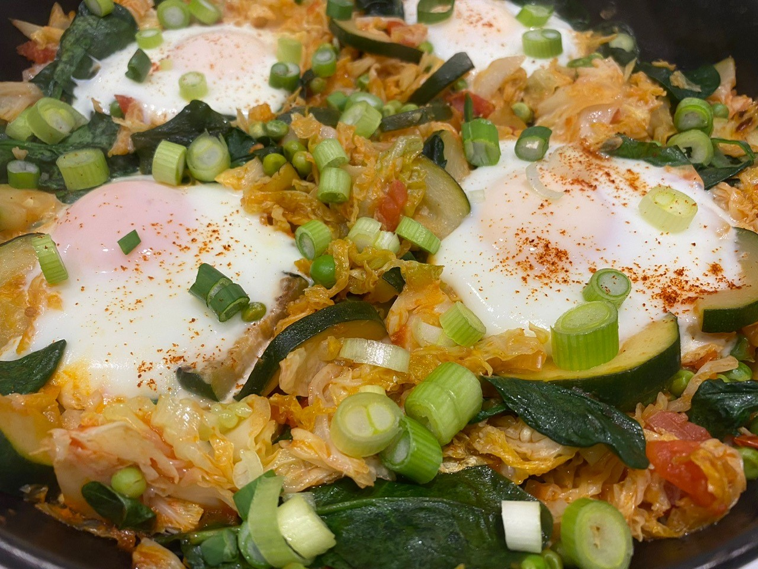
1 large courgette

4 spring onions

½ Savoy cabbage

60g baby spinach

1 x 15ml spoon oil

200g can chopped tomatoes

150g frozen peas

Black pepper

4 eggs

Pinch of smoked paprika

Optional

1 x 15ml spoon sweet chilli sauce

Equipment

Chopping board, vegetable knife, colander, large frying pan and lid/tin foil, can opener, mixing spoon.

Method
- Prepare the ingredients:
- wash and halve the courgette lengthways and then slice;
- wash and slice the spring onions;
- trim and shred the cabbage;
- wash and drain the spinach.
- Heat the oil in a large frying pan and sauté the courgette and the white part of the spring onion for 4-5 mins.
- Add the cabbage and cook for a further 4 minutes.
- Add the can of chopped tomatoes and stir.
- Bring to simmering point.
- Stir in the spinach and peas, then cook for a further 5 minutes.
- Season with black pepper.
- Make 4 small wells in the vegetables and crack an egg into each.
- Cover with a lid or large piece of foil and cook for 5-6 minutes until the eggs are cooked through.
- Sprinkle with the paprika and the remaining spring onion.
- If using, drizzle with the sweet chilli sauce before serving.

Top tips
- Use canned tomatoes with added herbs or garlic for a flavour change.
- Control the hob temperature to ensure the sauce does not stick or too much liquid evaporates.
- Use fresh peas or other vegetables when they are in season.
- Try other spices such as chilli powder for seasoning.

Food skills
- Weigh
- Measure
- Cut
- Trim
- Slice
- Mix
- Stir
- Fry/sauté
- Simmer

Did you know?
Shakshuka is a popular Middle Eastern and North African dish that may date back all the way to the Ottoman Empire. It is found in Libya and Tunisia, and it has become a staple dish in Israel.

Shakshuka (meaning ‘shaken or jumbled up’) is a very versatile dish – other ingredients can be added for example, vegetables such as broccoli, plant-based protein such as tofu or tempeh, minced lamb or beef, crumbled feta cheese or halloumi.

This recipe was kindly donated by Co-op Group Limited.

