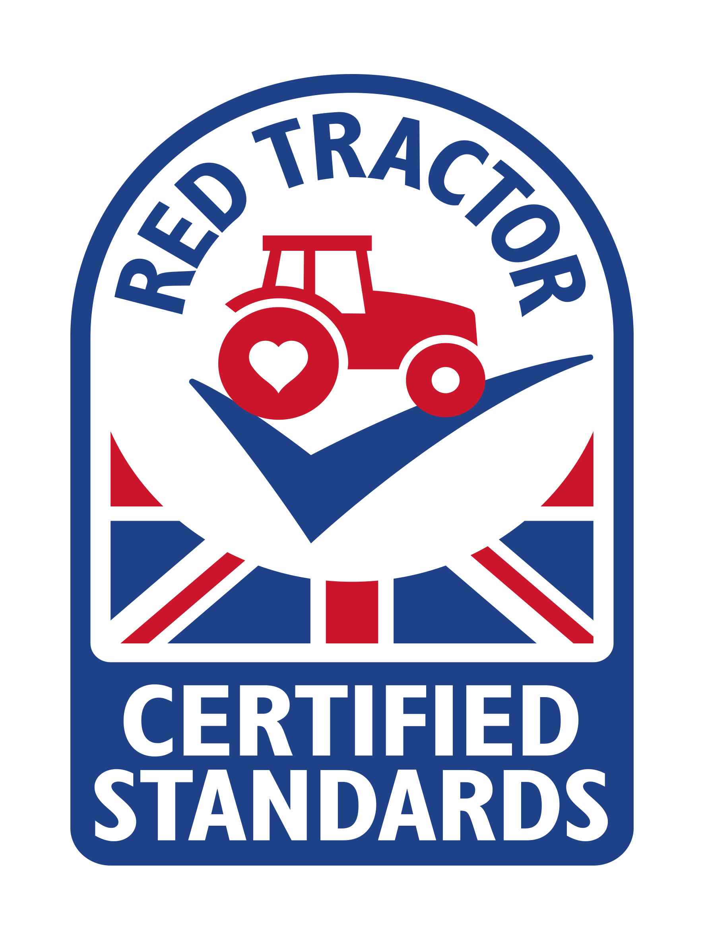
Red Tractor
The Red Tractor logo shows that farmers
look after their animals and produce food safely.

Name 4 foods that have a Red Tractor logo.

What else does the Red Tractor label it tell us about the food?

